WINGTRA LiDAR Collection and Data Processing
This workflow explains:
- Wingtra LiDAR flight planning
- Data collection in the field
- Data processing including LiDAR classification with Global Mapper Pro
I am using Polyanna #2 site near Gowen, OK as example (92 acres – Title 5 bond forfeiture).
- Flown 12/18/24.
- 7 GCPs set (AeroPoints)
- RiNEX collected via Emlid Reach RS3
- Both RGB and LiDAR Collected
- LiDAR. 250’ AGL, 50% overlap. 1 flight.
- RGB flown 393’ AGL for Orthoimage (see other RGB workflow for SFM processing)
Planning (Pre-flight)
Some of this process is documented on Wingtra knowledge base. Highly recommend you review the KB guides before you go to the field!
Preload the base maps and elevation data onto the tablet into WingtraPilot app before you go to the field. Upload a KML of the permit boundary directly to the root directory of the Wingtra tablet, which helps you identify the location easier. Then download the offline maps by following this process:
https://knowledge.wingtra.com/en/download-maps-for-offline-use
Also try to turn on your Wingtra (conduct a quick LiDAR & RGB test flight) before you go to field. This makes sure your firmware and software is up to date. (especially important if you have slow/no internet connectivity in the field). Next determine your strategy for flying. Build a flight plan in WingtraPilot, choose overlap, flight height etc. Make a separate flight plan for RGB and LiDAR. Follow these steps, and best practices:

https://knowledge.wingtra.com/en/capturing-data-with-wingtra-lidar

For LiDAR collection, ideal height is 250 ft AGL, 30% overlap.

Other pre-flight considerations:
- PASP done (flight safety plan)
- Equipment all charged (use checklists!)
- What GNSS Collection method will you use? (test nTRIP at hotel night before)
- If OPUS processing base location, look at nearest CORS station (see NGS control points website)
- Is Aeropoint and/or RTK nTrip network available at this site?
- Where will you set GCPs/CPs? Who will do it?
- What coordinate system (state plane, UTM etc.)
- The more you test before you go at hotel or in office, the better
- Print out at least 2 maps of the site on 11x17 paper, with permit boundary shown.
- Have a call/meeting with the team before going. Assign roles, goals, deliverables.
- Assign roles: Who will take field notes, pictures, GCPs, fly site, collect Rinex, etc.?

Field Data collection
Some of this process is documented well on Wingtra KB. Pay special attention to optimum flight height (75m sweet spot?), and overlap of 30%. Remember you MUST collect RiNEX with GNSS concurrently during LiDAR collection. (Unlike RGB workflows in which PPK-geotagging is optional).
Below I will document the general field collection steps and include pictures.
Field data collection:
- Start setting/collecting GCPs immediately. I prefer Aeropoints, if Aeropoint network is available on-site. Coverage map here: https://aeropointnetwork.propelleraero.com/. Have one person/team lay GCPs while the other person/team preps Wingtra for flight. Follow GCP best practices, remember these GCPs could be used for RGB processing as well. Use spray paint.
- If Setting Aeropoints, remember to collect them in reverse order at end of day, otherwise numbering scheme will be messed up in subsequent AP processing reports.
- Set up Base station over Point 1. We have had success setting Emlid Reach RS3 over Aeropoint 1. Use stable 2M range pole on Tripod with sandbags or other method to make certain tripod does not move during Rinex collection.
- Remember you MUST collect base location (XYZ), which can be done by using an Aeropoint, by post-processing OPUS solution later, or setting up base station over a previously surveyed point with known XYZ.
- Begin logging RINEX file immediately. This will log during the entire duration of flight(s). I prefer 2hr+ to ensure Static solution later in OPUS but 4 hrs. better. (See special note below on Rinex settings.)
- Fly the LiDAR mission with Wingtra.
- Fly the RGB mission with Wingtra. Ideally when sun is overhead or overcast skies.
- Pull memory cards, check you have good RGB and LiDAR data before you leave.
- BONUS – if time permits, fly additional LiDAR/RGB missions at varying overlap/height/direction, as backup data to use just in case
- Stop RINEX logging and collect Aeropoints or other GCPs.
---------------------
RiNEX Logging special note:
Set the Emlid receivers (Emlid Flow App) to log Rinex file in UBX format (later we will use Emlid Studio to Convert To RINEX). At least enable the option in the Receiver to also log in UBX format along with the RINEX format so you have UBX as backup.
For submitting to OPUS, I use the Convert to RINEX function in Emlid Studio to output a RINEX version 2.11 file at a 30 second interval with the "Time Rounding" option enabled and with GPS constellation only. This is all the data OPUS uses anyway. This RINEX file is very small and usually OPUS returns an answer very quickly.
Note if you only log Rinex Ver 3.03 (or latest version) this is fine too, we can convert it later in Emlid Studio.
----------------------
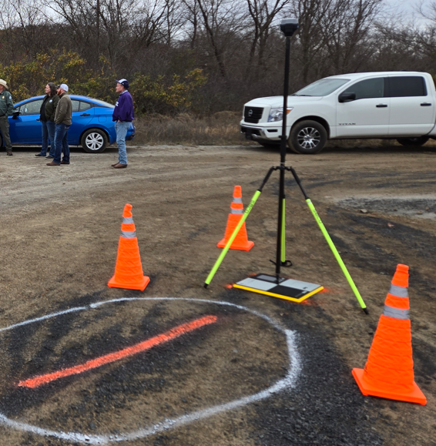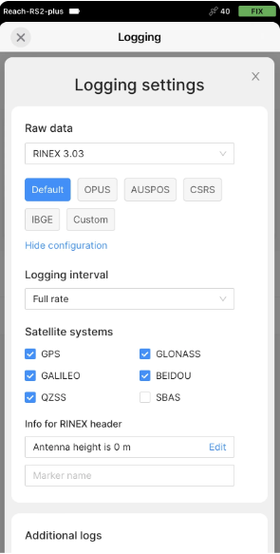
Pic above: Emlid Reach logging RINEX, over base location (point 1). Emlid Flow App shown.
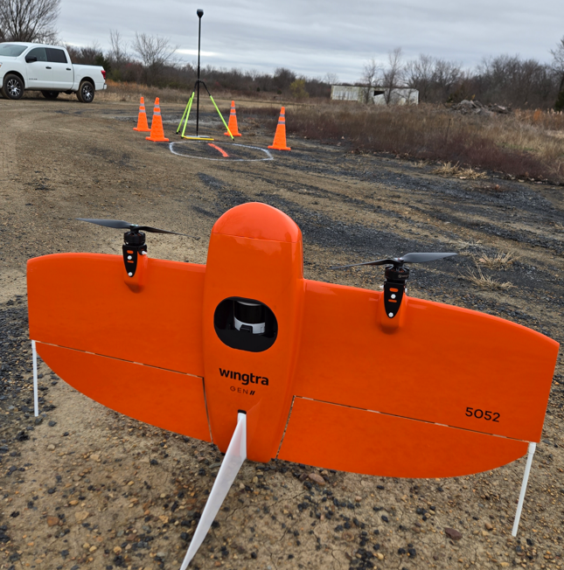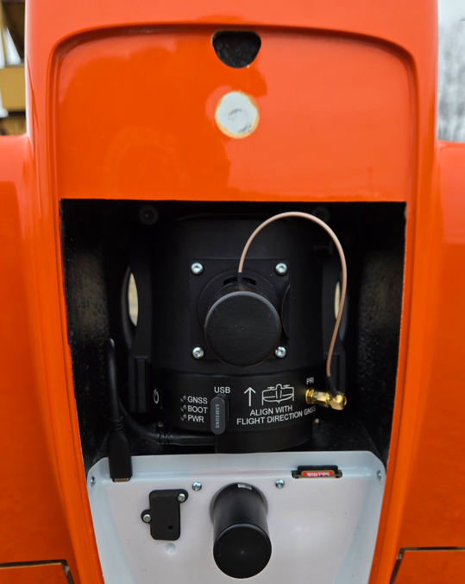
Pic above: Wingtra LiDAR set up.
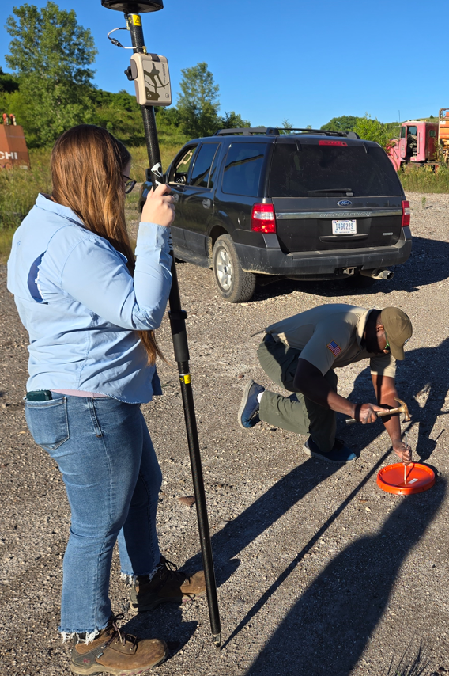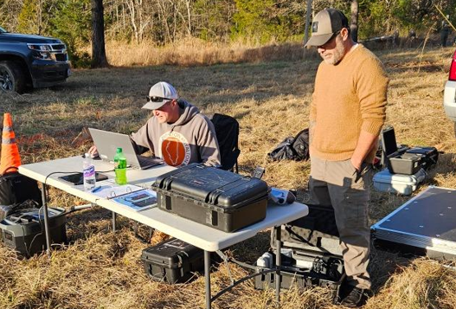
Pics above: Alternative GCPs (bucket lids). Checking all data BEFORE leaving field.
-------------
Do NOT leave the field without checking the data files on the USB stick (LiDAR) and memory card (RGB) to verify that data files are present after the flight(s). Note the file folder name below. Inside should at least be a “data” folder with .data files, which is your raw LiDAR data:

HIGHLY RECOMMENDED to fly an RGB mission after the LiDAR mission. This will give you a great ortho image overlay for use in subsequent data processing steps.
Have someone take FIELD NOTES. To document what you did, how many GCPs, how many flights, what details, who you met on site etc. These notes will come in handy later! Draw on printed map where your GCPs were set.

LiDAR data processing
Make sure you are running the latest version of Wingtra LiDAR Software (aka WLS). If not, download here:
https://knowledge.wingtra.com/en/install-and-activate-wingtra-lidar-application
(Kiser has a license for the software, we can share it back and forth by deactivating then activating on your PC)
First, copy over the files from the USB stick in LiDAR sensor over to your C drive. The following data files are recorded:
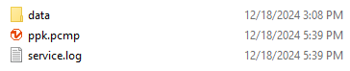
Next, before we start processing in WLS, copy/paste the RiNEX log files directly into the “data” folder like this. This saves a step later.
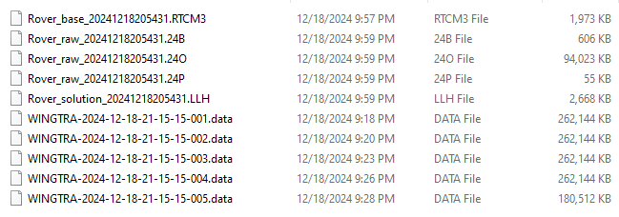
Next, Open up WLS. Click on File – Open Project. Select the “ppk.pcmp” file:
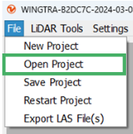
Here is the file you need:
WLS software will start unpacking data, converting/sampling Rinex file. This will take a moment:
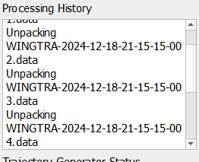
Next, you will enter the base location (usually the XYZ of the base point on the ground below the base station). And also enter the Antenna height (2m for me) and the distance from the top of pole to your antenna’s phase center (0.134m for Emlid Reach RS2 and RS3). The Latitude/Longitude I copied from my Aeropoints processing report. You may also get this base point location from OPUS processing of your Rinex logs, or from a known point you set over:
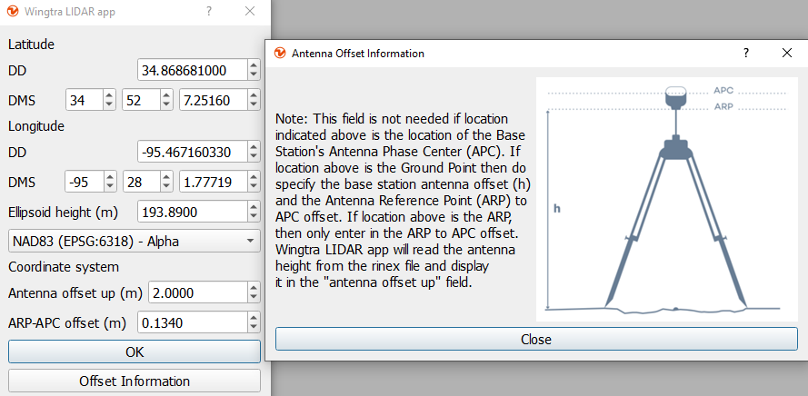
In our case, my Aeropoint solution (for Base1 location) was given in NAD83(2011) datum. You will find most nTRIP RTK solutions are in NAD83 as well. Had you used the OPUS solution for base location, the OPUS report will show both WGS84 and NAD83. Make sure you use the applicable datum. Also note it wants ELLIPSOIDAL height in meters.
NAD83 is tied to the North American tectonic plate and avoids issues with transformation related to time (WGS84/IRTF2014). Ellipsoidal height simplifies processing, is native to GNSS, and provides better vertical accuracy from RINEX. *In this workflow, the geoid is applied for orthometric heights AFTER data processing in Global Mapper or Pix4D (for RGB workflow).
If the base position is in State Plane or a local projection, then it is required to transform the coordinates before entry (hint: use Global Mapper to convert SP to Lat Long).
Click OK. WLS will start additional processing steps. This may take a moment.
After the processing is complete, a point cloud will appear in the viewer. The outlier removal function is applied automatically during the processing before the final visualization.
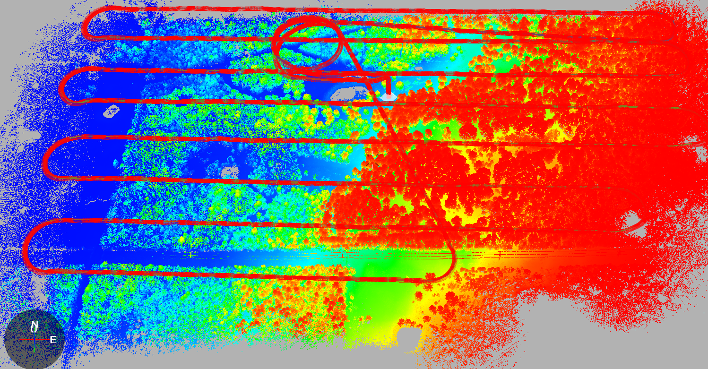
Next, follow these steps to Navigate the point cloud:
- To rotate the camera around its axis, press and hold Shift and Left mouse button and move the mouse.
- To move the focus horizontally, press and hold Ctrl and Left mouse button and move the mouse.
- To move the focus up and down, press and hold Ctrl, Shift and Left mouse button and move the mouse.
- Scroll with the mouse wheel to zoom in and out.
- Right mouse button – when it is clicked, it opens the context menu with actions. To look at the focus from different directions press and hold Left mouse button and move the mouse.
Follow these steps on KB to crop out the unwanted LiDAR collected at takeoff and landing:
https://knowledge.wingtra.com/en/processing-data-in-wingtra-lidar-app
As noted on KB, you can also crop out the turns, but this is optional. Here is my point cloud, “colored by elevation” with just the lidar transects selected. I did not crop out the turns. I did crop out the landing and take-off:
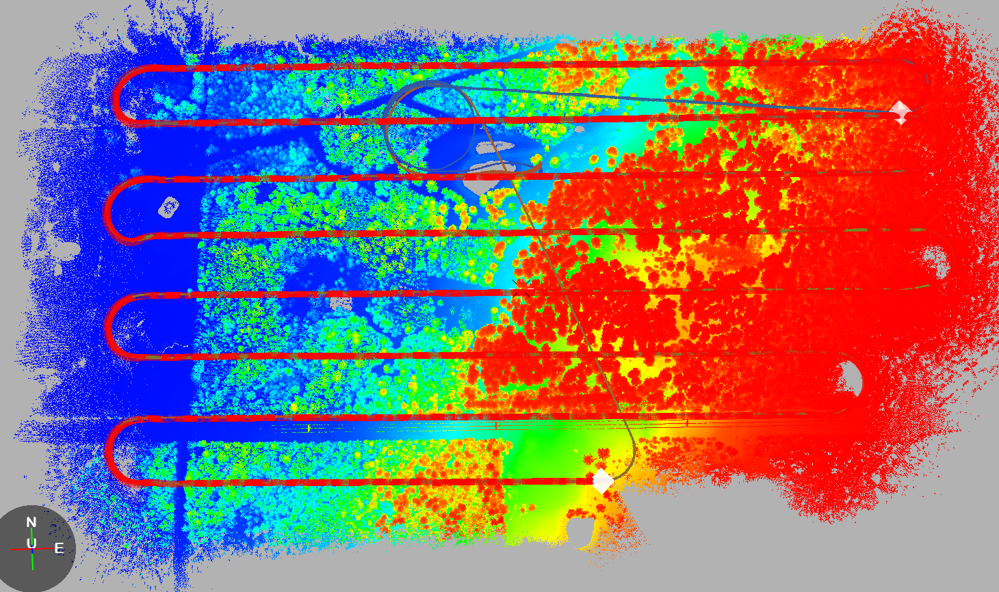

Checkpoint Views in WLS
Be aware that the GCP (checkpoint) viewer in WLS is “Quite Terrible” (quote directly from Wingtra!). This may change. Recommend using Global Mapper and/or LP360 for error checks. (i.e. calculation of RMSE).
In WLS, before you export the LAZ or LAS, you can do a rough accuracy check by entering or uploading your Checkpoints. Under LiDAR Tools – Ground Control Points. Note below I’ve manually entered 7 of the Aeropoints locations as my checks:
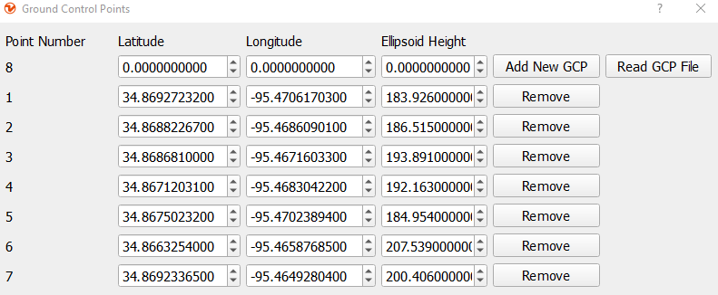

This drops the point(s) in amongst your LiDAR cloud, which makes it HARD to discern any meaningful information. It likely is dropping a point in there, but that point is no different than all of the lidar points. To see it, what you can do is right click on the point cloud and select the “color by path” option. This color can be configured in Lidar Tools --> Path, the GCP point defaults to red, but will still be challenging to find if it is not located near something unique to help pick it out.
EXPORTING the Point Cloud:
Next, File menu - Export to export your LAS or LAZ:
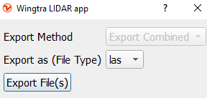
It will take a moment.
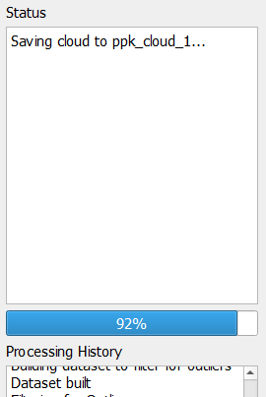

Note that it will save an LAS or LAZ. I saved an LAZ. Note it puts the exports into the “Point Clouds” folder:
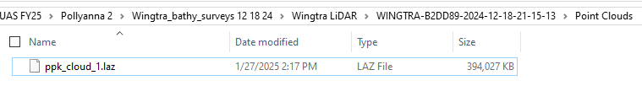
TIP: I noticed when I tried to re-export an LAS instead of LAZ, it deleted the old LAZ and replaced it with LAS. So if you want both LAZ and LAS, you can copy out of the folder “point clouds” folder first. Or convert in Global Mapper later.

Global Mapper processing:
By default, the LAZ/LAS is exported from Wingtra LiDAR software as UTM. In my case UTM Zone15, NAD83 datum, with planar units in Meters. I pulled this into Global Mapper by simply dragging and dropping the LAZ file, then opened up Configuration - Projection shown here. Note the projection GM automatically recognized because this was written into the LAZ. I will change my projection to OK – State Plane South, NAD83, with planar units in Feet.
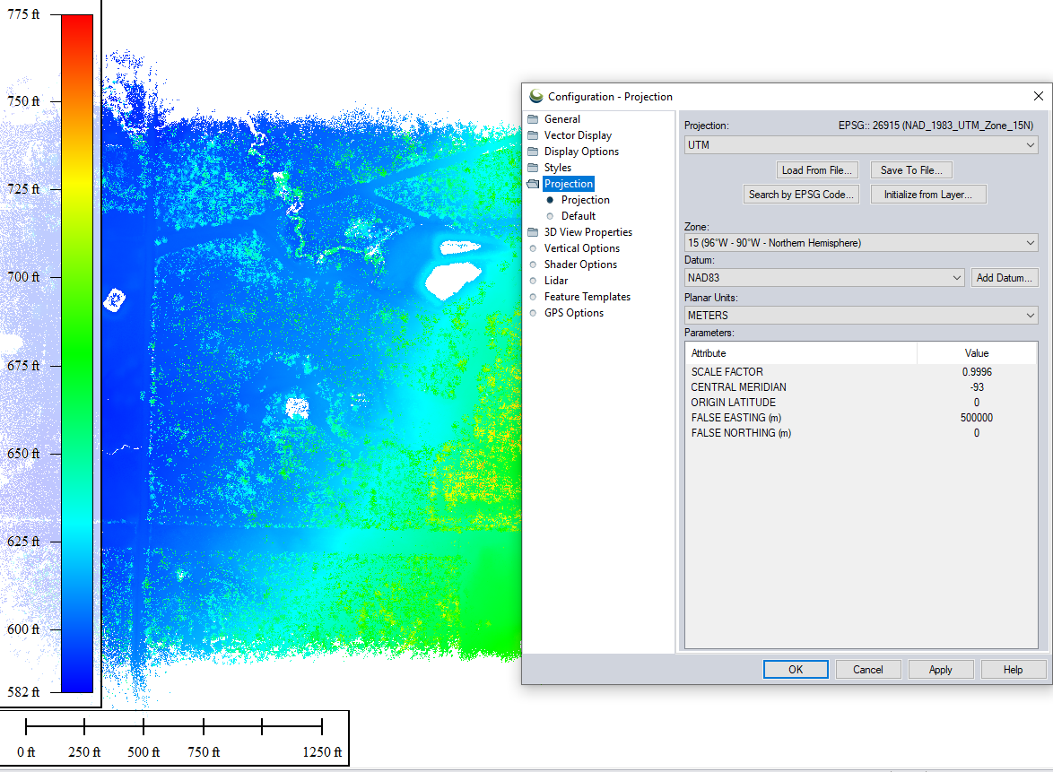

Next, lets look at our Checkpoints inside of Global Mapper. Using the QC/QA tool . I have taken my Aeropoints and created a simple CSV file representing my 7 points. The format is Lat Long, NAD83 datum, Ellipsoidal height in feet. Here is my CSV:
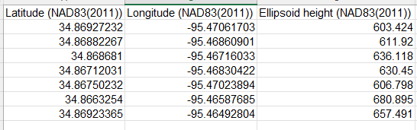
And here is GM shown, with my CSV loaded. I ran the QC/QA tool. Note my RMSE shown. GM only calculates this RMSE in the Z (vertical) at this point, but GM is working on making this tool work for horizontal RMSE as well. Note: You will need to use different targets for the horizontal to detect the centers in the lidar intensity. (Optional, you can use LP360 or similar software to calculate RMSE in the XY direction and generate ASPRS-standards error reports (POC Mark Bauer USGS). Or you can do “spot checks” by comparing your CPs against neighboring lidar points. Note: Spot checks may not detect issues with strip alginments unless you have sifficent checkpoints with good distribution.

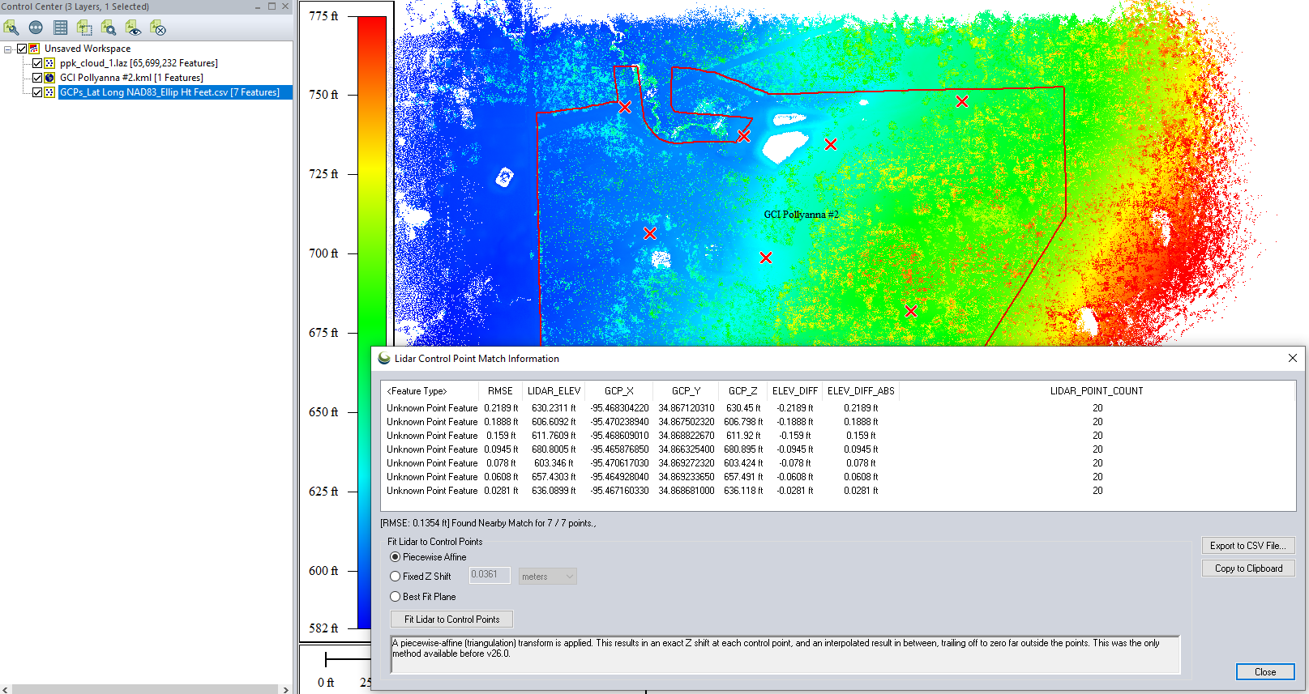
CSV error report generated by GM’s QC/QA tool:
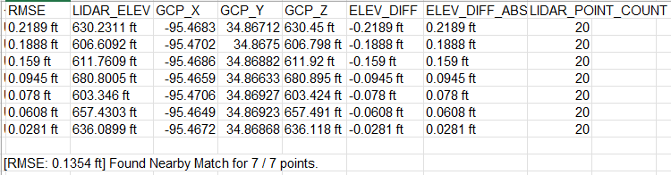
If you choose the option in the QC/QA too to “Fit LiDAR to Control Points”, just be aware that will shift everything in the Z direction to fit your control points. You should NOT have to do this if you did your PPK and WLS workflow correctly and entered in your base station parameters correctly like pole height and ARP offset (most common source of error).
Note my RMSEz is about 1.6 inches! I’m comfortable with that for SMCRA work!
Converting to Orthometric Height:
Up to now, we have our entire point cloud in Ellipsoidal height, including our GCPs. We need to apply the Geoid height and shift the Point cloud by this Geoid height. One quick way to determine Geoid height is NGS website, enter the coordinates of your base station. In my case -30.93 m or -101.48’. For simplicity, we will use GM to shift the entire point cloud UP by 101.48’.
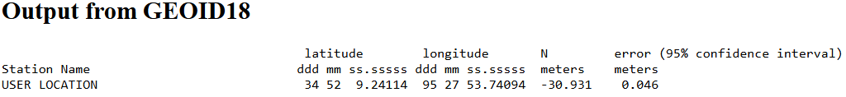

Note on Geoids: Newer Geoid models like 18B are of higher spatial resolution than previous ones. (think of Geoid18 as a raster image draped over your site). For smaller sites, the Geoid height does not vary by significant amounts, meaning from one end of the project site to the other. So we can just shift the whole point cloud by one, fixed amount. A more accurate way would be using Geographic Calculator or NGS’s online tools like VDatum. Eventually Global Mapper will support Geoids.
Right click on LiDAR layer, SHIFT selected layer a fixed distance:
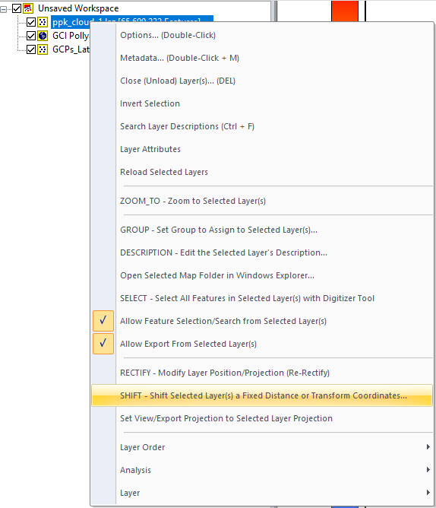
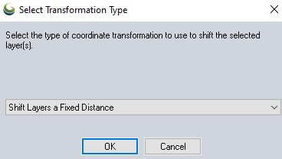
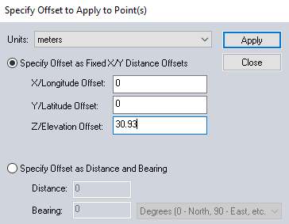
I renamed this shifted LAZ layer with suffix “Orthometric ft” to avoid confusion. Here is the point cloud shown in GM 3D viewer, all points shown, colored by elevation. Note power lines present:
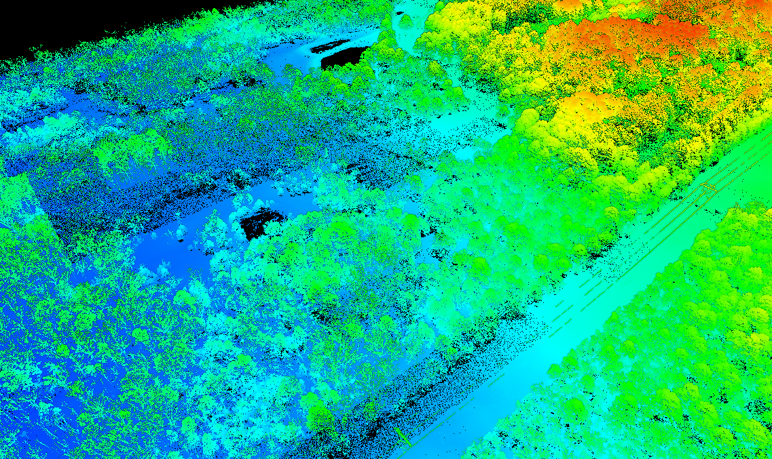
And here is my LiDAR layer’s metadata:
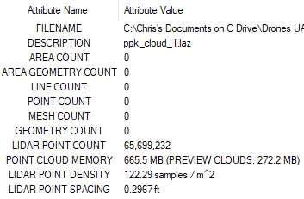
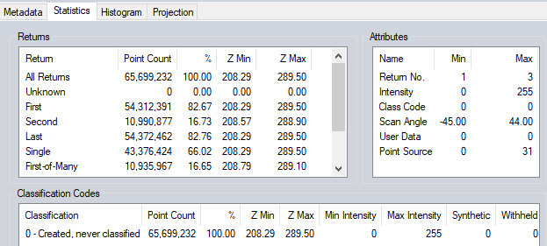

Colorizing the Point Cloud
Since I have an orthoimage (GeoTiff created from Pix4D mapper) from the same date of the LiDAR mission, I pulled that into GM. Ortho is large file with about 2cm GSD (pixel size). I will use this to colorize my point cloud.
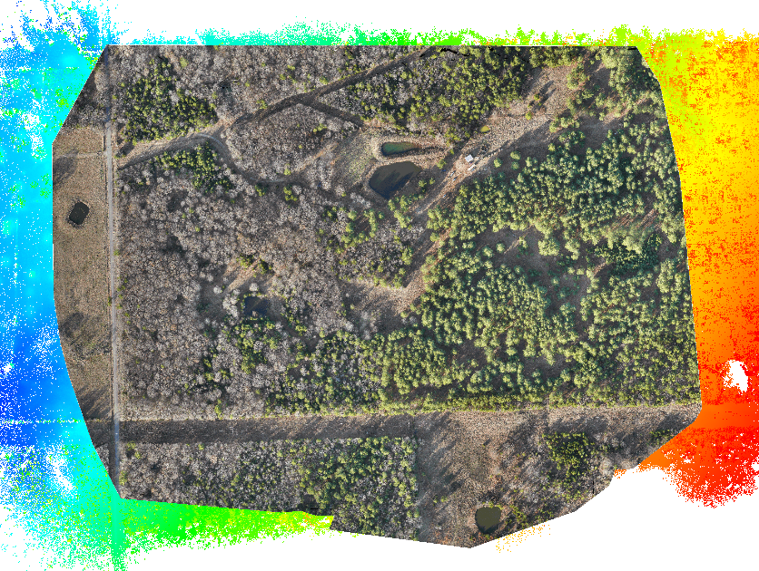
With the Ortho turned on, over the point cloud, select “Apply Color to LiDAR Points”. Button is this
This will add the RGB color as an attribute to each of the points. Below shown in 3D viewer:

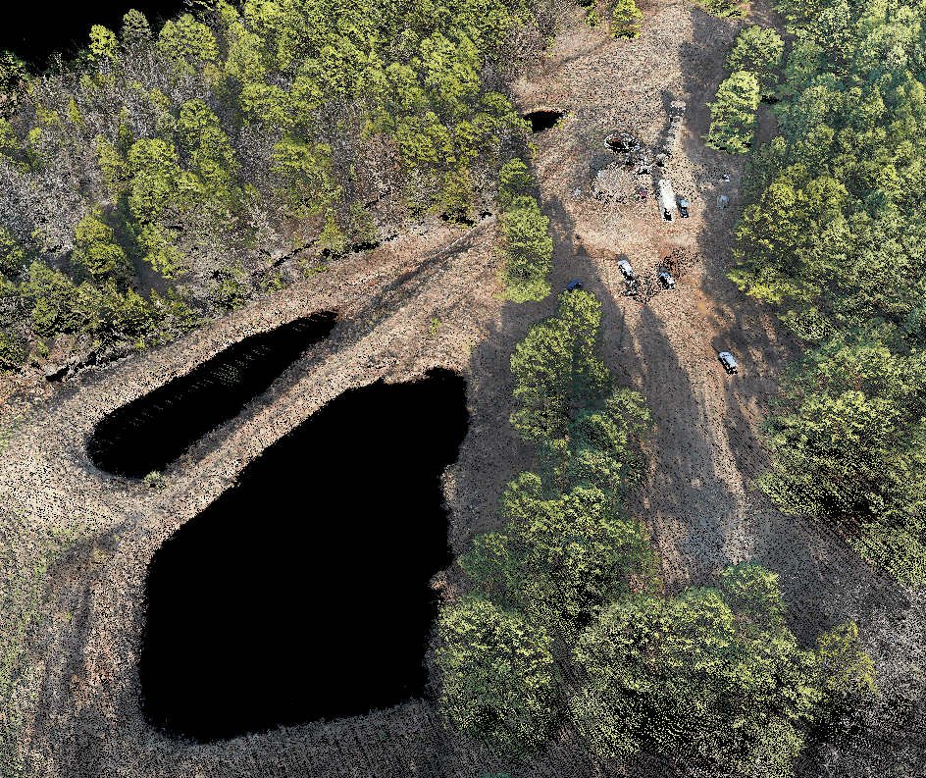
NOTE: The Pix4D orthoimage was a single band image, so I had to first re-export this as a 24-bit 3 band image, then pull back into GM, before using that to apply colors to point cloud. Colorization doesn’t work with single band imagery.
Along with the RGB-colorized cloud, now is a good time to view the cloud with different shaders, and in 3D. Here I switched to “Color by Height Above Ground”. Also try colorizing by intensity, classification, etc.
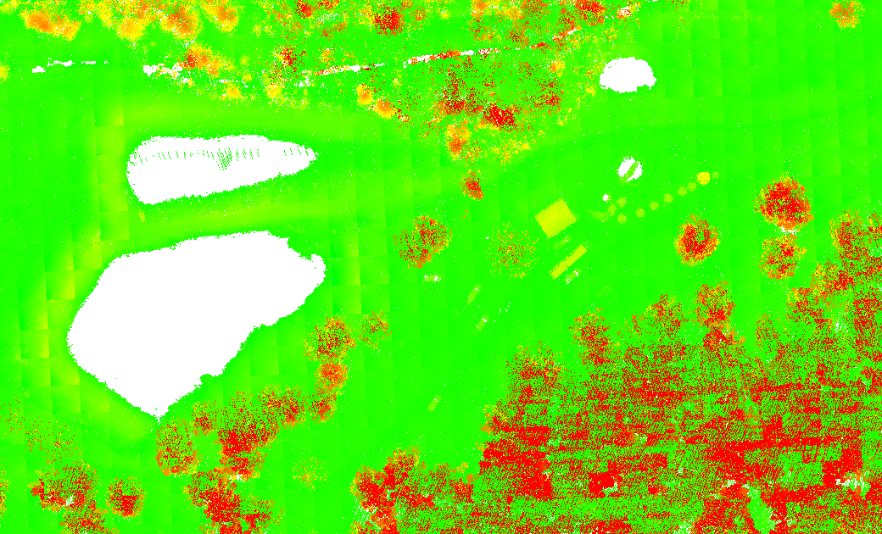
And in 3D viewer:
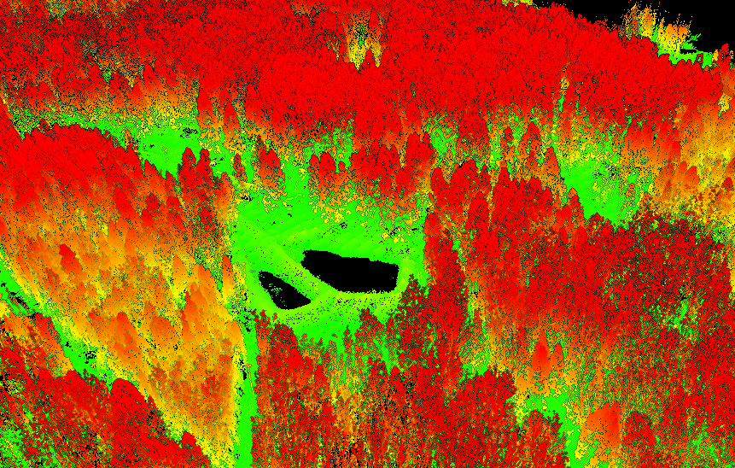
-----------------------------------------------------------------------------------------------------------
Point Cloud Classification Routine
Up to now, we have an UNCLASSIFIED point cloud. We will use GM auto-classification routines to remove noise, then classify ground, low and high vegetation. Why? Because our main goal is a DTM of bare earth, which will be used for contours, and subsequent CAD design etc. Thus, we must have confidence in our Ground points. (Pro tip – take GM LiDAR class).
Process:
- -Start with the unclassified LiDAR cloud. Run the automated PC classification routines in GM.
  - Chosen classifications will be run in a specific order: noise, ground, building, vegetation, powerline, then pole.
- -Next, Use Path Profile tool, with perpendicular cross sections, for manually inspecting and re-classification of points that were erroneously classified.
This classification process will take some trial and error.

Classify NOISE:
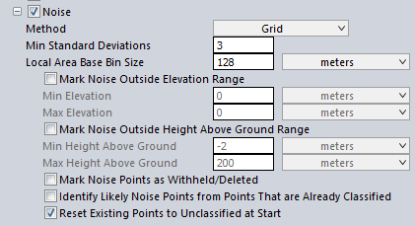
I have noticed with Wingtra very little noise points. (i.e. very high and low points, birds, etc.). In my case only 3 points were classified as noise. You can play with the settings and then “view LiDAR by classification” and in 3D viewer, to see if any noise exists.
Classify Ground:
I started with these settings:
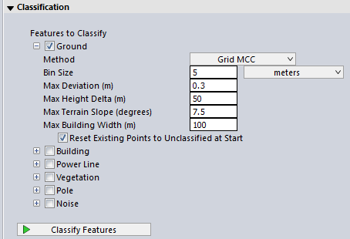
From Global Mapper help email later:
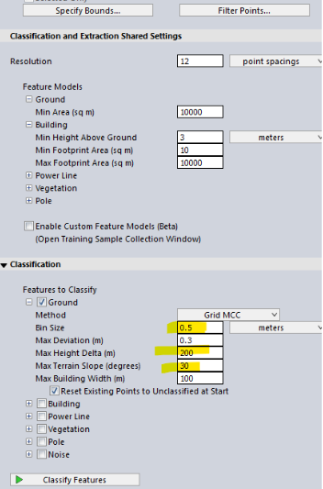
-------------------------------------
Some notes from GM help email:
I was able to generate pretty good results with the Grid MCC classification method. Adjust the max slope, and max height delta to unique characteristics of your site. I then changed the resolution to .5 meters. This significantly improved the results of the classification. In general, with higher resolution data, it is advisable to run classifications at a higher resolution.
The MCC ground classification algorithm depends on comparing points to their neighbors inside of a small local area. The Base Bin size defines the size of that area. If that area is defined to be too big, since Grid MCC works first to identify non-ground points many of these might get flagged as non-ground during classification. This is related to the maximum deviation parameter. When comparing points to other adjacent points within a particular bin, every point outside of that max deviation range is flagged as non-ground. With a larger bin size, since this max deviation is in comparison to an average elevation for that particular "bin", if the "bin" is too large, then this can lead to more points being farther from that average because the average is less precise to that specific localized area.
So I would recommend reducing the bin size to get better ground classification results. If after generating the grid you notice some bumps like the bottom of trees are getting picked up, I would reduce the max deviation parameter.
-------------------------------------------
Below is result of Ground classification. I ran a path-profile to show:
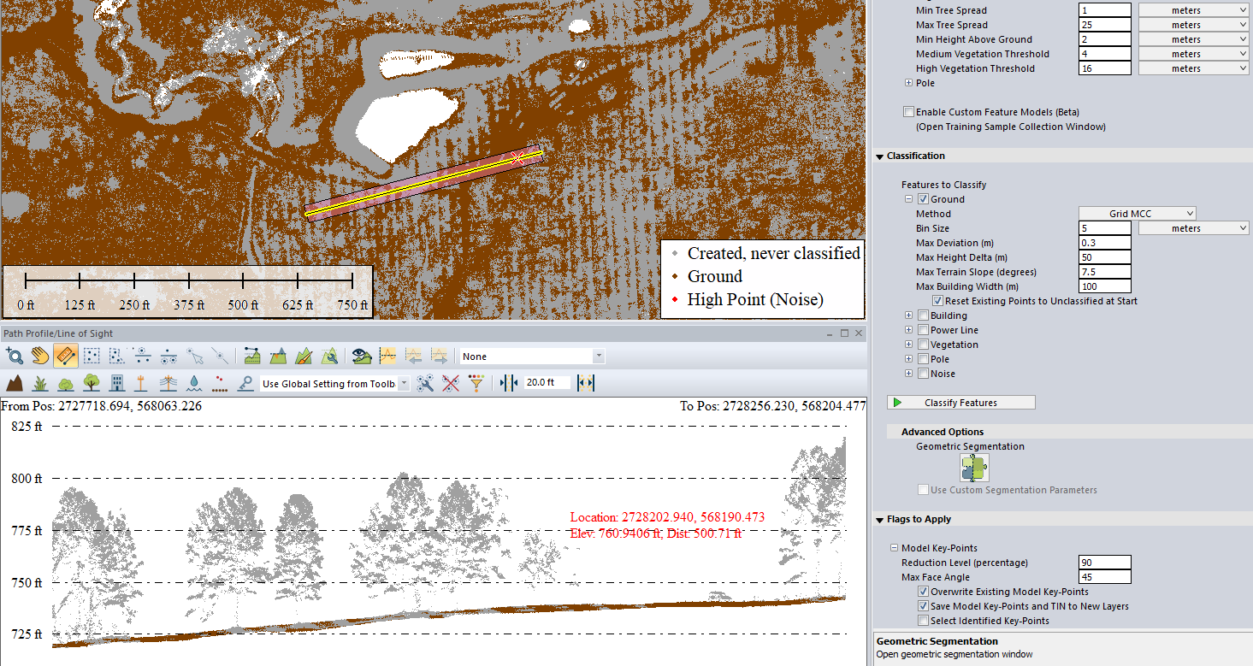
Let look at the Layer’s metadata now that ground is classified:
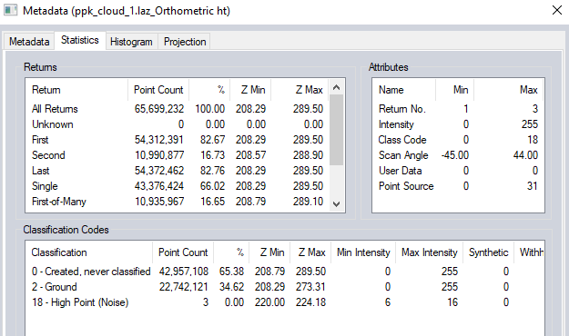
I didn’t like that iteration of Ground classifying. Too many points were missed!
I used these settings instead:
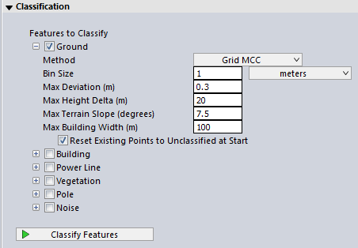
Those results seem better, based on visual inspection:
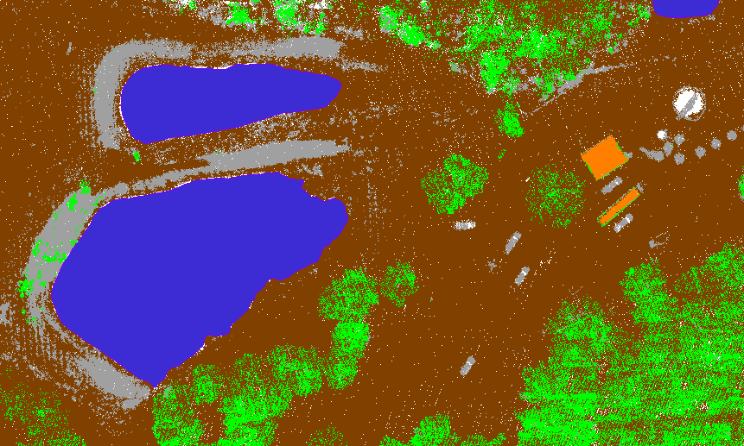
It did miss some ground points along the west and north edge of the ponds (steeper sloped area). But I’ll clean this up later manually with path profiles.
Classify Buildings
Next is Buildings. For this site there is a large shed, small trailer, some tanks, etc.
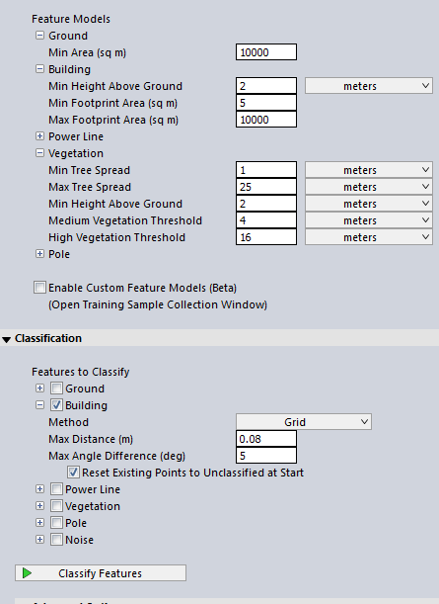
And the results:
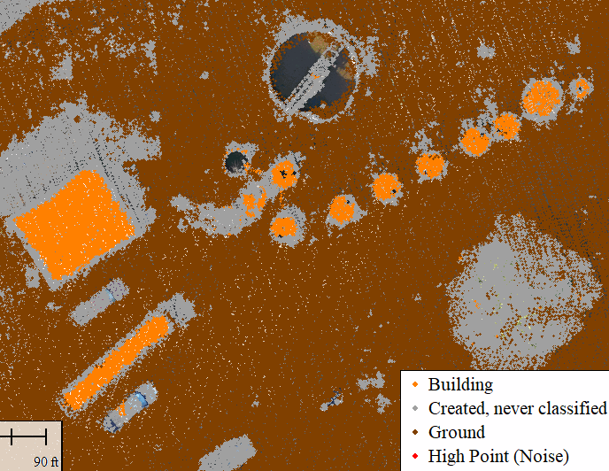
Here is another view. I went in and manually removed some erroneous building points:
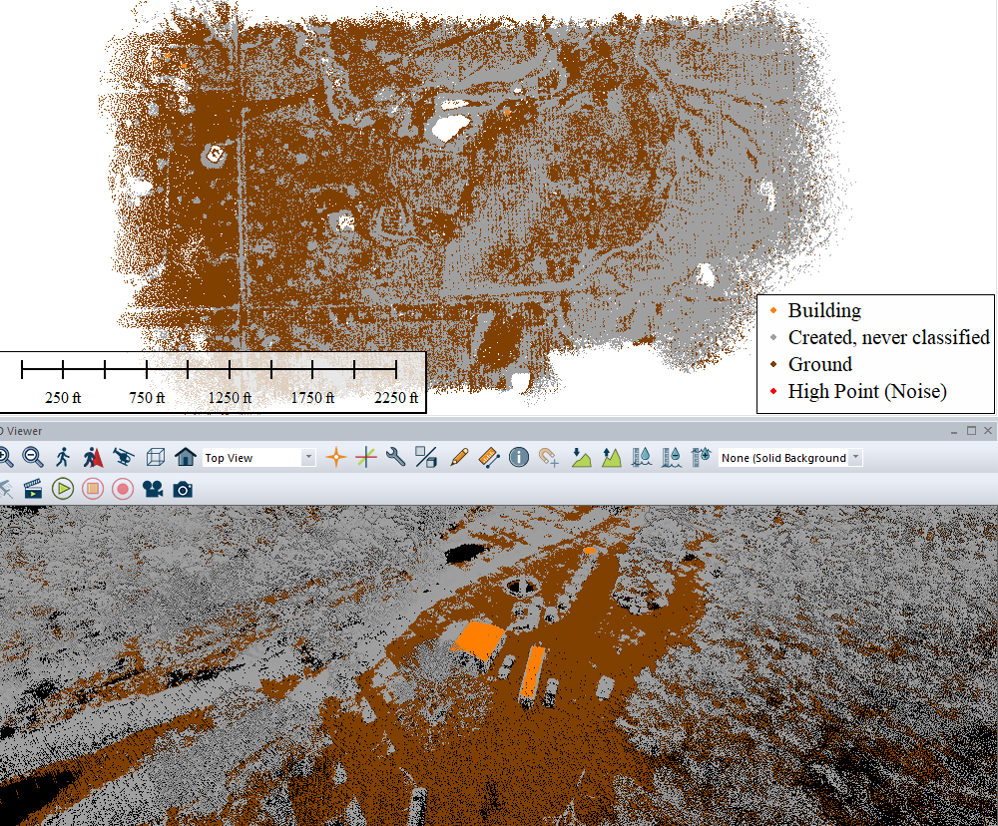
Remember we can manually clean all this up later, so I didn’t get too hung up if it missed a small trailer or shed as building.
Classify Vegetation:
Again, some trial and error:
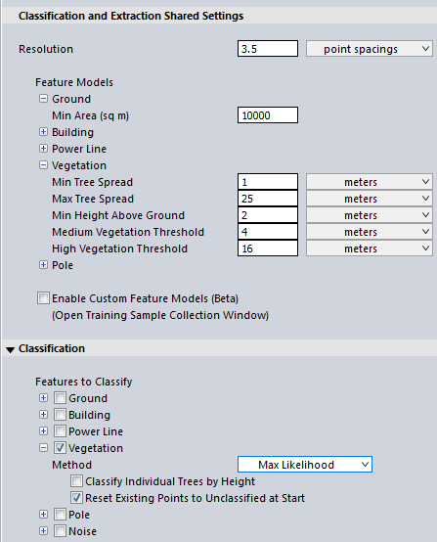
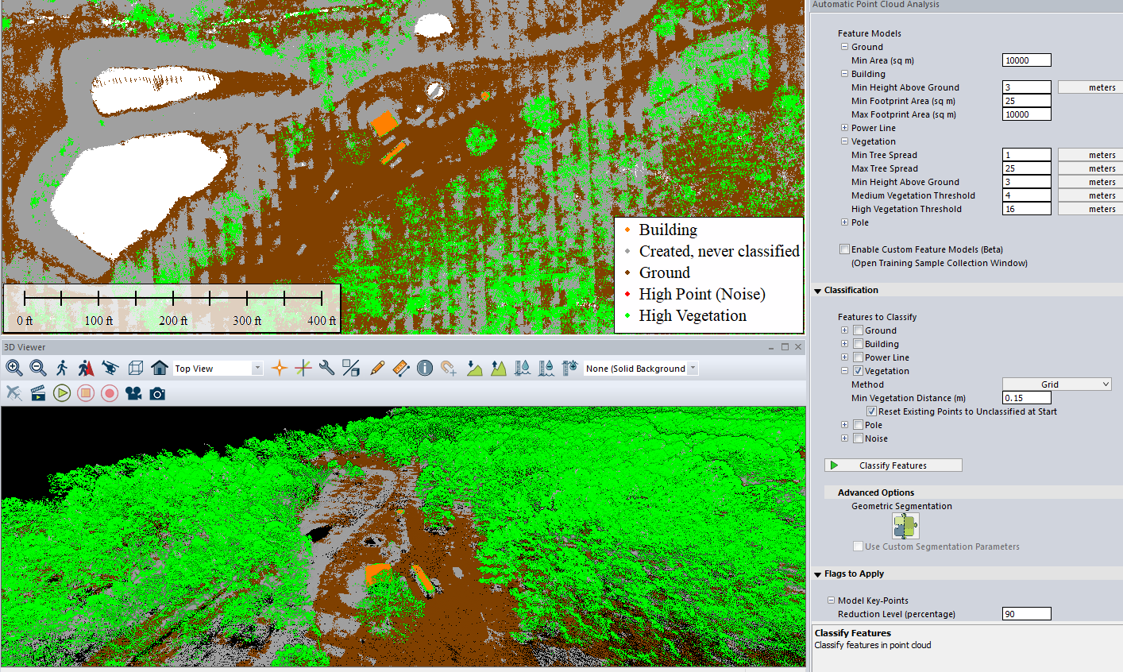
Powerline Classification:
After trying unsuccessfully to use the auto-classify tool, I classified power lines MANUALLY by using a path profile ran down the entire power lines. This is where having the Orthoimage is NICE!
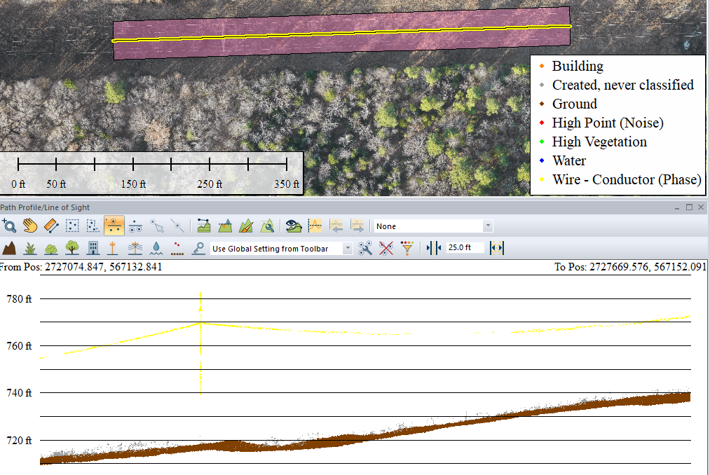
In Path Profile settings, under Data Display, I changed “Distance from Path to Show” to 25 ft.
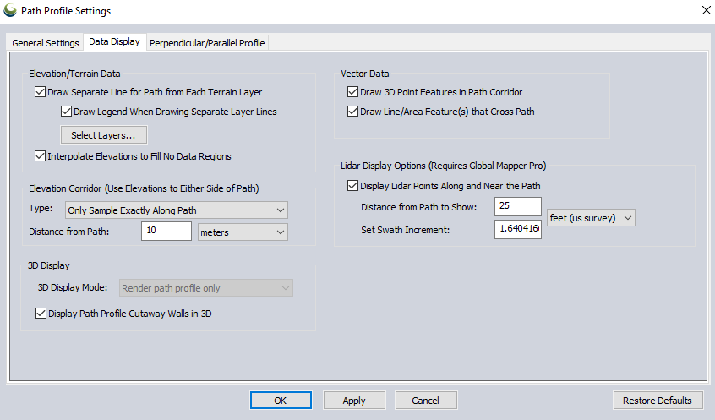
This allowed me to see all the wires. More trial and error.

Point Cloud Cleanup
Now that we’ve run auto-classify routines, we need to systematically clean up this cloud.
One way is to separate the site into sections or areas to stay organized. My site is relatively small, so I started by zoom into multiple buildings and vehicles in 2D view. Then clicking the appropriate class buttons as I go:

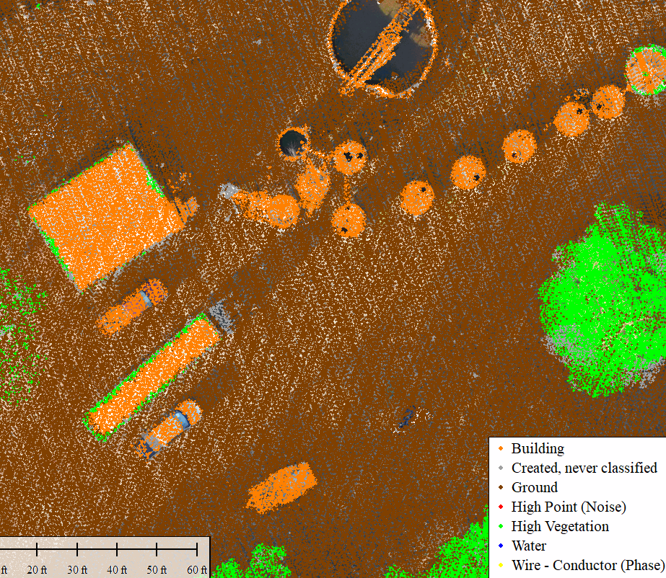
It REALLY helps to have the path profile tool open in another window. Below, I have PP tool and 3D viewer loaded. I used this method to classify the trailer as BUILDING.
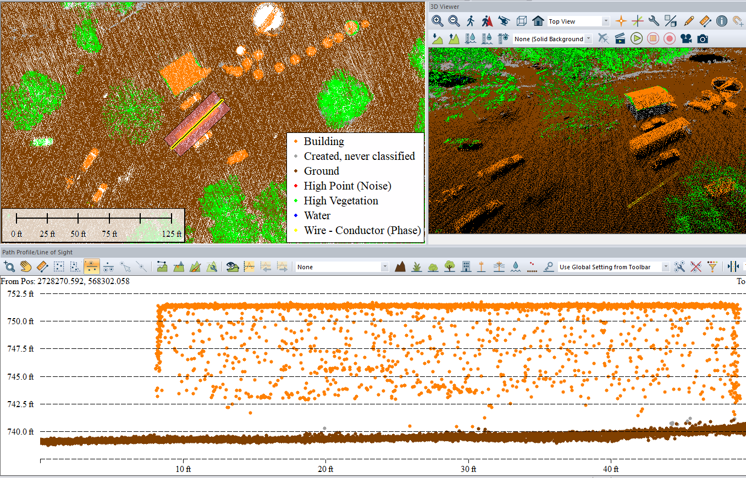

Path Profile Tool for Cleanup:
The general idea is this. We could randomly run path profiles throughout the site. Of random lengths and widths, and use the cross-sectional view to reclassify points.
A more systematic approach is run a baseline down the center of the site, and run perpendicular cross sections along this line at evenly spaced intervals. (Think how surveyors/engineers station out baselines and stations of roads). Below, I manually drew a line feature west to east across the permit boundary as my baseline. Then, I selected with digitizer, right clicked, path profile. I will use this to create routine perpendicular cross sections (N-S).
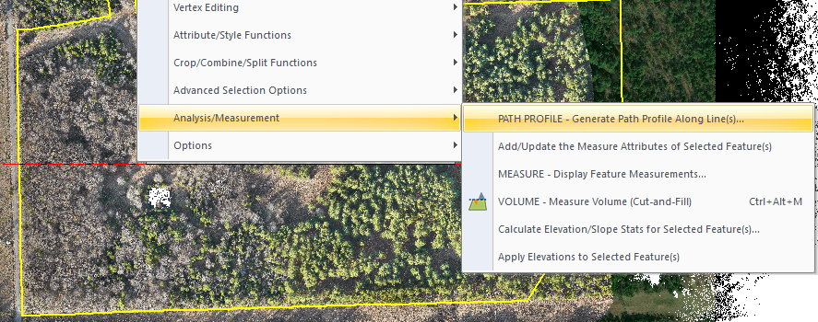
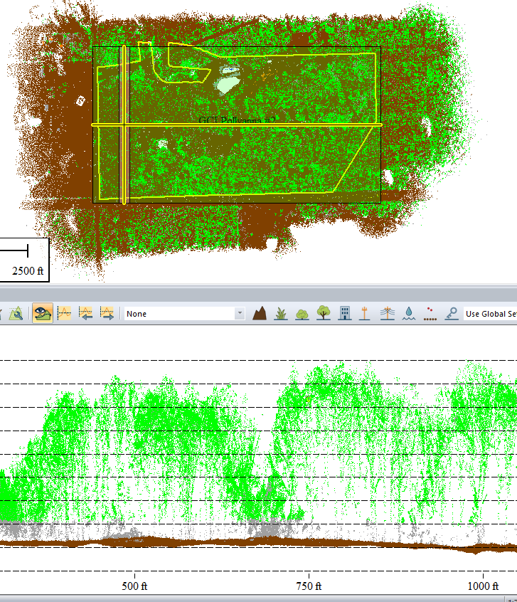
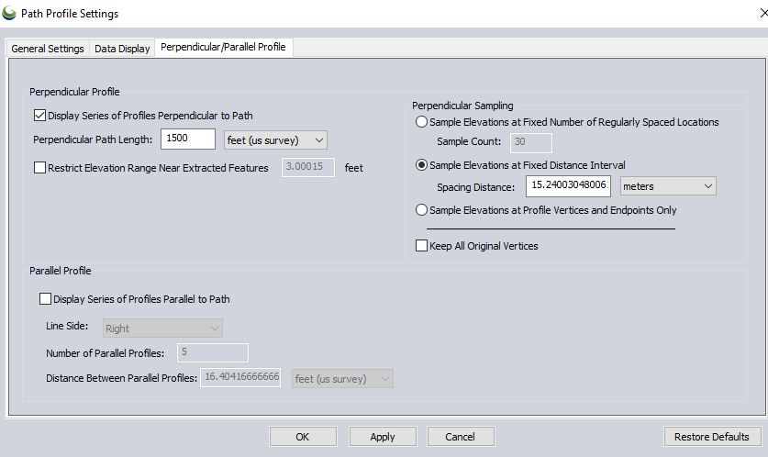

We can then click through each cross section, and reclassify points as needed. Since this means a ton of cross sections to look at, you can also break the site down into smaller sections first. Whatever method you choose, try to view 100% of the LiDAR in cross-sectional view so we don’t miss anything.
Again, with each X-sectional view, inside the PP Tool, use the various selection options and classification buttons to reclassify points as needed:
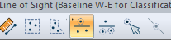
-----------------------------------------------------------------------------------------------------------
Building DTM and Contours:
Now that we are confident on our LiDAR has been classified, let’s build a surface model (DTM) and contours, which will be used in subsequent CAD design, GIS analysis, etc. Here is a 3D view (vertical exag of 2:1 to show relief, of just the Ground points. I also added area features to represent pond surfaces). I used the filter button to show just the Ground:
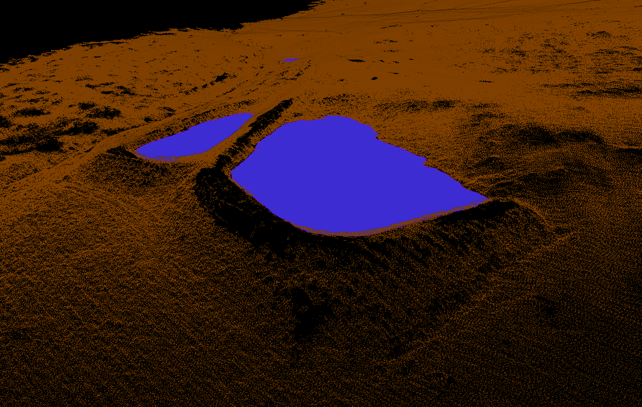

Click “CREATE ELEVATION GRID” button.
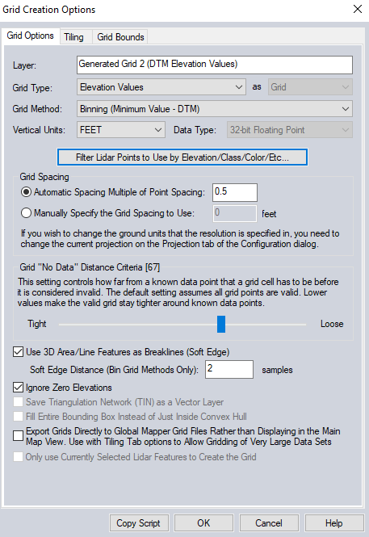
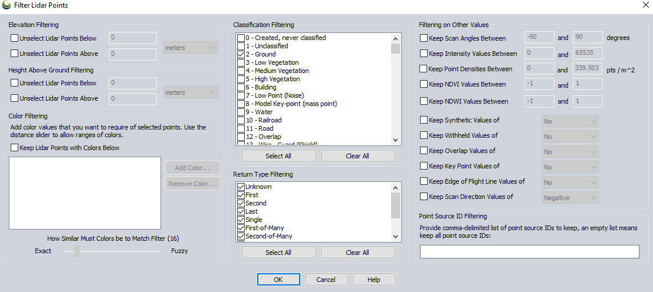
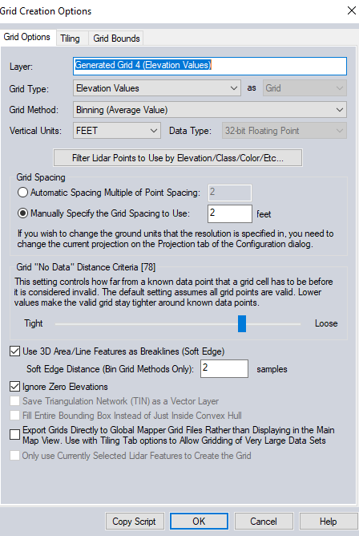
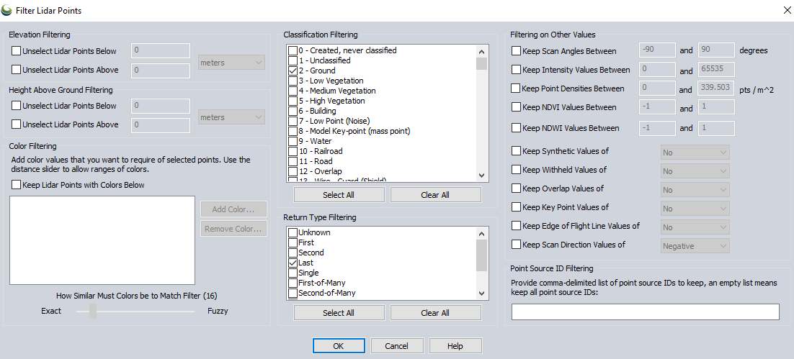
Gridding a surface takes Trial and Error. Here I notice some artifacts:
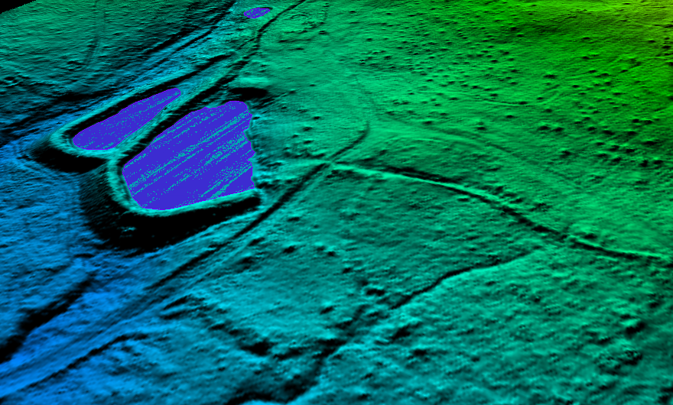
I experimented with various settings in the Create elevation Grid box. After I was satisfied with results, I used some terrain paint tools to smooth out erroneous “bumps” in this DTM, probably from tree artifacts, etc.
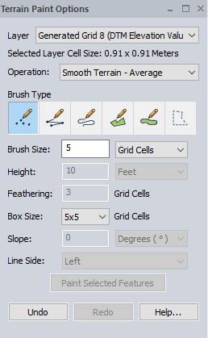
The final DTM product looks good...
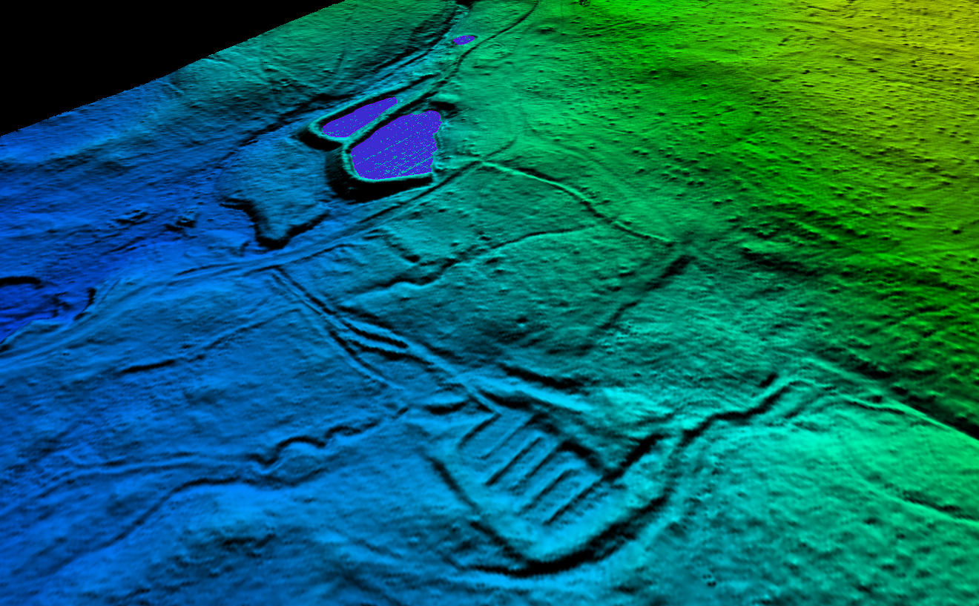
Here is plan view of final cleaned-up DTM. I used LiDAR ground points, last returns, Binning minimum values to best represent ground. Note the AMD treatment cells are visible in SW corner:
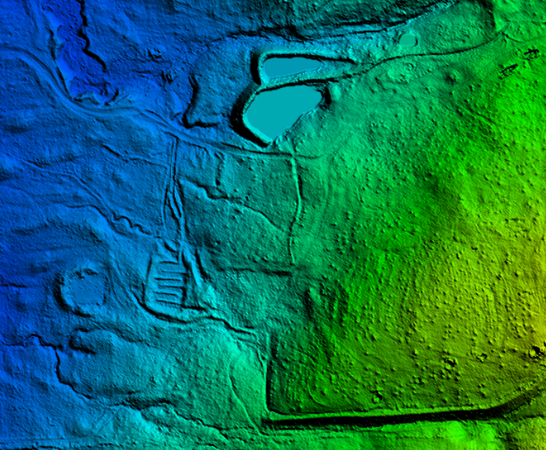
Contour Generation:
With the DTM shown, click “Create contours”. . For this relatively flat site, I created 1 ft Contours, generated from the DTM:
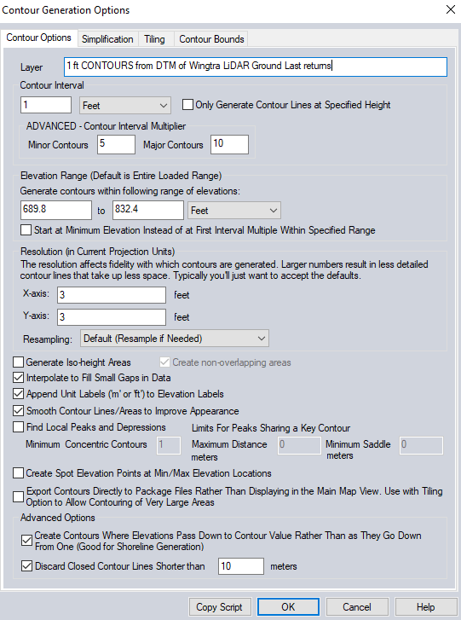
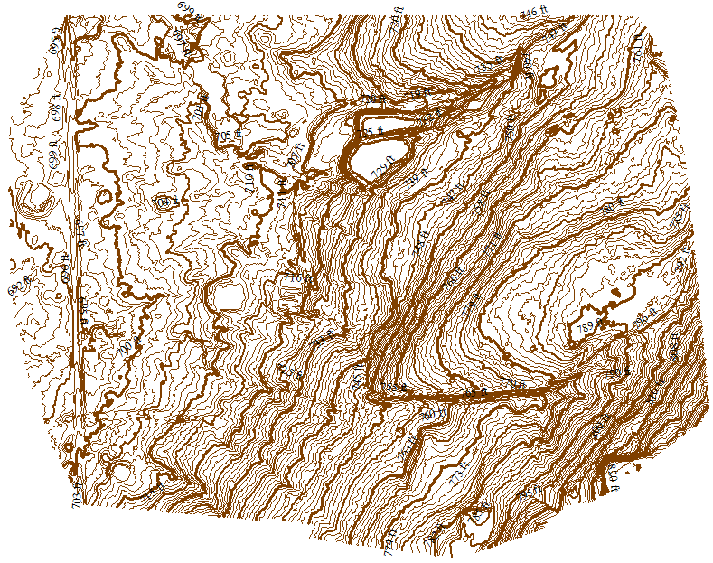
Final classified Point Clouds, Contours (and other layers) can be exported to the formats you desire.

_____________________________________________________________________________________________________
COMMON MISTAKES:
SOFTWARE NEEDS UPDATING. Always update to latest official version of Wingtra Pilot (field app) and Wingtra LiDAR software.
FILE STRINGS ARE TOO LONG. Move them to a base directory on C drive. Same thing happens in Pix4D if your file string is buried in too many subfolders.
Useful links:
Wingtra Knowledge base and LiDAR guide. https://knowledge.wingtra.com/en/kb-search-results?term=Lidar
GEOID height at specific point(s). https://www.ngs.noaa.gov/GEOID/GEOID18/computation.html
CORS map. https://www.arcgis.com/apps/webappviewer/index.html?id=190385f9aadb4cf1b0dd8759893032db&extent=-30657930.8234%2C-3999003.0107%2C3507586.3314%2C12379311.914%2C102100&showLayers=17bf0a87f3a-layer-16%3B17bf0a87f38-layer-14%3B17bf0a87f36-layer-13
OPUS (for post processing RINEX to get base location). https://geodesy.noaa.gov/OPUS/
nTRIP/RTK Providers by State. https://e38surveysolutions.com/pages/ntrip-rtk-network-access-by-state
NOAA VDatum tool. https://vdatum.noaa.gov/vdatumweb/
Blue Marble Youtube channel (tons of useful how-tos). https://www.youtube.com/channel/UCAl6eWYOzEyaawEMQ4jZh_Q

Appendices:
Aeropoints Report showing GCPs (Kiser insert PDF from Aeropoints)
Orthometric Height vs Ellipsoidal (Kiser insert cheat cheat)
How to convert Rinex files in Emlid Studio, then run OPUS solution (Kiser insert email you sent)

