Wingtra RGB Mapping Workflow
NOTE: This is a draft document created when flying multiple sites with Wingtra+RGB61 and processed in Pix4D Mapper. Update document as needed. Remember that Wingtra Knowledge base is LOADED with great how-tos. https://knowledge.wingtra.com/en. Also recommend you re-watch both the basic and advanced Wingtra training videos, which walk you thru planning, flights and processing.
-------------------------------------------------------------------------------------------------------------------
Pre-Flight Planning:
Use KMLs (i.e. permit boundaries). Save this to the root directory on the Wingtra Samsung tablet.
On your desktop in WingtraHUB. Make a new flight plan and import your KML file. Here you can do the entire flight plan in the office before hand, or simply get it started and do the rest in the field on the tablet. Export these flight plans to your PC, then drag and drop these file(s) to the root directory of the tablet.
On the tablet, open up the flight plan you created. The reason I do this is to download MAPS in the office, so the imagery is cached, in case internet is unavailable in field. Click offline maps and download them. This also downloads the elevation (terrain) model.
Other pre-flight considerations:
- PASP done (flight safety plan)
- Software/Apps all updated
- Equipment all charged (use checklists!)
- What GNSS Collection method will you use? (test nTRIP at hotel night before)
- If OPUS processing base location, look at nearest CORS station (see NGS control points website)
- Is Aeropoint and/or RTK nTrip network available at this site?
- Where will you set GCPs/CPs? Who will do it?
- What coordinate system (state plane, UTM etc.)
- The more you test before you go at hotel or in office, the better
- Print out at least 2 maps of the site on 11x17 paper, with permit boundary shown.
- Have a call/meeting with the team before going. Assign roles, goals, deliverables.
- Assign roles: Who will take field notes, pictures, GCPs, fly site, collect Rinex, etc.?
- What flight height and GSD? (i.e. 400 ft AGL, 2 cm GSD).
------------------------------------------------------------------------------------------------------------------
Field Data collection:
Pay special attention to optimum flight height (400 ft AGL sweet spot), and front/side overlap of 70%. Unlike LiDAR, RGB data collection allows PPK-geotagging to be optional, but I would highly recommend if you have access to a base station.
Below I will document the general field collection steps and include pictures.
Field data collection:
- Start setting/collecting GCPs immediately. I prefer Aeropoints, if Aeropoint network is available on-site. Coverage map here: https://aeropointnetwork.propelleraero.com/. Have one person/team lay GCPs while the other person/team preps Wingtra for flight. Follow GCP best practices, remember these GCPs will be used for RGB processing as well. Use spray paint w large numbers!
- If Setting Aeropoints, remember to collect them in reverse order at end of day, otherwise numbering scheme will be messed up in subsequent AP processing reports.
- Set up Base station over Point 1. We have had success setting Emlid Reach RS3 over Aeropoint 1. Use stable 2M range pole on Tripod with sandbags or other method to make certain tripod does not move during Rinex collection.
- Remember you MUST collect base location (XYZ), which can be done by using an Aeropoint, by post-processing OPUS solution later, or setting up base station over a previously surveyed point with known XYZ.
- Begin logging RINEX file immediately. This will log during the entire duration of flight(s). I prefer 2hr+ to ensure Static solution later in OPUS but 4 hrs. better. (See special note below on Rinex settings.)
- Fly the RGB mission with Wingtra. Ideally when sun is overhead or overcast skies.
- Pull memory card from camera, check you have good RGB data (pictures) before you leave. TIP - run a quick non-PPK geotag process on WingtraHub in the field and view in Global Mapper to see pictures!
- BONUS – if time permits, fly additional RGB missions at varying overlap/height/direction/sensors, as backup data is usually always a good thing.
- Stop RINEX logging and collect Aeropoints or other GCPs.
---------------------
RiNEX Logging special note:
Set the Emlid receivers (Emlid Flow App) to log Rinex file in UBX format (later we will use Emlid Studio to Convert To RINEX). At least enable the option in the Receiver to also log in UBX format along with the RINEX format so you have UBX as backup.
For submitting to OPUS, I use the Convert to RINEX function in Emlid Studio to output a RINEX version 2.11 file at a 30 second interval with the "Time Rounding" option enabled and with GPS constellation only. This is all the data OPUS uses anyway. This RINEX file is very small and usually OPUS returns an answer very quickly.
Note if you only log Rinex Ver 3.03 (or latest version) this is fine too, we can convert it later in Emlid Studio.
----------------------
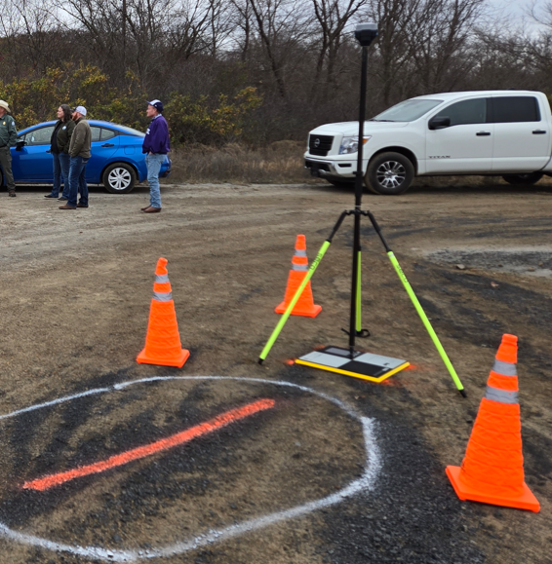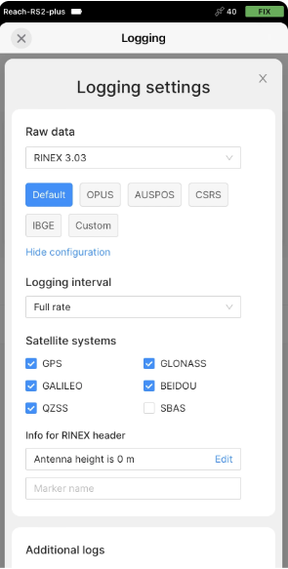
Pic above: Emlid Reach logging RINEX, over base location (point 1). Emlid Flow App shown.
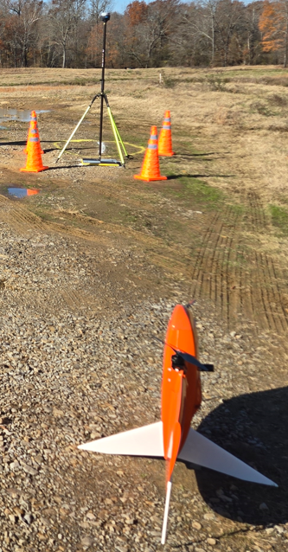
Pic above: Wingtra set up near base location.
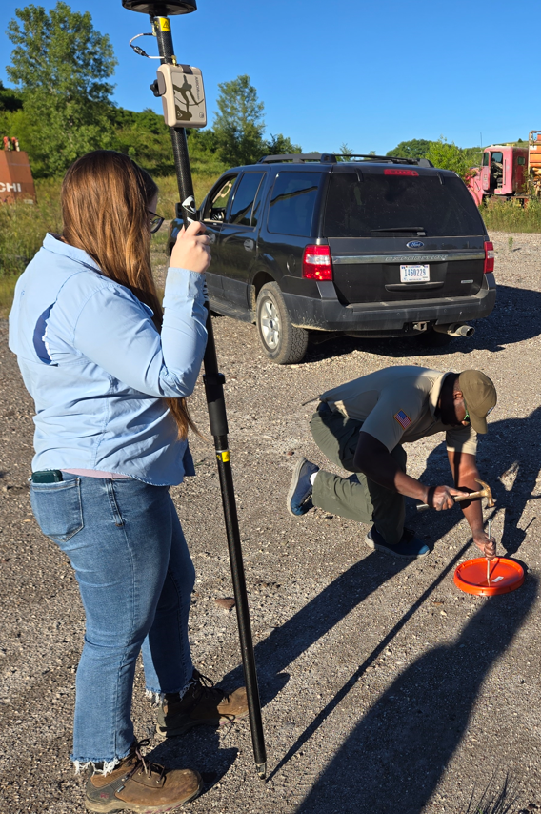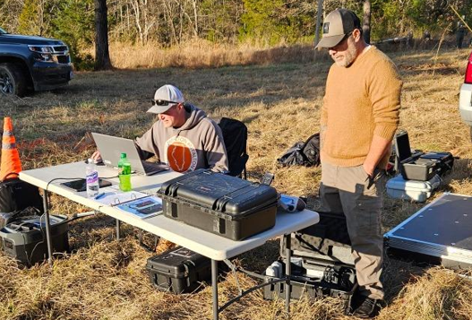
Pics above: Alternative GCPs (bucket lids w/ Spikes). Checking all data BEFORE leaving field.
-------------
Do NOT leave the field without checking the data files on memory card (RGB) to verify that data files are present after the flight(s). You can do a quick non-PPK geotag process in WingtraHub, and load into Global Mapper along with permit boundary. This ensures you at least have all the images. Also ensure you have Rinex file.
Have someone take FIELD NOTES. To document what you did, how many GCPs, how many flights, what details, who you met on site, flight parameters, etc. These notes will come in handy later! Draw on printed map where your GCPs were set.
------------------------------------------------------------------------------------------------------------------
Post Processing (WingtraHub, Pix4D and Global Mapper):
Download all GCPs. Walkthru the steps to get a clean CSV. Most software like Pix4D expects your CSV in a certain format. The beauty of Aeropoints is this csv is already formatted for Pix4d. But it’s easy to modify CSV if needed.
Download the RINEX log file from Emlid Flow. (WingtraHub will ask for Rinex, which is .24O i.e. observation file).
Look in Wingtra Pilot Projects folder.
See below on memory card. 59GB. 3 Flight Plans. 5 total flights. 2,614 total images. This was a LARGE project. Copy the WPP folder from the memory card to your C drive.
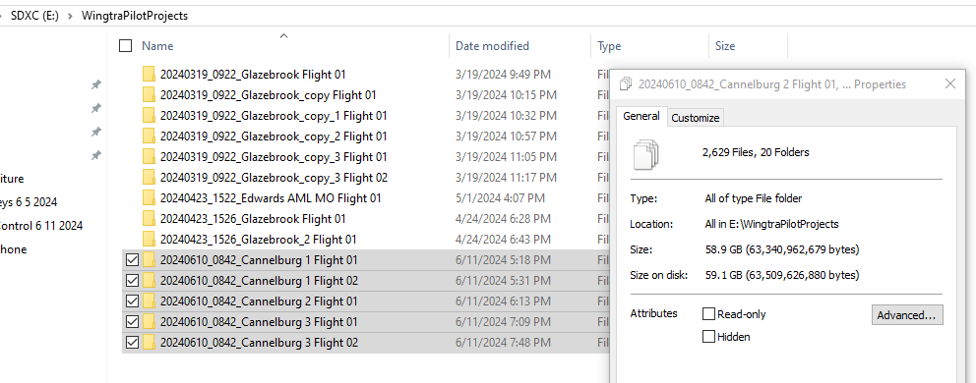

Inside of Wingtra Hub. Select Geotagging. Navigate to the folder where your Wingtra Projects (i.e. raw images from your flights are located). Here I had 5 separate flights.
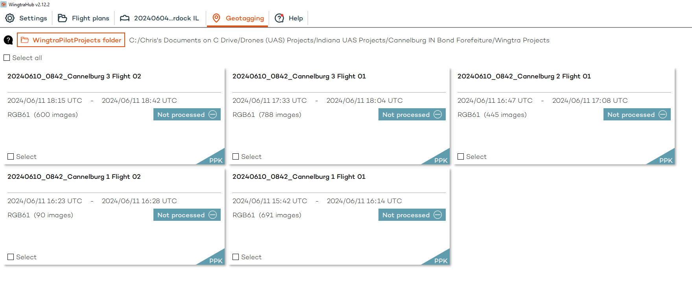
Select the flights you want to process. For the Base File, it wants just the “observation” file - the one ending in “.24O” file format. We used the Emlid Reach RS3 to log the RINEX over known point.
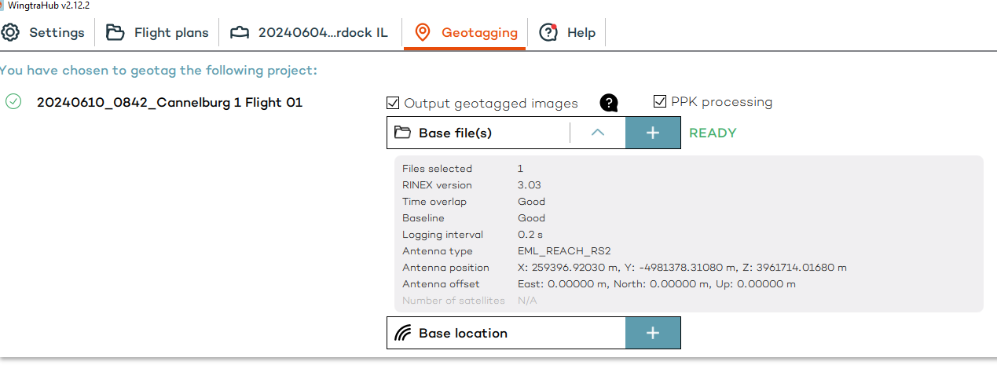

Look at how you input the RINEX observation file. And specify the base location. In this case, prior to setting up the Emlid base station, I surveyed in the bucket lid with the Arrow Gold, using IN RTK nTrip correction network, which are broadcast in NAD83(2011) datum. Here they want the ELLIPSOIDAL height not ORTHOMETRIC. Note my antenna height is 2M (ground to base of antenna), and my ARP-APC is 0.134m for the Emlid. (bottom of antenna to phase center).
I also captured GCPs using Global Mapper Mobile with Arrow Gold. In this GM Mobile CSV file, geoid height at GCP1 (base location) and other GCPs is shown as an attribute. This makes it simple to convert between both ORTHOMETRIC and ELLIPSOIDAL height. Note later in Pix4D post processing, we will convert everything to orthometric height.
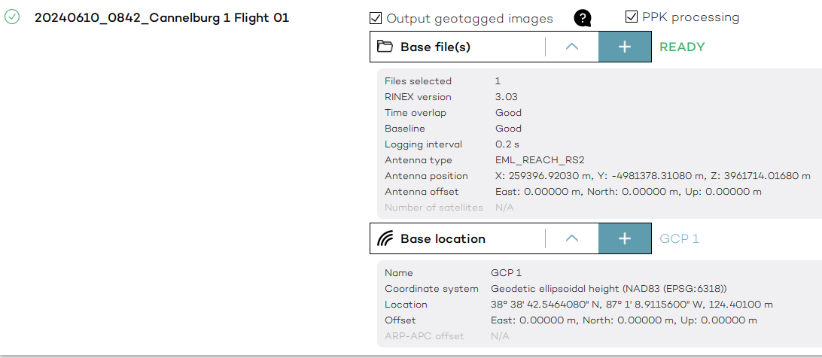

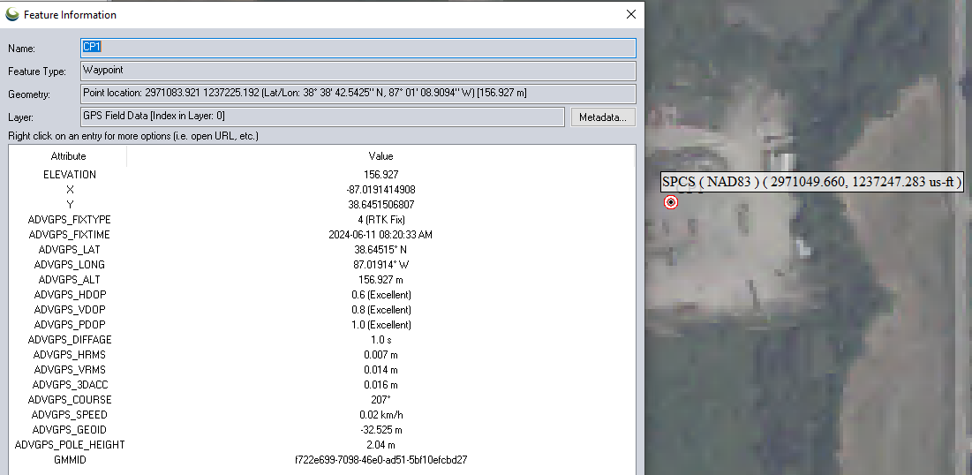

Note for base location in WingtraHub. I surveyed the control points with the Arrow Gold to get the true ground elevation. Which I entered under “Base Location”. I am specifying the base station antenna offset because I set up the Reach over this point and collected RINEX. The RINEX is collected at the antenna phase center, thus 2.134m above the base location. (see pic below). For the Base File, I chose the RINEX observation file from the Reach which ends in a “.O” file extension.

Note at the top under “Antenna Offset”, the 2m and 0.134m ARP-APC is being applied!
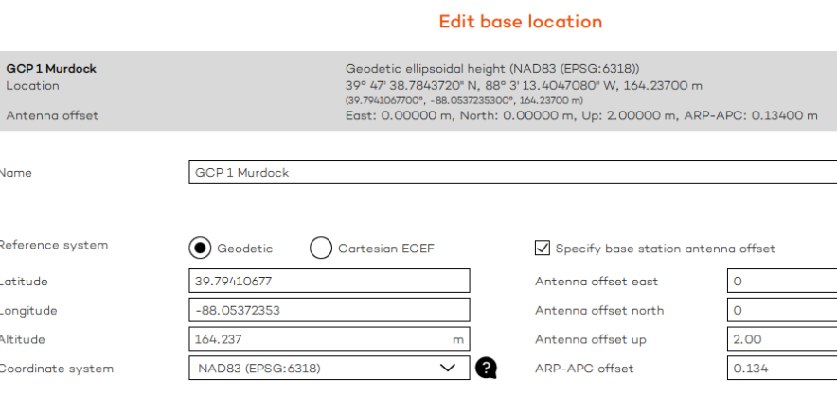

Here I am outputting the geotagged images, just be aware this takes up time and memory, and Pix4d doesn’t need the geotagged images, it can use the CSV file along with the non-geotagged images. But I chose to output the geotagged images. One reason is, I could use these geotagged images in Global Mapper Pixel-to-Points tool directly if I didn’t have access to Pix4d Mapper. This can take up LOTS of hard drive space (because you’ll end up with both geotagged and non-geotagged images) so don’t create duplicate geotagged images if you don’t need them.
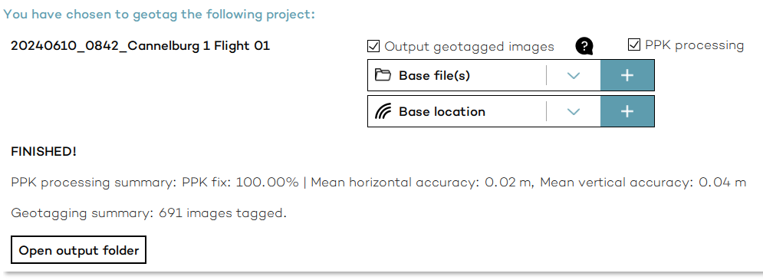
As another example, here I am batch processing all 5 flights at once, since the base file (RINEX from the Elmid Reach) and the base location (GCP 1 location that I shot with the Arrow) are all the same for each flight. Just make sure your base location is Ellipsoidal height.
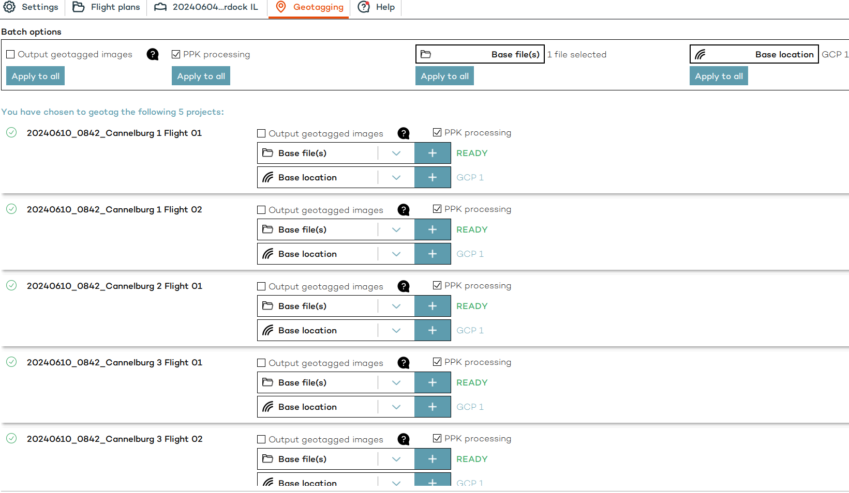

Now you have either PPK or NON-PPK Geotagged photos. And you have the photos with the CSV file w/ metadata.
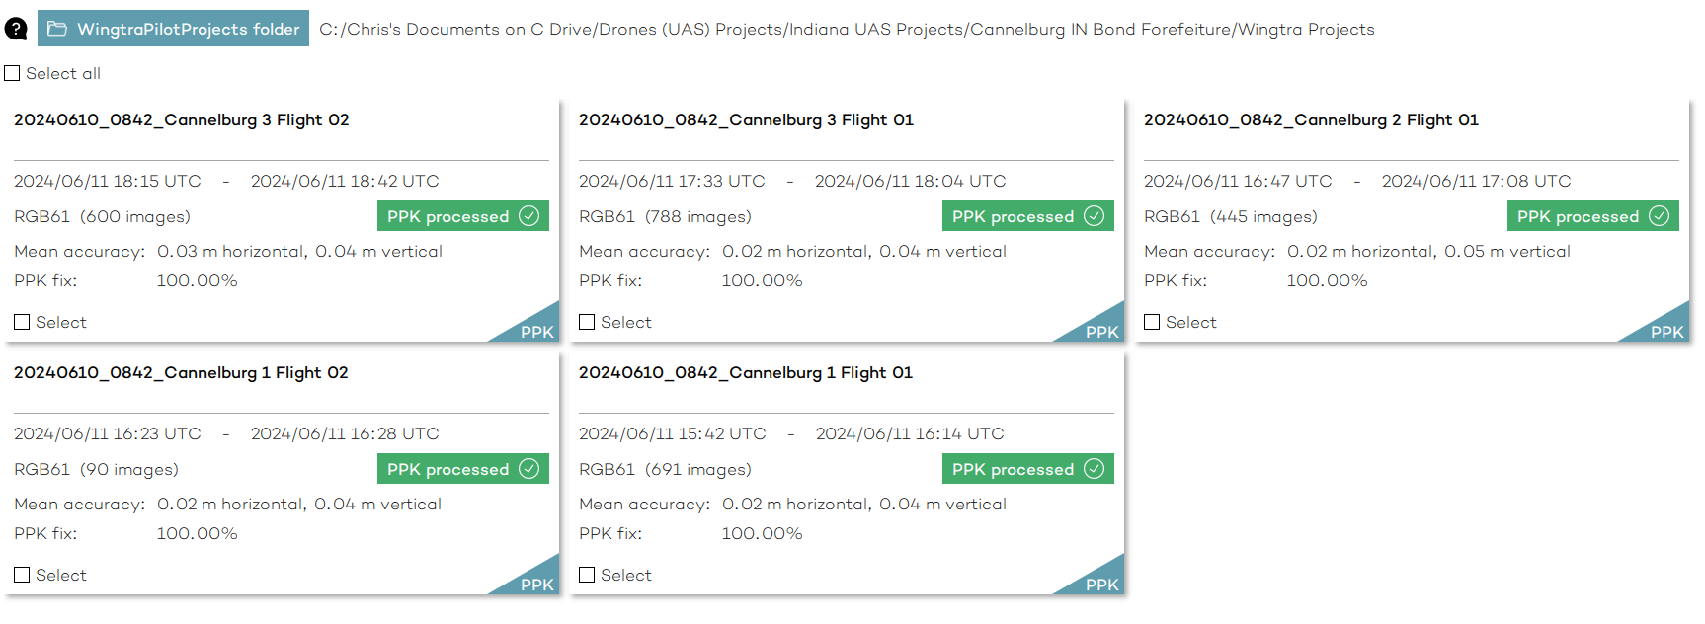
Note that now inside the OUTPUT folder, you can view the accuracy report.
-----------------------------------------------------------------
PIX4D Workflow
Open Pix4D Mapper. Create a new project.
Next upload images. In this case, I have a total of 2614 Images between 5 different flights. Note the warning since the images themselves are not geotagged. (Again, you won’t have this warning if you chose to geotag in WingtraHub).
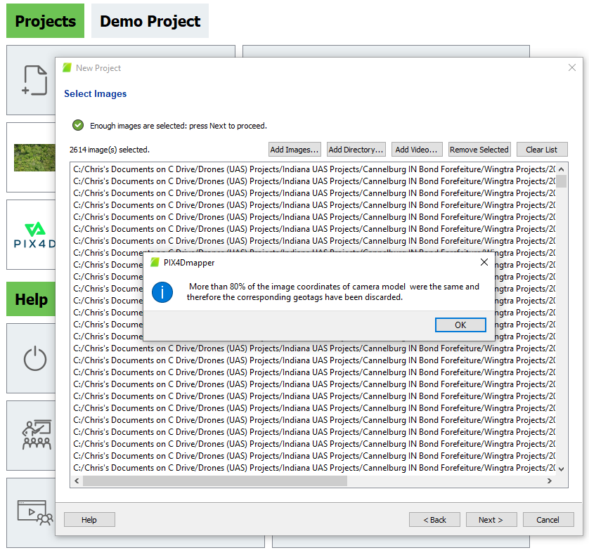
Next, I click on the Geolocation and Orientation section, “From EXIF”. Here I select the CSV file in the OUTPUT folder. This is where the geotagging information is stored for each one of my 2,614 images. Since there were 5 different CSV files (one from each flight), first I created a CSV that had all the rows combined into one file.
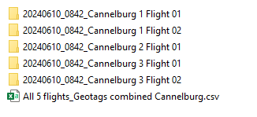
Next, we need to define the Coordinate System of the images. Because my base point was defined in NAD83 datum, my images were outputted from WingtraHub in NAD83 Datum, Ellipsoidal height in meters. (Hint- Check the Flight Record PDF file in the OUTPUT folder). Note the Output coordinate system.
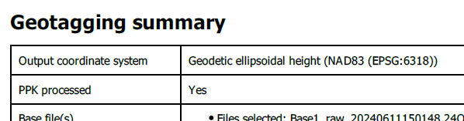
So, In Pix4d, I used this below. Note the Vertical Coordinate System.
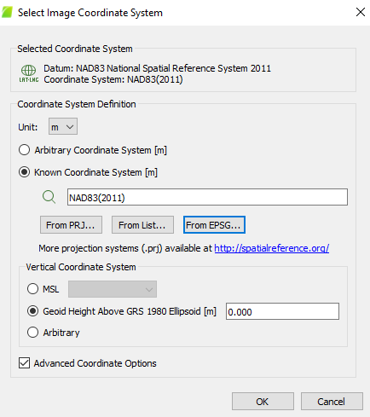
Note because these images are in Ellipsoidal Height, “geoid height above ellipsoid” is set to Zero.
Click OK, and this is what I have:
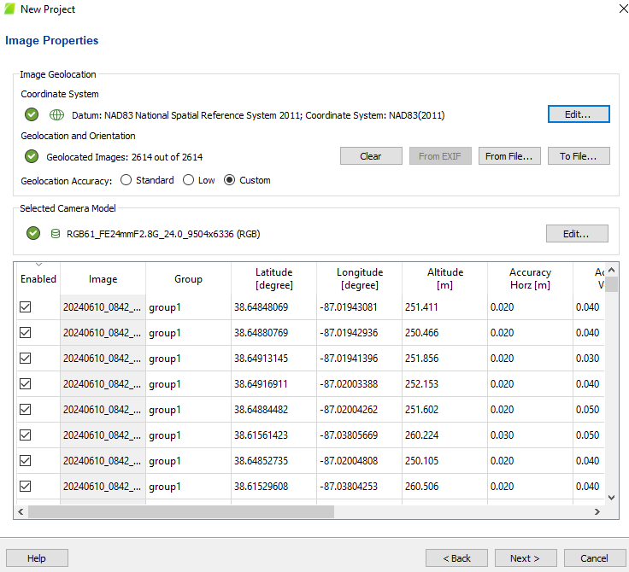
Note Pix4D has correctly read in the locations XYZ, camera model and Datum.
Next, I want to define the OUTPUT coordinate system of the model. I changed my unit to feet, which auto populated the Specific coordinate system output of IN State Plane West. As a general rule, you want your OUTPUT coordinate system to be in the same coordinate system/datum as your GCPs/CPs.
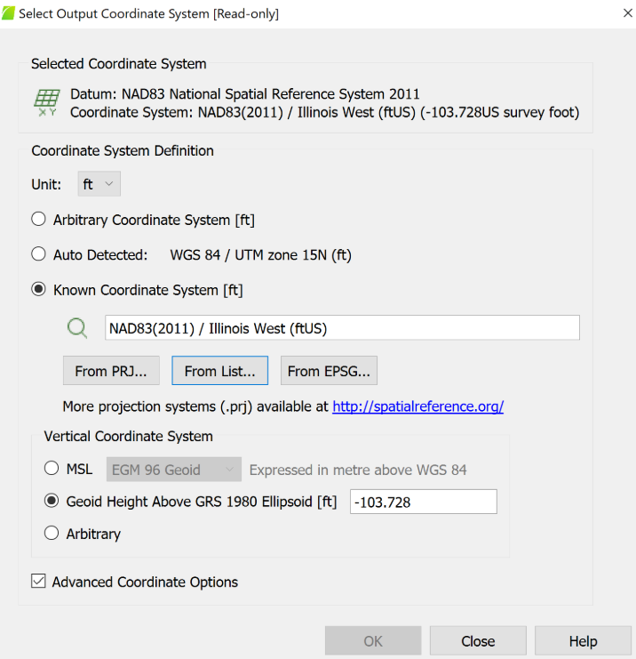
NOTE: Here you can choose your outputs to be in ORTHOMETRIC height. You would manually type in the Geoid height at the base location under the “Vertical Coordinate System” box. This applies a vertical shift to the entire DTM, DSM etc. (Another option would be keep this at zero (meaning keep outputs in Ellipsoidal height) and then apply the vertical shift later in Global Mapper).
Processing Options:
I selected “3D Maps” from the Processing options. Note we will not process all 3 steps in a row, because we first want to make sure the CHECKPOINTS match the image locations in the accuracy report, which we can do by first running only Step 1.
Under PROCESSING OPTIONS click ADVANCED. Note the settings below. The “Geometrically Verified Matching” is good for large vegetated or homogenous (water) areas.
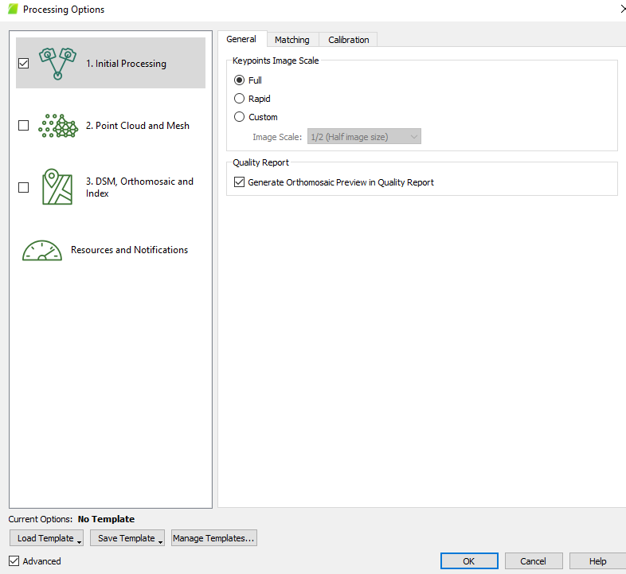
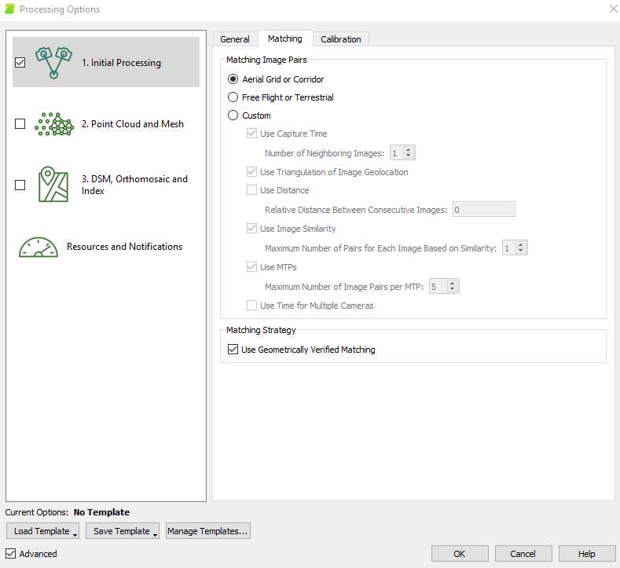
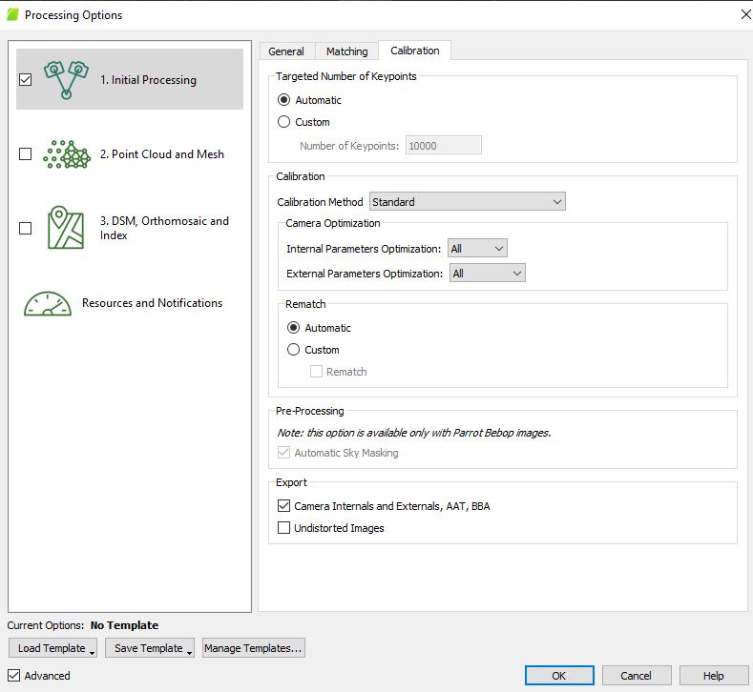
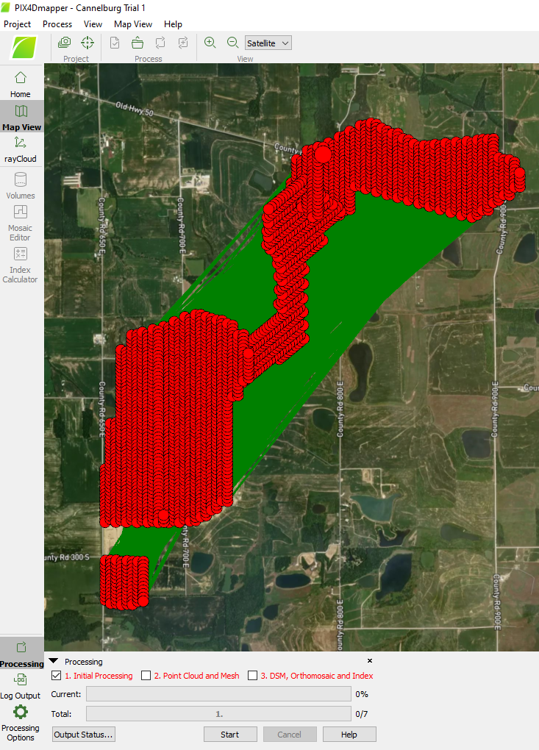
Next Under GCP/MTP Manager I’m going to import my CHECKPOINTS. Note with Wingtra since the images are already PPK-geotagged, we are just using these 8 points as checks. Typically, you only need 3 checkpoints.
Before I imported my GCPs, I used Global Mapper to convert the CSV from Lat Long meters to Northing Easting ft. That way my checkpoints will be in the same coordinate system as my Pix4D outputs. Below is screenshot of my final CSV file I’m using for checkpoints. Note I changed some columns around, so Pix4d likes the format.
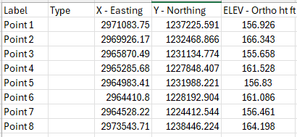

NOTE that I right clicked on “type” to change these from GCPs to CHECKPOINTS. Click OK. You will then see a Blue cross mark on the main map.

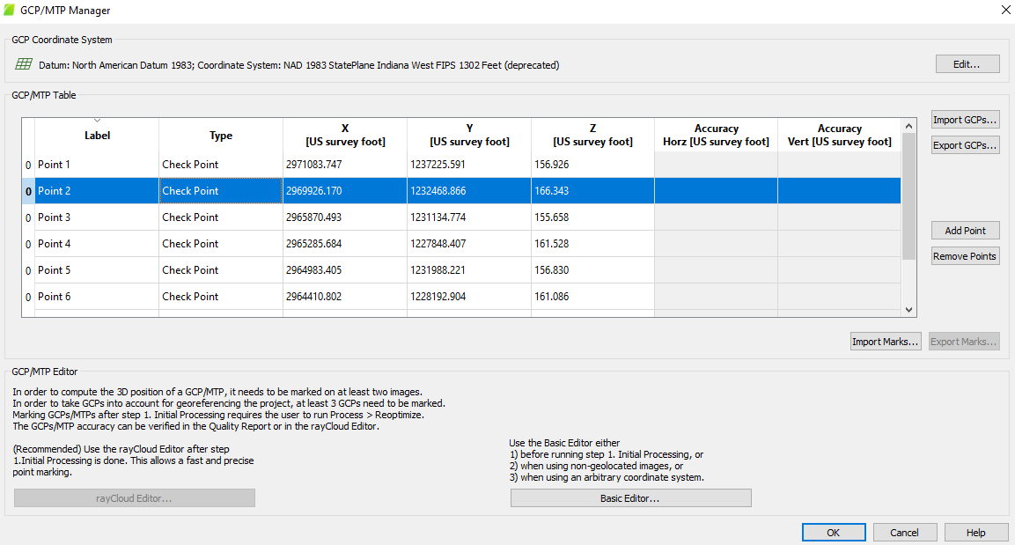

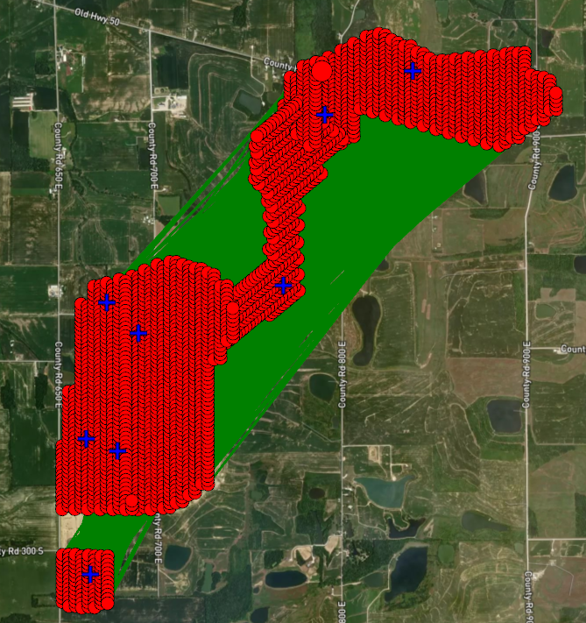

Next, we need to mark the location of the CHECKPOINTS in the images using the Ray Cloud viewer. Under Tie Points, GCPs. Click on one of the points. I had trouble with my cameras showing up, so I’m using BASIC EDITOR to mark the checkpoints in at least 3 images. You can use the SPACE BAR while hovering over the image to get a full screen view.
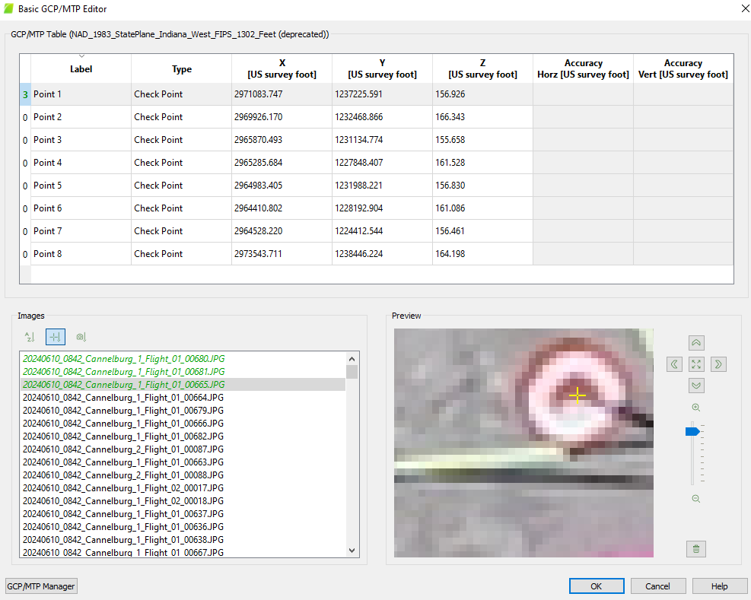
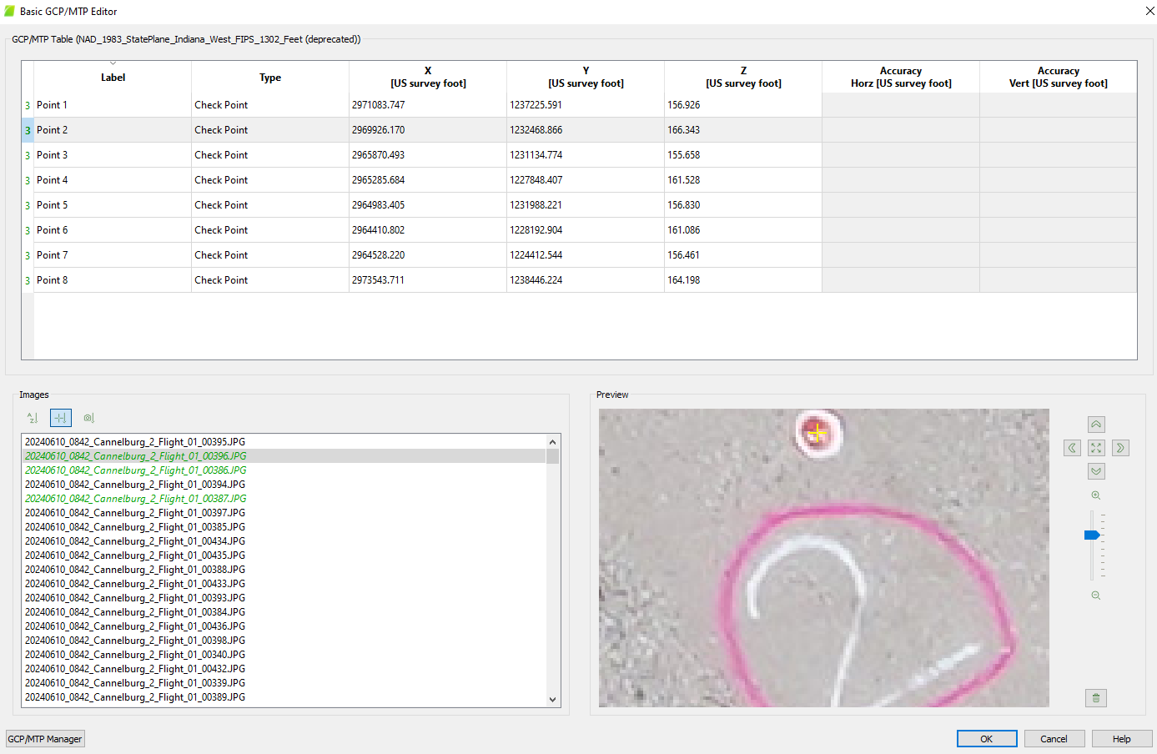

Click OK when done marking all points. Then click START back at the main screen to begin Step 1 – Initial Processing. This will take a while depending on project complexity and computer capability.
The results of Step 1 are
- Automatic tie point cloud (key points)
- Quality report
- Initial camera parameters

Next, we will run the RAY CLOUD EDITOR.

Do not run Step 2 or Step 3 until you are satisfied with locating all GCPs with the Ray Cloud!!!
Marking Photos with RAY CLOUD:
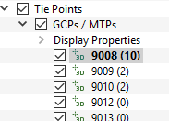
Click on each point (Under Layers - tie points – GCPS - display properties). Over on the right sidebar, selection and images shows up. Hover over each image and click SPACE BAR. You can zoom into each image and left click tag center of target. After you mark at least 2 photos, AUTOMATIC MARKING becomes available to mark the center of each target each photo. Be careful with automatic marking. Do it yourself. Click Apply in the selection box for that GCP to apply it. If you incorrectly mark a point hit the delete key to get rid of it on that image.
You’ll note that each GCP shows in parathesis the number of images you’ve marked the target.
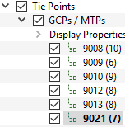

Once you are done with Ray Cloud target matching go to Process Reoptimize.
(Optimize is only Part of Step 1, so Re-Optimize redoes this part of Step 1 again).
ReOptimizing is very important as it:
- Updates the camera parameters and positions based on newly marked points
- Improves the overall accuracy of the project before steps 2 and 3

Below are the screenshots of the Processing Options. Let me adjust these (if you haven’t done that already), before we start Steps 2 and 3.
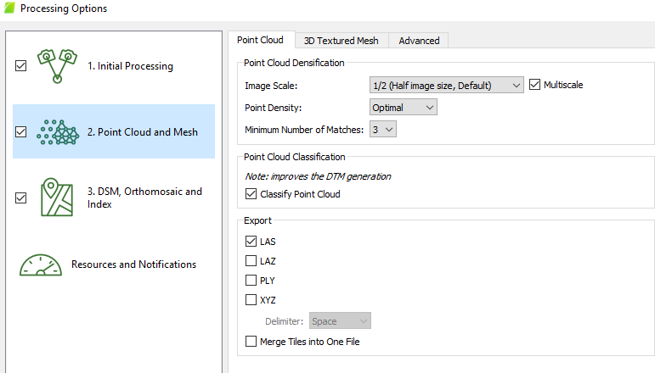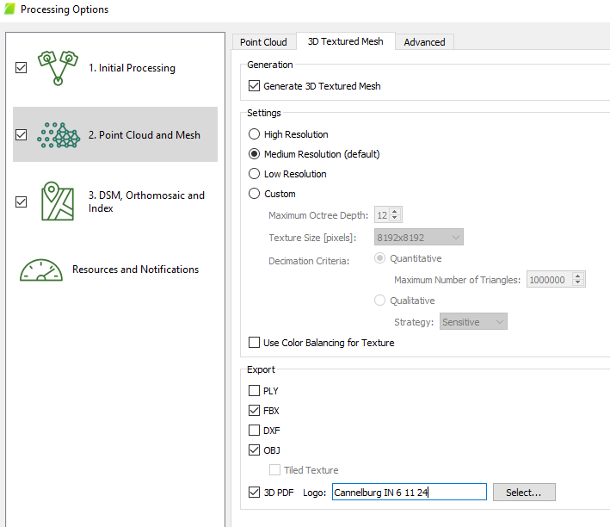
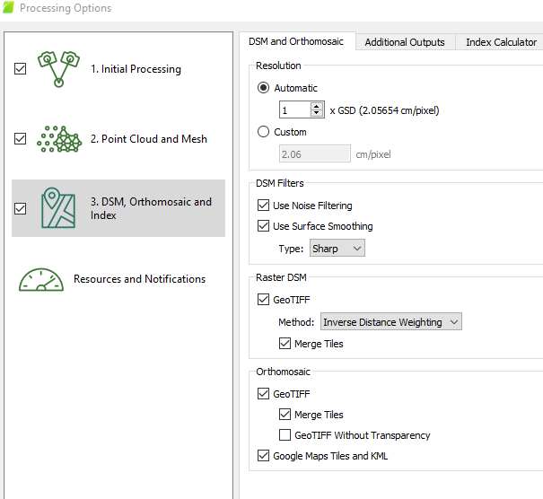
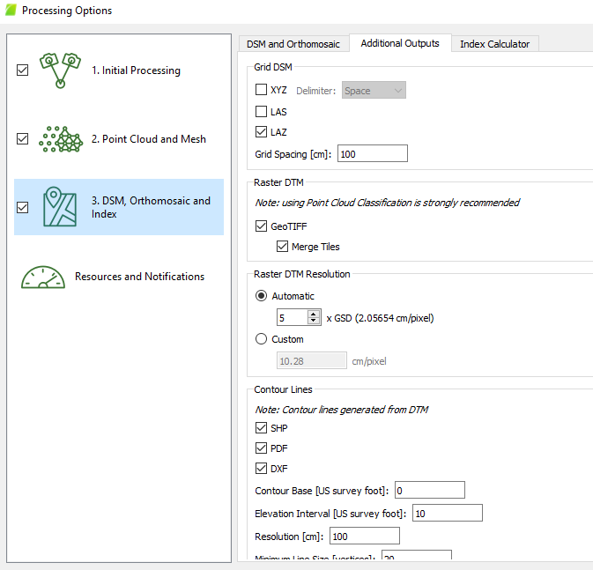

After ReOptimizing, check the Quality Report. You may need to re-run the quality report, so it updates to reflect the reoptimization step. Look at your RMSE values to ensure they are acceptable, and verify checkpoints meet desired accuracy.
PROCEED to run Steps 2 and 3 to generate:
- Dense Point Cloud and Mesh (Step 2)
- DSM, DTM, Orthomosaic, and classified dense point cloud (Step 3)
_______________________________________________________________

In the Quality report, note the RMS Error in X, Y, Z direction. This is under the “Geolocation Details” section. This error represents Independent validation of the model accuracy (meaning against the independent checkpoints).
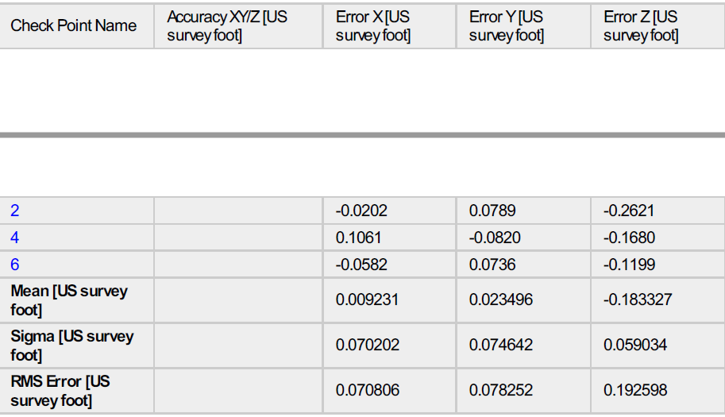

Here is my Orthoimage shown in Global Mapper:
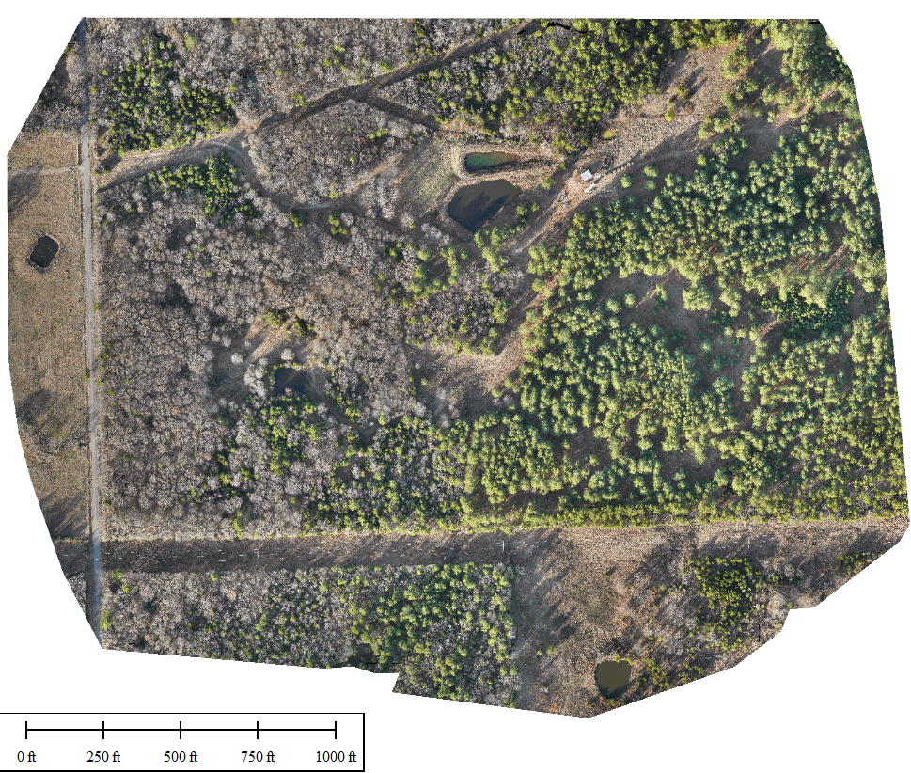
And the Classified Dense Point cloud:
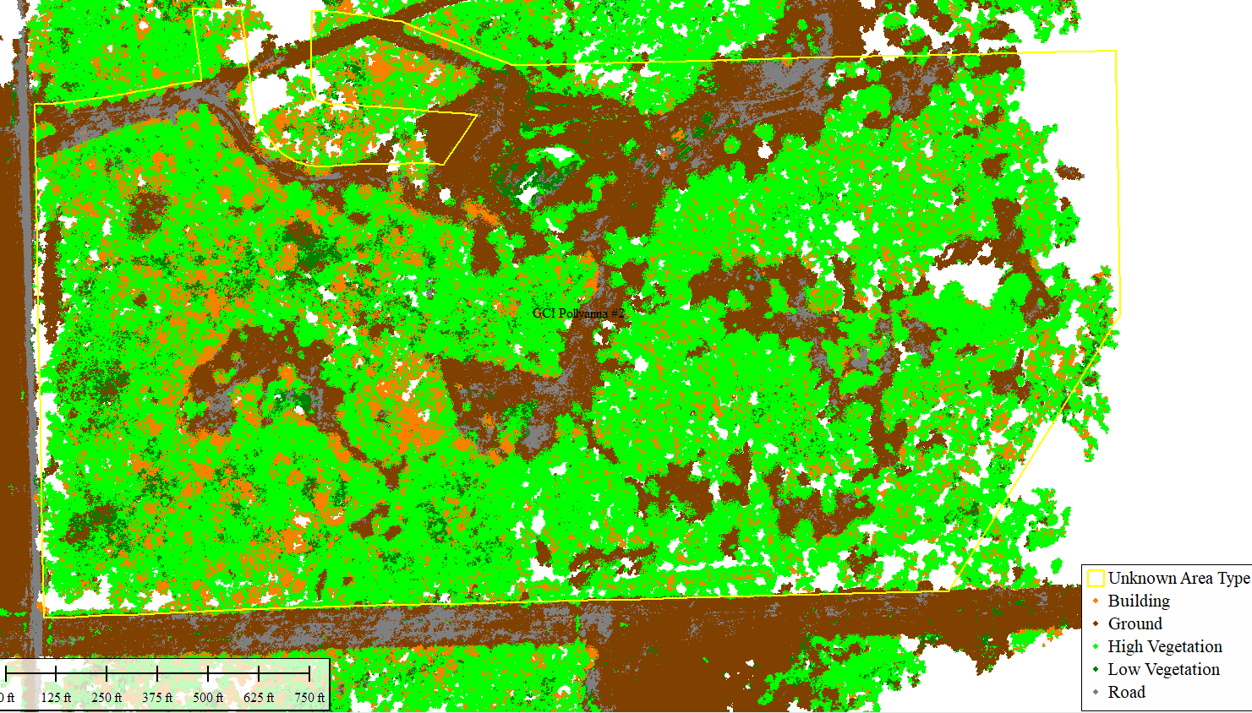
Note the absence of any points under trees (limits of photogrammetry):
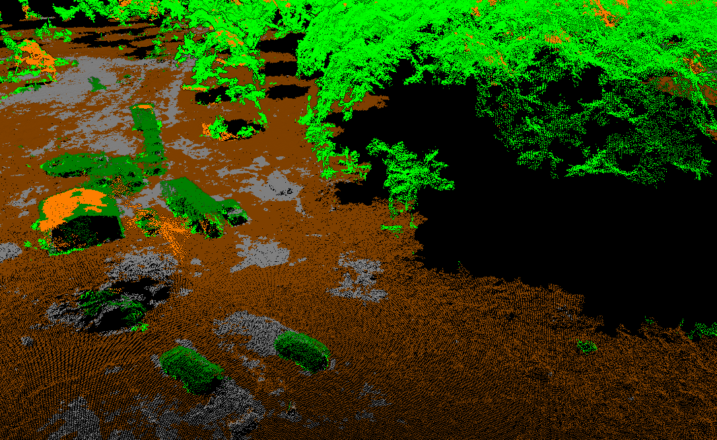

Below I have filtered just the GROUND points, note how Pix4D’s classification scheme has erroneously labeled some points as ground, which are actually trees. This can be expected, we flew during LEAF ON in this example to show limits of photogrammemtry:

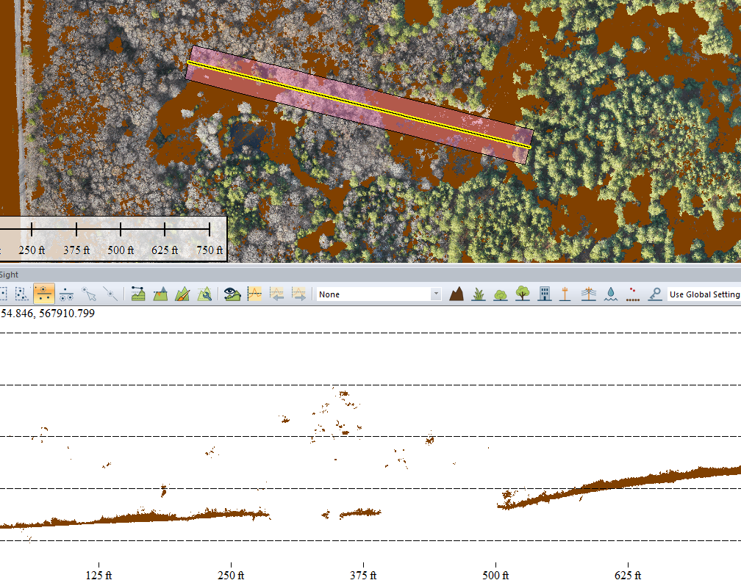

Thus, we would need to use Auto-Classify and path profile tools in Global Mapper, to further filter out what the true ground points are. The DTM spit out by Pix4D is this:
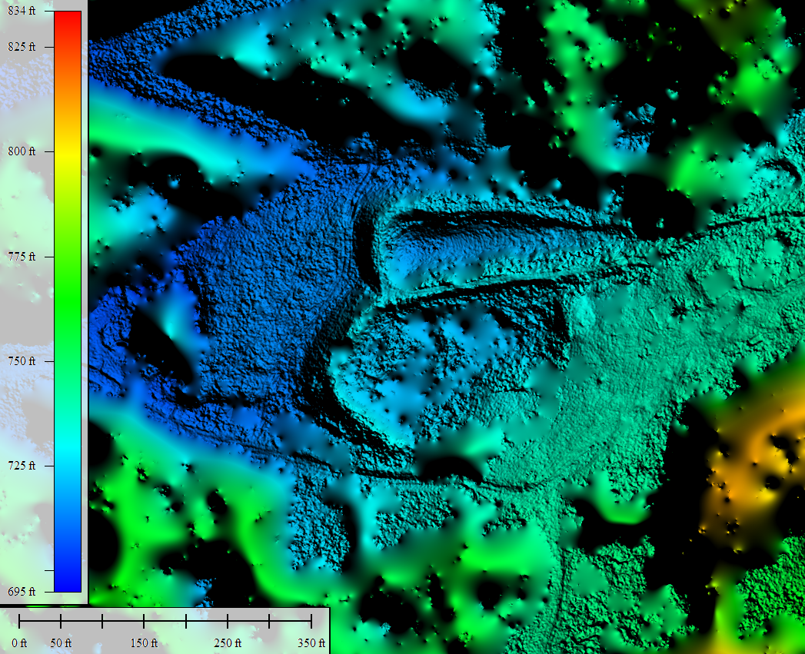
Compare that against the DTM we made using LiDAR:
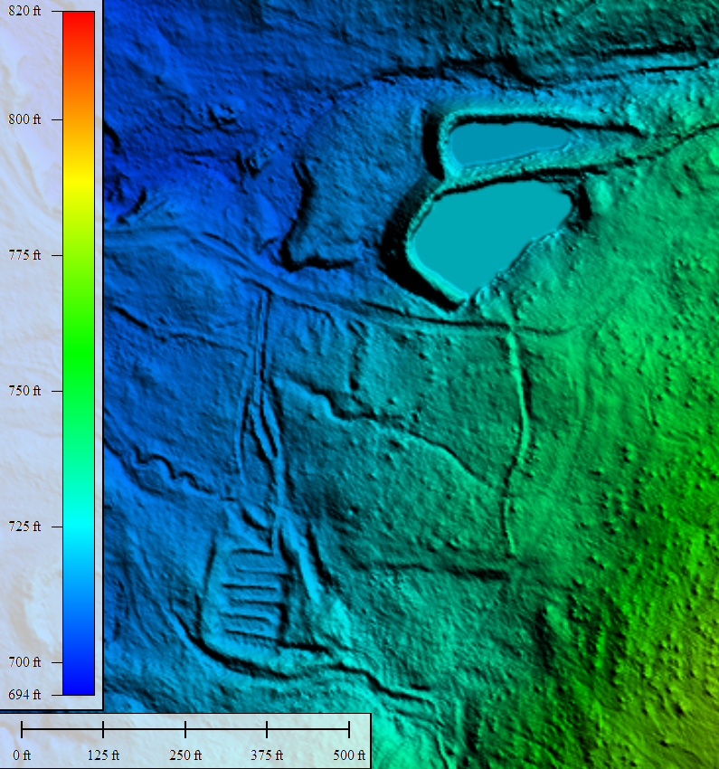

NON PPK GEOTAGGING option:
In WintraHub this is very simple. Had I just wanted an Orthoimage, that would be one example of when PPK-geotagging may not be necessary. Another one would be if I had a bunch of GCPs, and I didn’t have a base station to collect Rinex.
Non-PPK Geotagging steps:
Select the root folder WingtraPilotProjects, and process with PPK geotagging Unselected. Have it output all the images without PPK geotagging. The geotagged images will be placed in the OUTPUT folder.
Pix4D processing of NonPPK-geotagged images.
In Pix, create a new project and upload the geotagged images from the output folder. Note the Datum is WGS84, and the elevation is EGM 96 geoid. Unit is meters.
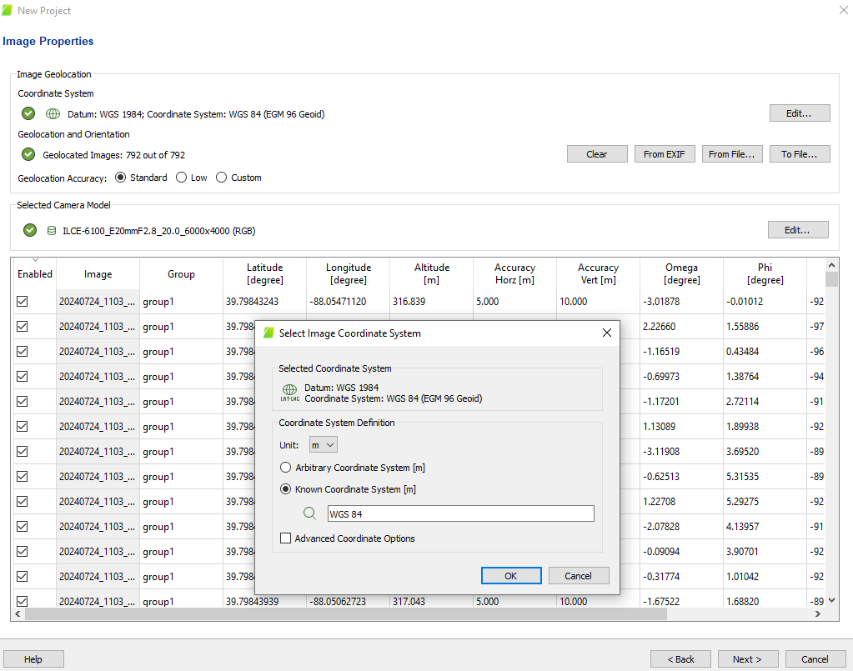
For Murdock, IL (IL State Plane East zone). Here is what I’m using for output coordinate system. Pix will transform this to FT into that coordinate system:
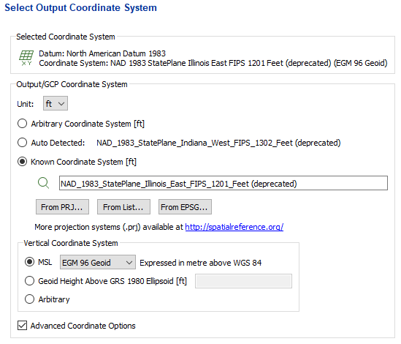
Next in Pix I created a project boundary under Map View pull down. I manually drew in a boundary, but you could also import a KML/KMZ like your flight plan boundary.
I just started STEP 1 Processing and deselected step 2 and 3. I went to processing options first to verify those were correct. Then I clicked start. 792 pictures. Non geotagged. This Step 1 only took a few minutes. Next Step 2 and 3. (uncheck step 1). I wanted to create an ortho, DSM, DTM and mesh for a powerpoint.

