Characterizing the influence of remotely sensed wetland and lake water storage on discharge using LSTM models

Melanie K. Vanderhoof (0000-0002-0101-5533)^{1*}, William Keenan (0009-0007-4686-1796)², Wayana Dolan (0000-0001-8405-4302)¹, Heather E. Golden (0000-0001-5501-9444)³, Charles R. Lane (0000-0003-0066-8919)⁴, Jay R. Christensen (0000-0003-4961-6132)³, Kylen Solvik (0000-0001-6537-1791)⁵, Adnan Rajib (0000-0003-2302-1421)⁶

¹U.S. Geological Survey, Geosciences and Environmental Change Science Center, PO Box 25046, MS 980, Denver Federal Center, Denver Colorado 80225, USA
²Department of Watershed Science, Colorado State University, 1231 Libbie Coy Way, Fort Collins, CO, USA
³Office of Research and Development, U.S. Environmental Protection Agency, 26 W. Martin Luther King Dr., Cincinnati, Ohio, 45268, USA
⁴Office of Research and Development, U.S. Environmental Protection Agency, 980 College Station Road, Athens, Georgia 30605, USA
⁵Department of Geography, University of Colorado, 260 UCB, Boulder, CO, USA
⁶Hydrology & Hydroinformatics Innovation Lab, Department of Civil Engineering, University of Texas at Arlington, Texas, USA

Corresponding author: Melanie Vanderhoof (mvanderhoof@usgs.gov)

Abstract
Globally, many wetlands and lakes are at risk for further loss, which may have unintended consequences for downstream river discharge, including exacerbating flood and drought impacts. We converted multi-sensor surface water extent to a time series of surface water storage. We trained four Long Short-Term Memory (LSTM) models, that differed in their inclusion of storage data and catchment characteristics, to simulate daily river discharge (2016-2023) for select watersheds across the conterminous United States. Adding surface water to a meteorology or meteorology and catchment characteristics model improved upon model Nash-Sutcliffe Efficiency (NSE) in 80.6% of the watersheds. Residuals during low flow (Q70) events decreased by 47.6% when adding storage to meteorological data. Improvements were most consistent in ecoregions with a high density of non-floodplain lakes and wetlands. This effort represents the first exploration to ingest and train a multi-watershed LSTM on landscape scale remotely sensed time series of surface water storage.

Keywords
Baseflow, catchment, deep learning, inundation, floodplain, Prairie Pothole Region, surface water, storage capacity

1 Introduction
Much of the freshwater stored in wetlands, ponds, lakes, and floodplains, has been lost or degraded over time (Brooks et al. 2016; Fluet-Chouinard et al. 2023), attributable to agricultural and urban development, invasive species, pollution, and sea level rise (Van Asselen et al. 2013; Schieder et al. 2018), with a 30% decrease in global wetland extent between 1970 and 2008 (Dixon et al. 2016). Changes to surface water storage (SW_{storage}) may have unintended consequences for river systems, yet our understanding of how SW_{storage} influences river discharge still has serious limitations (Golden et al. 2021). Hydrologic modeling efforts have demonstrated that potential SW_{storage}, in select, wetland-dense watersheds, can increase baseflow (McLaughlin et al. 2014; Ameli and Creed 2019; Yeo et al. 2019) and reduce high flows (Evenson et al. 2018; Yeo et al. 2019; Wu et al. 2020). However, it is still unclear if the influence of SW_{storage}, particularly relative to the influence of meteorological inputs and catchment characteristics (e.g., geology, vegetation) (Beck et al. 2015; Trancoso et al. 2016; Addor et al. 2017), can be discerned at greater spatial scales and across watersheds varying in their SW_{storage} capacity. An improved understanding of wetland-river interactions can help prioritize protection and guide restoration of wetlands and other waterbodies, and in turn, potentially reduce the impact of extreme climate events such as flood-hazard exposure and drought on river systems and the communities that they travel through (Roni et al. 2019; Singh et al. 2019). Here, we generated multiple Long Short Term Memory (LSTM) models each trained on a distinct combination of variable groups, to assess when and where accounting for SW_{storage} dynamics improved predictions of river discharge.
Efforts to model river discharge commonly utilize hydrological models, which use datasets to parameterize and calibrate a mathematical representation of the hydrological cycle (e.g., Fathy et al. 2015; Seiller et al. 2015; Rajib et al. 2020; Mahoney et al. 2023). Discharge has also been modeled using machine-learning or statistical approaches (Slater and Villarini 2017; Wasko and Sharma 2017; Jibril et al. 2022). Given sufficient data, empirical relationships can be derived between hydrologic inputs and outputs (Beven 2020). Increasingly, deep-learning methods, like artificial neural networks, have proven effective in predicting or forecasting discharge (Maier et al. 2023). Specifically, Long Short-Term Memory (LSTM) models, which are recurrent neural networks designed for time series simulations (Hochreiter and Schmidhuber 1997), can effectively learn long-term temporal dependencies between variables to predict discharge and model rainfall-runoff (Tang et al. 2023; Kratzert et al. 2018). Consequently, LSTM’s have been applied to stream discharge data across regions, including the conterminous United States (CONUS; Feng et al. 2020; Konapala et al. 2020; Xie et al. 2022; Wilbrand et al. 2023).Previous LSTM efforts have demonstrated the value of including catchment characteristics (Kratzert et al. 2019; Wilbrand et al. 2023), but have not yet tested the inclusion of SW_{storage} dynamics. LSTMs have been used to predict water level in lakes (e.g., Barzegar et al. 2021; Yao et al. 2023; Zhang et al. 2023; Du et al. 2024), but rarely have wetland or lake dynamics been considered in predicting discharge. A few LSTM efforts have included wetland or lake fraction as a static catchment attribute (e.g., Althoff et al. 2021; Yu et al. 2024). More commonly LSTMs have been used to improve predictions of reservoir outflows (Ouyang et al. 2021; Tandon and Sen, 2024; Li et al. 2025). Reservoirs, which regulate flow, tend to occur on a stream network. Several studies have shown that incorporating time series of reservoir storage improves LSTM estimates of reservoir outflows (Lang et al. 2025; Tran et al. 2025). But to our knowledge no prior LSTM studies have incorporated landscape-scale time series of surface water. This gap is particularly important for non-floodplain surface water which show very different temporal lags relative to a reservoir (Lane et al. 2018).
Most previous efforts exploring the influence of SW_{storage} on discharge have instead been limited to small, wetland-dense watersheds, and relied on process-based hydrologic models, like the Soil and Water Assessment Tool (SWAT; Evenson et al. 2015, 2018; Rajib et al. 2020; Zeng et al. 2020), PHYSITEL/HYDROTEL (Fossey et al. 2015; Wu et al. 2020), or Hydrologic Modeling System (HEC-HMS) (Grimm and Chu 2020). Incorporating depressions or wetlands into hydrological models has been shown to improve streamflow simulation accuracy (e.g., Fossey et al. 2015; Grimm and Chu, 2020; Rajib et al. 2020), particularly for wet and dry periods (Zeng et al. 2020; Golden et al. 2021), where the loss of wetlands, or SW_{storage}, can increase the variability of downstream flow (Lee et al. 2018). While these studies provide critical insights into wetland-river interactions (Golden et al. 2021), most efforts have estimated storage capacity from a digital elevation model (DEM), alone (Evenson et al. 2015; Grimm and Chu 2020; Rajib et al. 2020; Zeng et al. 2020) or utilized a static wetland map (Wu et al. 2020). Very few, all limited in geographic extent, have tested using remotely sensed surface water to inform or calibrate hydrologic model parameters (e.g., Evenson et al. 2018; Lee et al. 2018; Yeo et al. 2019).
In watersheds with limited SW_{storage} capacity external to the stream network, precipitation is captured by vegetation, infiltrates the soil, or is transported downgradient as infiltration-excess or saturation-excess runoff (Eamus et al. 2006). In contrast, for watersheds with wetlands and lakes, precipitation can be stored and gradually released through time - via groundwater baseflow, fill-spill surface runoff, or fill-and-merge with streams (Cohen et al. 2016; Rains et al. 2016; Vanderhoof et al. 2016; Stepchinski et al. 2023). This introduces a delayed or attenuated release of surface water into the stream network, with the delay length depending on its watershed position (Shaw et al. 2012; Kuppel et al. 2015; Wu et al. 2020). Hence, the influence of SW_{storage} on discharge is not expected to be uniform across watersheds.
Satellites provide a mechanism to track landscape-scale surface water temporal dynamics (e.g., Jones 2019; Vanderhoof et al. 2023). The short return-interval of the Moderate Resolution Imaging Spectroradiometer (MODIS), for instance, has made it appealing for hydrologic applications, most commonly correlating river discharge with MODIS-based surface water extent (Zimba et al. 2018; Fuentes et al. 2019; Hou et al. 2020; Soulard et al. 2022). Other satellites, including multispectral - like Landsat (Allen et al. 2020) and Sentinel-2 (Filippucci et al. 2022), and radar, including altimeter (Tourian et al. 2017), Sentinel-1 (Mengen et al. 2020), and microwave (Van Dijk et al. 2016), have been used to predict discharge directly by estimating river width. Yet, since both inundation extent and river discharge are informed by meteorological conditions, it is impossible to attribute the influence of surface water on discharge, using a positive correlation alone. Despite this, efforts to isolate the influence of surface water by modeling discharge as a function of meteorology and surface water have been limited (e.g., Heimhuber et al. 2017).
Integrating remotely sensed surface water extent into a hydrologic modeling framework will require converting extent (m²) to storage (m³). In wetland dense regions, area to volume equations are available for small depressional wetlands (Hayashi and van der Kamp 2000; Minke et al. 2010), while at the watershed scale, DEM contour mapping and sink fill methods can map depressional wetland storage capacity (Wu and Lane 2016; Rajib et al. 2020; Bian et al. 2021). For deeper waterbodies, like lakes, adjacent topography (Xiao et al. 2023) or lake depth can be used to estimate lake bathymetry (Khazaei et al. 2022). Nonetheless, none of these approaches were intended to monitor change in storage over time and their efficacy across diverse water body types (e.g., inundated floodplains, lakes, wetland depressions, riparian wetlands) remains untested. Alternatively, existing sensors to measure changes in water storage are coarse in resolution, like the Gravity Recovery and Climate Experiment (GRACE; Vishwakarma et al. 2018), limited in collection length, like the Surface Water and Ocean Topography (SWOT) satellite mission (Papa and Frappart, 2021), or typically limited to localized efforts, like Synthetic Aperture Radar interferometry (InSAR) (Adeli et al. 2020). Consequently, we currently lack an approach to convert time series of landscape-scale, remotely sensed surface water extent to SW_{storage}.
Further research is needed to understand where and when inundation dynamics within wetlands and lakes may show a detectable influence on river discharge. Process-based hydrologic modeling efforts to date on this topic have been limited to single, small, wetland-dense watersheds, and no hydrological modeling or LSTM analyses, that we are aware of, have ingested and trained a multi-watershed model on landscape scale remotely sensed time series of SW_{storage}. Consequently, our research questions were, (1) How does the inclusion of dynamic SW_{storage} affect LSTM model performance, and do SW_{storage} related changes in model performance vary regionally and temporally? And (2) to what extent is there an association between regions with high or low SW_{storage} and LSTM model performance improvements? To answer these questions we used Sentinel-1 and Sentinel-2 based surface water algorithms (Vanderhoof et al. 2023) to track surface water extent for 2016-2023 at two-week timesteps across 72 watersheds in the conterminous U.S. We used a DEM-based approach to convert surface water extent to SW_{storage}. We then trained four LSTMs, testing the inclusion and exclusion of SW_{storage} and catchment characteristic variables. Our multi-model approach was designed to facilitate deep learning model interpretation and explore how accounting for SW_{storage} may influence our ability to predict river discharge.

2 Materials and Methods
2.1 Watersheds and time period
A total of 72 gaged, inland watersheds within CONUS were selected from the Geospatial Attributes of Gages for Evaluating Streamflow-II data set (GAGES-II) (Figure 1) based on the rubric described below. The GAGES-II dataset is limited to watersheds within CONUS that are the least disturbed by human activities (Falcone 2011). Watershed size influences runoff (Pilgrim et al. 1982) and potential storage capacity, especially via lakes, therefore we prioritized selecting non-nested watersheds within a bounded size class. Of the watersheds, 80% were between 1500 km² and 5000 km² (complete range was 292 km² to 9918 km²) (Figure 1). Watershed sizes closely reflect those of 8-digit hydrological units (HUC08, average size = 4374 km²), a scale commonly utilized by federal and state agencies (Griffith et al. 1999). In comparison, most of the Catchment Attributes and Meteorology for Large-sample Studies (CAMEL) watersheds are small (86%<1500 km²), with only 74 watersheds (11%) between 1500 and 5000 km² (Newman et al. 2014). We stratified watersheds by the regions (6 per region) used to train the Sentinel-1 and Sentinel-2 satellite-based surface water algorithms to maximize the accuracy of the algorithms (Vanderhoof et al. 2023). The algorithms were used to track surface water dynamics over time. However, the intensity of computing resources needed to process the Sentinel-1 and Sentinel-2 imagery also limited the number of watersheds that was feasible to include. Further, while complete avoidance of dams was not feasible, potential watersheds were reviewed to avoid the inclusion of major dams (i.e., dams >15.2 m high with a storage capacity of >6.17 million m³; National Atlas of the United States 2006) near watershed outlets that could severely impact flow dynamics (Rajib et al. 2020). We recognize that watershed selection inherently introduces uncertainty. For example, our watersheds were under-sampled in the northeastern U.S. and mountainous regions where a high proportion of forest cover and steep slopes, respectively, tend to increase our uncertainty in mapping surface water.
Our study period (2016-2023) was chosen to match the data availability from Sentinel-1 and Sentinel-2 missions. Annual precipitation (2016-2023) averaged 967 mm and ranged from 325 mm to 1659 mm (GRIDMET; Abatzoglou 2013) between watersheds. Annual aridity (potential evapotranspiration/precipitation; TerraClimate, 4.6 km; Abatzoglou et al. 2018; Figure 1) ranged from 0.84 to 5.88 with a median value of 1.27, where higher values represent more arid watersheds (Budyko 1958). Land cover was dominated by agriculture (36 watersheds), forest (18 watersheds) and grassland or shrub/scrub (13 watersheds) (Homer et al. 2020). Wetland area averaged 5.6% and ranged from 1.1% to 48.7% (USFWS 2019; Table A1). Watersheds were clustered geographically into nine groups, using the level 3 ecoregions (Omernik and Griffith 2014): (1) Mid-Atlantic (n=5), (2) Southern Coastal Plain (n=7), (3) South-Central Plains (n=11), (4) Great Plains (n=13), (5) Northern Forests (n=7), (6) Prairie Pothole Region (n=11), (7) Middle Rockies (n=6), (8) Northwest (n=6), and (9) Southwest (n=6) (Figure 1).
To contextualize the climate conditions represented by the 8-year period (2016-2023), we converted the GRIDMET 5-day Palmer Drought Severity Index values (PDSI; Abatzoglou 2013) to a rank percentile for 1980-2023, where 100% represented the wettest PDSI for the 44-year period. Relative to the 44-year period, the 8-year period (2016-2023) had a median PDSI of 62%, indicating that our study period was slightly wetter than average. Most watersheds exhibited a wide range of PDSI conditions with the minimum and maximum PDSI rank percentile for the 2016-2023 period averaging 5% and 100%, respectively (Table A1).
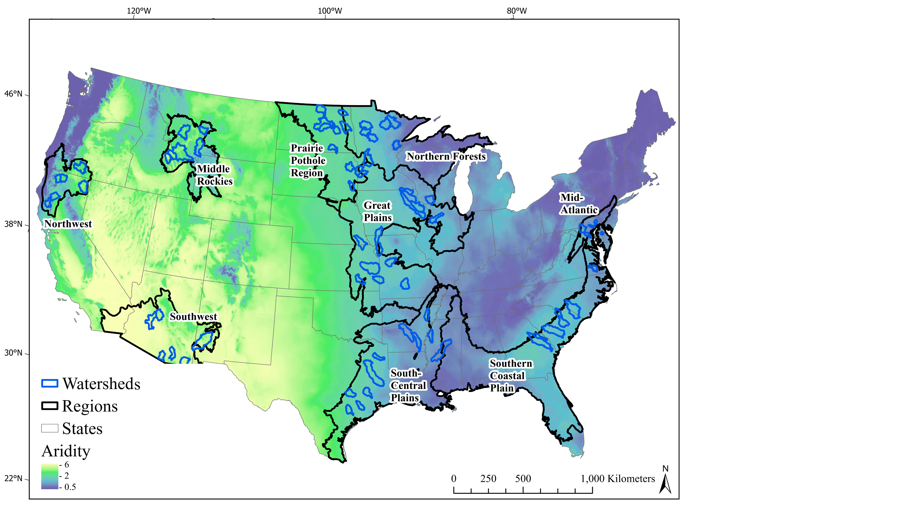
Figure 1. Selected U.S. Geological Survey (USGS) gaged watersheds (blue polygons) in relation to median aridity (2016-2023), where increased aridity is indicated in yellow. Black lines encompass the labeled ecoregions. A histogram equalize stretch was applied to present the aridity data.

2.2 Hydrological, meteorological, and catchment characteristic variables
We acquired daily stream discharge from the USGS National Water Information System (https://waterdata.usgs.gov/nwis) for January 1, 2016 to December 31, 2023 and converted it to daily mean m³ sec⁻¹. Meteorological variables included daily GRIDMET (4 km resolution; Abatzoglou 2013) (1) precipitation, (2) surface downward shortwave radiation, (3) minimum temperature, (4) maximum temperature, (5) vapor pressure deficit, and (6) daily grass reference evapotranspiration. From DAYMET V4 (1 km resolution; Thornton et al. 2022), (7) daily snow water equivalent (SWE), (8) total precipitation, with all forms converted to water-equivalent, and from MODIS, (9) 8-day evapotranspiration (ET), which incorporates leaf area index (LAI) to improve estimates of transpiration (Mu et al. 2014) (Table 1). Both GRIDMET and DAYMET V4 rely on surface observations. DAYMET V4 directly interpolates observations with supporting data sources, while GRIDMET blends high-resolution spatial data from PRISM with high-temporal resolution data from the National Land Data Assimilation System (NLDAS) (Abatzoglou 2013; Thornton et al. 2022). The 8-day MODIS ET was linearly interpolated using forward fill to daily ET.
Catchment attributes included in our analysis were related to: (1) topography, (2) land cover, land use, and vegetation, and (3) soil and geology. We used the 2019 National Land Cover Database to quantify the fraction of each watershed classified as developed or urban (low, medium and high intensity), agriculture (cultivated crops, hay/pasture), and forest (evergreen, deciduous, mixed) (Homer et al. 2020). We also included the watershed proportion with irrigated agriculture (Pervez et al. 2010) and predicted to be tile drained agriculture (Valayanmkunnath et al. 2020), both of which can influence the timing of water being extracted from or added to river discharge. Topography was characterized using mean elevation and slope from the 10 m USGS DEM (Gesch et al. 2022). To characterize the amount of vegetation, we included the peak monthly MODIS LAI (Figure 2) and annual range in monthly MODIS LAI (Yang et al. 2006). Since even small dams can affect flow dynamics (Graf 1999), we included the number of dams, total dam storage and average distance from dams to watershed outlet (US ACOE 2009; Falcone 2011). Soil and geological attributes, including average depth to bedrock, geologic permeability, fraction silt, clay, and sand (Figure 2), as well as rainfall and runoff factor (Table 1), which reflects the long-term (1971-2000) average rainfall amount and peak intensity for storm events. These variables were obtained from the GAGES-II attributes and originally derived from the Soil Survey Geographic (SSURGO) Database (Falcone 2011).

Table 1. Forcings, surface water time series, and catchment attribute variables used as inputs to the Long Short-Term Memory (LSTM) models. As multiple LSTM models were generated, the inclusion of each variable group is indicated after each heading. MET: meteorological, SW: surface water, CC: catchment characteristics, GAGES: Geospatial Attributes of Gages for Evaluating Streamflow, DEM: digital elevation model, NLCD: National Land Cover Database, MODIS: Moderate resolution imaging spectroradiometer, LAI: leaf area index, SSURGO: Soil Survey Geographic Database, ~ indicates a static attribute
Meteorological Forcings (MET, MET+SW, MET+CC, ALL) | Units | Frequency | Source
Precipitation | mm | daily | GRIDMET (Abatzoglou 2013)
Precipitation (all forms) | mm | daily | DAYMET V4 (Thornton et al. 2020)
Snow water equivalent | kg m⁻² | daily | DAYMET V4 (Thornton et al. 2020)
Surface downward shortwave radiation | W m⁻² | daily | GRIDMET (Abatzoglou 2013)
Minimum temperature | K | daily | GRIDMET (Abatzoglou 2013)
Maximum temperature | K | daily | GRIDMET (Abatzoglou 2013)
Vapor pressure deficit | kPa | daily | GRIDMET (Abatzoglou 2013)
Evapotranspiration (grass reference) | mm | daily | GRIDMET (Abatzoglou 2013)
Evapotranspiration (MOD16A2) | mm | daily | MODIS (Mu et al. 2014)
Surface Water Time Series (MET+SW, ALL)

Surface water storage (total) | m³ | daily | Vanderhoof et al. (2023)
Surface water storage (floodplain) | m³ | daily | Vanderhoof et al. (2023)
Surface water storage (non-floodplain) | m³ | daily | Vanderhoof et al. (2023)
Surface water storage (stream connected) | m³ | daily | Vanderhoof et al. (2023)
Surface water storage (stream disconnected) | m³ | daily | Vanderhoof et al. (2023)
Catchment attributes (MET+CC, ALL)

Topography
Catchment area | km² | ~ | GAGES-II (Falcone 2011)
Elevation (mean) | m | ~ | DEM (Gesch et al. 2002)
Slope (mean) | m km⁻¹ | ~ | DEM (Gesch et al. 2002)
Land Cover
Developed | fraction | ~ | NLCD (Homer et al. 2020)
Agriculture | fraction | ~ | NLCD (Homer et al. 2020)
Forest | fraction | ~ | NLCD (Homer et al. 2020)
Irrigated agriculture | fraction | ~ | MODIS (Pervez et al. 2010)
Tile drained agriculture | fraction | ~ | Valayamkunnath et al. (2020)
Maximum monthly LAI | ~ | ~ | MODIS MCD15A3H (Yang et al. 2006)
LAI maximum – LAI minimum (monthly) | ~ | ~ | MODIS MCD15A3H (Yang et al. 2006)
Number of dams | count | ~ | GAGES-II (Falcone 2011)
Dam storage | megaliters km⁻² | ~ | GAGES-II (Falcone 2011)
Distance from dams to gage (mean) | km | ~ | GAGES-II (Falcone 2011)
Soil and Geology
Depth to bedrock | cm | ~ | SSURGO (Falcone 2011)
Geological permeability | cm day⁻¹ | ~ | SSURGO (Falcone 2011)
Silt Fraction | fraction | ~ | SSURGO (Falcone 2011)
Clay fraction | fraction | ~ | SSURGO (Falcone 2011)
Sand fraction | fraction | ~ | SSURGO (Falcone 2011)
Rainfall and Runoff Factor | ~ | ~ | SSURGO (Falcone 2011)

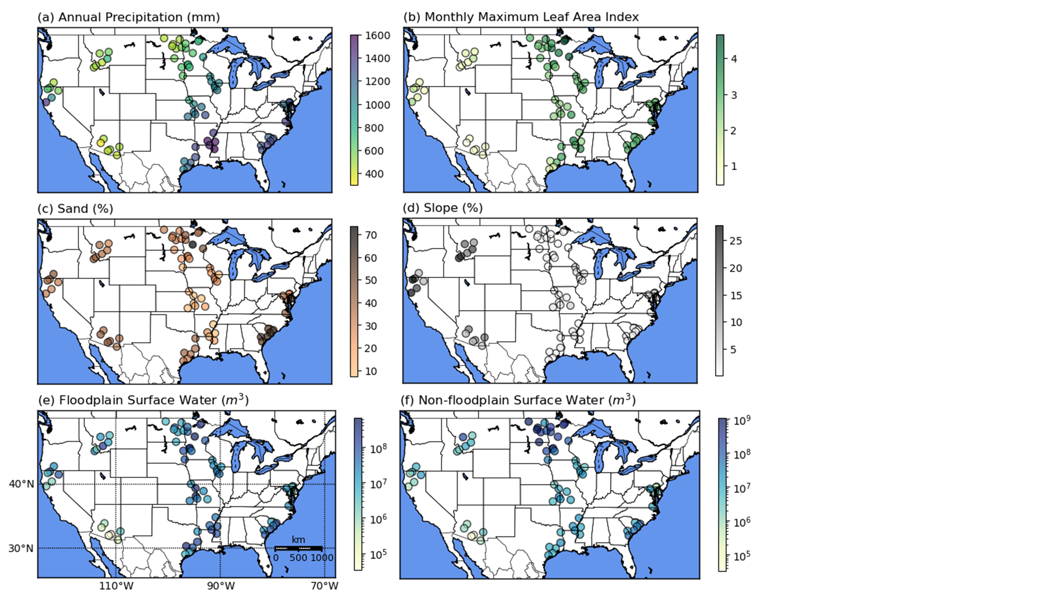
Figure 2. Catchment characteristics including (a) annual precipitation, (b) maximum monthly leaf area index, (c) percent sand, (d) percent slope, (e) total floodplain surface water, and (f) total non-floodplain surface water.

2.3 Surface water estimates
2.3.1 Surface water extent time series
Surface water extent was mapped using Sentinel-1 (S1) and Sentinel-2 (S2) based algorithms, which utilize gradient boosted regression models to classify individual S1 and S2 images into open water (e.g., lakes, ponds, rivers), vegetated water (e.g., wetlands, riparian corridors) and non-water (Vanderhoof et al. 2023). All images, collected between January 1, 2016 and December 31, 2023, overlapping each of the gaged watersheds, were classified. Although Landsat can provide a longer temporal record of surface water dynamics, observations are restricted to periods free of clouds, snow, and ice, meaning that complete estimates would be limited to a monthly or coarser timestep and for a subset of watersheds, exclude months with persistent snow cover (Egorov et al. 2019). While S2 faces similar challenges as Landsat (Yang et al. 2020), the more frequent S2 revisit (5 days using both Sentinel-2A and Sentinel-2B), and complementary derivation of surface water from the SAR satellite, S1, helped minimize cloud and snow data gaps. We used the Cloud Probability dataset produced by Copernicus to mask S2 pixels with a cloud probability of >30%. Cloud shadows were identified and masked as pixels with a near-infrared value of <0.17 within the estimated shadow location, derived from the Cloud Probability dataset and the mean solar azimuth angle, and buffered by 5 pixels to account for uncertainty in shadow length (Vanderhoof et al. 2023). We used the MODIS snow cover (500 m) product to mask out S2 pixels classified as snow or ice. Complete details on the algorithms are presented in Vanderhoof et al. (2023).
The S1 algorithm has a documented omission and commission error of 3.1% and 0.9% for open water, and a 28.4% and 16.0% commission error for vegetated water, respectively. The S2 algorithm has an omission and commission error of 3.1% and 0.5% for open water, and a 10.7% and 7.9% commission error for vegetated water, respectively (Vanderhoof et al. 2023). When the algorithms were consolidated to a monthly time-step, errors of omission and commission for water (open and vegetated water) averaged 1.6% and 10.4%, respectively (Vanderhoof et al. 2024). The use of a water mask (Appendix A) was previously shown to reduce commission error to 6.5% for the monthly time step (Vanderhoof et al. 2024).
In our study, the classified images were consolidated at a 14-day time step, integrating an average of two S2 images and two S1 images for 2017-2021, and two S2 images and one S1 image for 2022-2023. This composite period minimized data gaps and maximized consistency between the classifications by improving the probability that clear-sky optical data was included in each timestep. Pixel values were assigned as the majority classification, water (defined as open water plus vegetated water), or non-water (Figure 3). If observations of water and non-water were equal, then the open water classification, if present, was prioritized, to improve the probability that peak surface water extents were captured. In the absence of an open water classification, non-water was prioritized over vegetated water to reduce commission error (Fig. 2), consistent with a higher accuracy of the open water class relative to the vegetated water class (Vanderhoof et al. 2023). Where no valid observations were present in the 14-day period, pixels were gap-filled using observations from the t-1 and t+1 timestep, and as needed from t-2 and t+2 timestep (Figure 3 Appendix A). Additional details are provided in Appendix A. We used the terms inundation and surface water interchangeably throughout the paper to represent surface water that is external to streams or rivers.

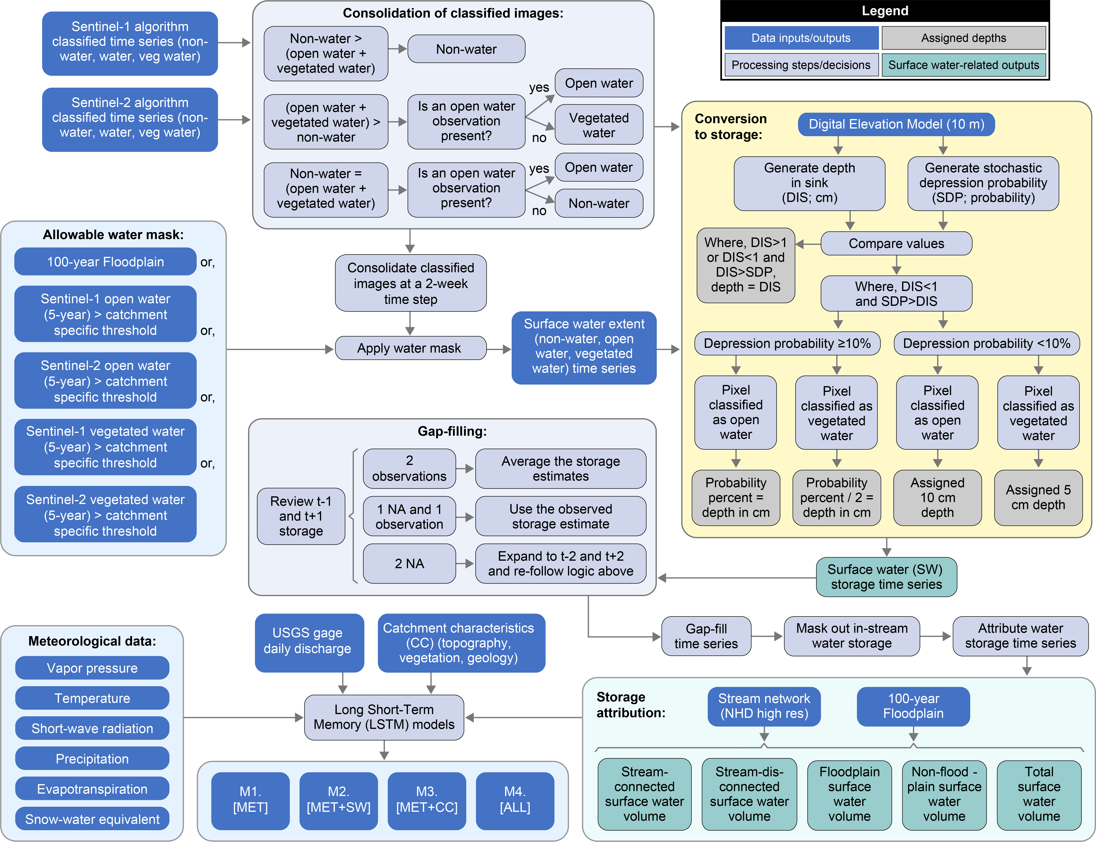
Figure 3. Flowchart showing data processing and analysis including the development of the surface water extent and surface water storage time series, as well as the development of the Long Short-Term Memory models. USGS: United States Geological Survey, NHD: National Hydrography Dataset, MET: meteorological data; NA: not available
2.3.2 Conversion of surface water extent to storage
We converted surface water extent to SW_{storage} for pixels classified as open water or vegetated water at each two-week time step (Figure 3). The WhiteboxTools Open Core was used to calculate the depth of sink (i.e., the depth of the SW_{storage} feature, such as a wetland or depression) from the U.S. Geological Survey, 3D Elevation Program 10-meter resolution digital elevation model (DEM). However, many waterbodies, including most wetlands, are shallower than the reported vertical accuracy of the DEM (vertical RMSE = 82 cm, Stoker and Miller 2022), so that the initial estimates of depth for these waterbodies would be zero or near zero (Figure A1). To provide a more complete estimate of storage capacity, we generated the stochastic depression probability for each watershed (Figure 3). This tool uses a Monte Carlo method to account for the DEM vertical uncertainty when mapping depressions (Lindsay and Creed 2006). The output is a probability (0-100%) that a pixel is within a depression (Figure A1). Where the depth of sink was <1 m and the pixels were classified as open water, we used a 1:1 ratio to convert the depression probability to a depth in cm (range = 1 to 100 cm), reasoning that depressions with a higher probability could be presumed to be deeper than depressions with a lower probability. Where the depth of sink was <1 m and pixels were classified as vegetated water, we used a 1:0.5 ratio (range = 1 to 50 cm) to convert depression probability to depth. These conversions produced a range of depths consistent with wetland depressions (Hayashi and van der Kamp 2000; Nilsson et al. 2013), and wetlands with rooted vegetation (Haag et al. 2005; Raulings et al. 2010), respectively. Surface water outside of topographic depressions can occur with flood events or because of erroneous DEM flowpaths resulting from the presence of features like bridges, roads, ditches, and tile drains (Lindsay and Dhun 2015). Therefore, where the probability of a depression was <10%, pixels were assigned a nominal depth of open water = 10 cm and vegetated water = 5 cm (Figure 3).
While this approach provides a novel method to convert surface water extent to storage, there are several sources of uncertainty. The depth of water in large lakes was likely under-estimated by the depth of sink tool. Further, as depth at each time step is based on an estimated fill depth, it is constant for a given pixel over time, except for transitions between shallow (1< m) open and vegetated water. Consequently, changes in volume reflected changes in water extent and the corresponding estimated water depths within that extent. This means that variability in SW_{storage} over time will be underestimated, as fluctuations in depth for a water pixel at two adjacent timesteps will not be accounted for.
SW_{storage} for each watershed at each time step was summarized as (1) total SW_{storage} (i.e., across the entire watershed), (2) SW_{storage} (floodplain), (3) SW_{storage} (non-floodplain) (Figure 2), (4) SW_{storage} (stream connected), and (5) SW_{storage} (stream disconnected) (Figure 3). The floodplain was defined as the 100-year floodplain (Woznicki et al. 2019). SW_{storage} at each time step was classified as stream connected if it was adjacent to or connected with the rasterized (20 m) NHD high resolution flowlines classified as intermittent or perennial streams, named artificial paths, or NHD waterbodies that occurred along the stream network (USGS 2022). All five SW_{storage} variables were linearly interpolated to daily values using forward fill. Although the interpolation introduced additional uncertainty by over-simplifying the SW_{storage} dynamics, it was necessary to match the daily timestep of the discharge and meteorological variables.

2.4 Derivation and analysis of Long Short-Term Memory models
2.4.1 Model derivation
LSTMs were used to model daily river discharge for 2016-2023 as a function of daily meteorological and SW_{storage} time series, as well as catchment characteristics. Each LSTM was trained across all watersheds jointly. While all four LSTMs were trained and run using meteorological data, they varied in their inclusion or exclusion of the SW_{storage} variables and catchment characteristics (CC) (Table 1):
M1. Meteorological time series variables only [MET]
M2. Meteorological and SW_{storage} time series variables [MET+SW]
M3. Meteorological time series and catchment characteristics [MET+CC]
M4. Meteorological, surface water times series and catchment characteristics [ALL]
In comparing the MET to MET+SW we sought to evaluate the impact of adding SW_{storage} dynamics to a model trained only on meteorological data. Since some catchment characteristics could reflect differences in surface water dynamics, we compared MET+CC to ALL in order to assess if SW_{storage} dynamics still provided additional relevant information to improve model performance. Daily discharge was the dependent variable in each LSTM. Data from January 1, 2016 – December 31, 2020, at a daily timestep, were used to train each LSTM and tune hyperparameters (i.e., training period). Because of the limited time series length, a validation set was not used to tune hyperparameters. Daily data from January 1, 2021 – December 31, 2023 were used to evaluate model performance (i.e., test period).
LSTMs were originally proposed to solve the problem of vanishing and exploding gradients in Recurrent Neural Networks trained on long sequences, which limited their ability to adequately reflect the influence of antecedent meteorological conditions when predicting river discharge (Hochreiter and Schmidhuber 1997). Unlike Recurrent Neural Networks that stack contextual information using only the hidden state, LSTMs have dedicated memory cells controlled by gates to remember long-term information and exclude irrelevant information. The memory cell varies slowly and is updated by adding new information rather than multiplying, while the hidden state changes relatively fast (Xie et al. 2022). Therefore, a LSTM at each time-step requires, (1) the value at time t, (2) the hidden state value from the previous time step, and (3) the memory cell value from the previous time step. The LSTM models in this analysis were trained using NeuralHydrology, specifically the CudaLSTM, a LSTM model class built on PyTorch’s CUDA LSTM implementation (Kratzert et al. 2022). Additional algorithm details are provided in Appendix A as well as provided in Kratzert et al. (2019; 2022).
We tested a suite of hyperparameter values for each of the four LSTM models including (1) the hidden size (32, 64, 128, 256) which refers to the number of features used to compute each hidden state, (2) the dropout rate (0, 0.2, 0.3, 0.4) or the proportion of the hidden state that is randomly dropped during training to help avoid overfitting, (3) the batch size (256, 512, 1024) which refers to the number of training samples or observations included in each iteration step, (4) epochs (30, 50, 100), where one epoch refers to the number of iterations before all of the training samples or observations are used once to update model parameters (Kratzert et al. 2018), and (5) the length of training instances or input sequence length (90, 182, 365), which refers to the number of timesteps or days before each observation considered in the model (Xie et al. 2022; Table 2). Using an Adam optimizer, the learning rate decayed from 0.001 (initial) to 0.0005 (after 10 epochs), and then to 0.0001 (after 20 epochs). The Nash-Sutcliffe efficiency (NSE) was used as the loss function. Since the Mean Squared Error (MSE) from a high discharge watershed is generally larger than from a low discharge watershed, using MSE as the loss function would underweight low discharge watersheds (Kratzert et al. 2019; Xiang et al. 2020). The loss function was calculated as a function of the difference between the observed and simulated discharge and was used to update the model weights and biases between each model iteration. We selected the hyperparameters that maximized NSE on the training set.
Table 2. Selected hyperparameter values for each Long Short-Term Model (LSTM). MET: meteorological data; SW: surface water, CC: catchment characteristics
Hyperparameter | MET | MET+SW | MET+CC | ALL
Hidden size | 256 | 256 | 128 | 256
Dropout rate | 0.2 | 0.2 | 0.4 | 0.2
Epochs | 100 | 100 | 100 | 100
Batch size | 256 | 256 | 256 | 256
Input sequence length | 365 | 365 | 365 | 365

2.4.2 Model uncertainty
Uncertainty in a deep learning models like LSTMs is inherent, but difficult to quantify, as it accumulates from noise in the input data, sampling and training data decisions, as well as model parameterization and generation (Fang et al. 2020; Klotz et al. 2022). To help quantify LSTM uncertainty related to within model development, we evaluated changes in median NSE with increasing epochs, or how each model performance changed with each iteration of training samples used to update model parameters, across all watersheds and by region. In addition, because of the stochastic nature of deep learning models, each trained LSTM model will produce slightly different predictions of discharge each time the model is trained. To characterize model uncertainty attributable to model generation, or uncertainty in prediction interval (Vinokić et al. 2025), we generated an ensemble of model runs (Herbert et al. 2021). LSTM models are computationally intensive to generate, which limited the number of model runs that were feasible for us to generate, and included an ensemble of MET (n=20), MET+SW (n=20), MET+CC (n=22), and ALL (n=22) models. Uncertainty in model-based prediction was characterized using the R-factor, which was calculated as the average distance of uncertainty, or the average difference between the 5th percentile prediction and the 95th percentile prediction at each timestep, divided by the standard deviation of the observed discharge data. An R-factor of 0, indicates that the simulation results match the observed data (Abbaspour, 2011).
2.4.3 Metrics of surface water influence on streamflow
We evaluated model performance using the NSE and the Kling-Gupta Efficiency (KGE, Gupta et al. 2009; Kling et al. 2012) to compare agreement between predicted and observed discharge (Knoben et al. 2019). A NSE and KGE value of 1 indicates a perfect fit, while a value of <0 or < -0.41, respectively, indicates that the predicted value is (on average) a poorer predictor than the long-term observation mean (Knoben et al. 2019). An NSE or KGE >0.5 was classified as “satisfactory”, while an NSE or KGE >0.7 was classified as good (Moriasi et al. 2015; Evenson et al. 2018). NSE was used for most of the analysis to maximize comparability with other CONUS-based LSTM discharge modeling efforts (e.g., Feng et al. 2020; Konapala et al. 2020; Wilbrand et al. 2023). We used NSE to identify the highest performing LSTM model for each watershed. To evaluate relative model performance for low and high flow conditions, the mean percent error (MPE) was calculated from the difference between the predicted and observed daily discharge. We found the MPE, relative to the root mean square error (RMSE) to better represent average error across a range of discharge conditions and to be more easily interpretable. Observed low and high flow conditions were defined as daily discharge within each watershed which were exceeded 70% or more of the time, referred to as Q70, and exceeded only 2% of the time, referred to as Q2, respectively (Feng et al. 2019; Lees et al. 2022). As MPE cannot be calculated if the observed low flow is equal to zero, which was the case for 7 watersheds, we reported residual values (modeled – observed discharge) for the low flow conditions or Q70. We note that while residual values allowed us to include observed no flow conditions, it did not control for variability in mean discharge.The application of feature importance methods in time series modeling, especially LSTMs, are still controversial (Ley et al. 2024). Common methods including SAGE, SHAP and expected gradients often produce noisy and biased values, particularly when features are correlated (Gorski et al. 2024; Takefuji et al. 2025). Therefore, instead, we used per watershed comparisons of model NSE to attribute the contribution of specific variable groups. Values ranged from 0% to 100%. If the NSE comparison was negative, then the variable contribution was assigned a value of 0. If the model NSE was <0, then the variable groups in that model were assigned a value of 0. Contributions were summarized by region. By quantifying variable importance by variable group, we were able to reduce the bias of individual variable correlations influencing variable importance values. Importance, where Variable_{importance} refers to the percent of NSE attributable to that variable group, and was calculated per watershed as:
MET_{importance} = (MET NSE) / (maximum observed model NSE) *100 [1]
SW_{importance} = ((MET+SW NSE) – (MET NSE)) / (MET+SW NSE) * 100 [2]
[SW after CC]_{importance} = ((ALL NSE) – (MET+CC NSE)) / (ALL NSE) * 100 [3]
CC_{importance} = ((MET+CC NSE) – (MET NSE)) / (MET+CC NSE) * 100 [4]
[CC after SW]_{importance} = ((ALL NSE) – (MET+SW NSE)) / (ALL NSE) * 100 [5]
To focus the analysis on the differences between an LSTM trained using meteorology data only, compared to meteorology and surface water data, we compared seasonal differences in the absolute percent bias (PBIAS) and related surface water characteristics to changes in model performance (MET compared to MET+SW). We evaluated relative model performance by hydrologic season. We converted daily discharge to monthly discharge, and averaged over the study period and by ecoregion. Monthly average discharge for each ecoregion was then normalized using the corresponding annual average discharge (Figure A2). We classified monthly, normalized discharge into four components, (1) wetting months, (2) high flow months, (3) drying months, and (4) low flow months. Because of differences in the hydrograph pattern between ecoregions, the hydrograph components were visually classified. High flow (1 to 5 months) and low flow months (3 to 7 months) were identified as the months with the most and least average discharge, respectively. Wetting (1 to 3 months) and drying months (1 to 4 months) were identified as the months preceding and following high flow months, respectively, in which discharge was increasing or decreasing relative to low flow or high flow months, respectively. We calculated the change in absolute PBIAS between the MET and MET+SW models for each ecoregion and hydrograph component.
To quantify if there was an association between ecoregions with high or low SW_{storage} and LSTM model performance improvements with the addition of SW_{storage} variables, we compiled a suite of surface water characteristics, calculated from the 2016-2023 period, for each watershed. These characteristics including the (1) median SW_{storage}, (2) standard deviation of SW_{storage}, and (3) the difference between average spring (March, April, May) and average summer (June, July, August) SW_{storage}, where storage values were calculated for the floodplain and non-floodplain (Woznicki et al. 2019), separately. We also included variables representing hydroperiod, derived from the inundation extent time series, including the percent of each watershed with (1) temporary inundation extent (>3 days and <1 month annually (Cowardin et al. 1979; Scott et al. 2019)), (2) seasonal inundation extent (inundation present ≥1 month and <6 months annually), and (3) semi-permanent to permanent inundation extent (inundation present ≥6 months annually average (Cowardin et al. 1979; Donnelly et al. 2019)), within the floodplain and non-floodplain, respectively. Watersheds with the top quartile of each water variable were identified (e.g., watersheds with the most SW_{storage} or the greatest variability in SW_{storage}). This approach avoided between watershed differences in SW_{storage} from being averaged out. We compared the observed frequency of top quartile watersheds relative to the expected frequency between watersheds in which adding surface water to meteorology improved performance (i.e., MET NSE < MET+SW NSE) or did not. We used the Pearson’s chi-square goodness of fit test to test if the distribution of high surface water conditions between groups was significantly different from expected. Lastly, we correlated the suite of surface water characteristics with catchment characteristics using Spearman correlation with a Bonferroni correction, to evaluate what catchment characteristics could potentially represent summarized surface water characteristics.

3 Results
3.1 Spatial differences in relative model performance
Our meteorology-only model, MET, had a median NSE and KGE for the test period of 0.69 and 0.70, respectively. Adding SW_{storage} to the MET model (i.e., MET+SW) showed minimal improvement upon the median test period NSE and KGE, increasing it from 0.69 to 0.71 and from 0.70 to 0.72, respectively. However, the poorer performing basins saw more improvement, where the first quartile threshold NSE and KGE increased from 0.33 to 0.40 (21% improvement) and from 0.40 to 0.47 (18% improvement), respectively (Figure 4). Adding SW_{storage} improved upon the MET model NSE (MET+SW NSE > MET NSE) in 52.8% of the watersheds, with a median improvement in NSE of 9.3% (from NSE=0.63 to 0.70). After we included CC, adding SW_{storage} (i.e., ALL compared to MET+CC,) did not improve the median NSE or KGE, but the poorer performing basins still saw moderate improvement, so that the first quartile threshold of NSE and KGE increased from 0.38 to 0.50 (32% improvement) and from 0.51 to 0.59 (16% improvement), respectively (Figure 4). This finding suggests that the contribution of SW_{storage} disproportionatly improved weaker performing watersheds (Figure 4c). Further, adding SW_{storage} to the model after CC had been included (ALL NSE > MET+CC NSE) also improved upon model NSE in 52.8% of the watersheds, with a median improvement in NSE of 9.1% (from NSE=0.69 to 0.76; Table 3). Adding SW_{storage} either alone or in addition to CC, improved upon model NSE in 80.6% of the watersheds.
The multi-model comparison of model performance was relatively stable across model development, as measured using epochs. The median NSE after performance began to stabilize, defined as epochs 30-100, was 0.68, 0.70, 0.70, and 0.71 for MET, MET+SW, MET+CC, and ALL, respectively (Figure 4d). In addition, the median R-factors for all four models, generated from the model ensembles, were well below a value of one, with a median R-factor of 0.16, 0.16, 0.08 and 0.07 for MET, MET+SW, MET+CC, and ALL, respectively (Figure A3), indicating that uncertainty attributable to model generation was not substantial.

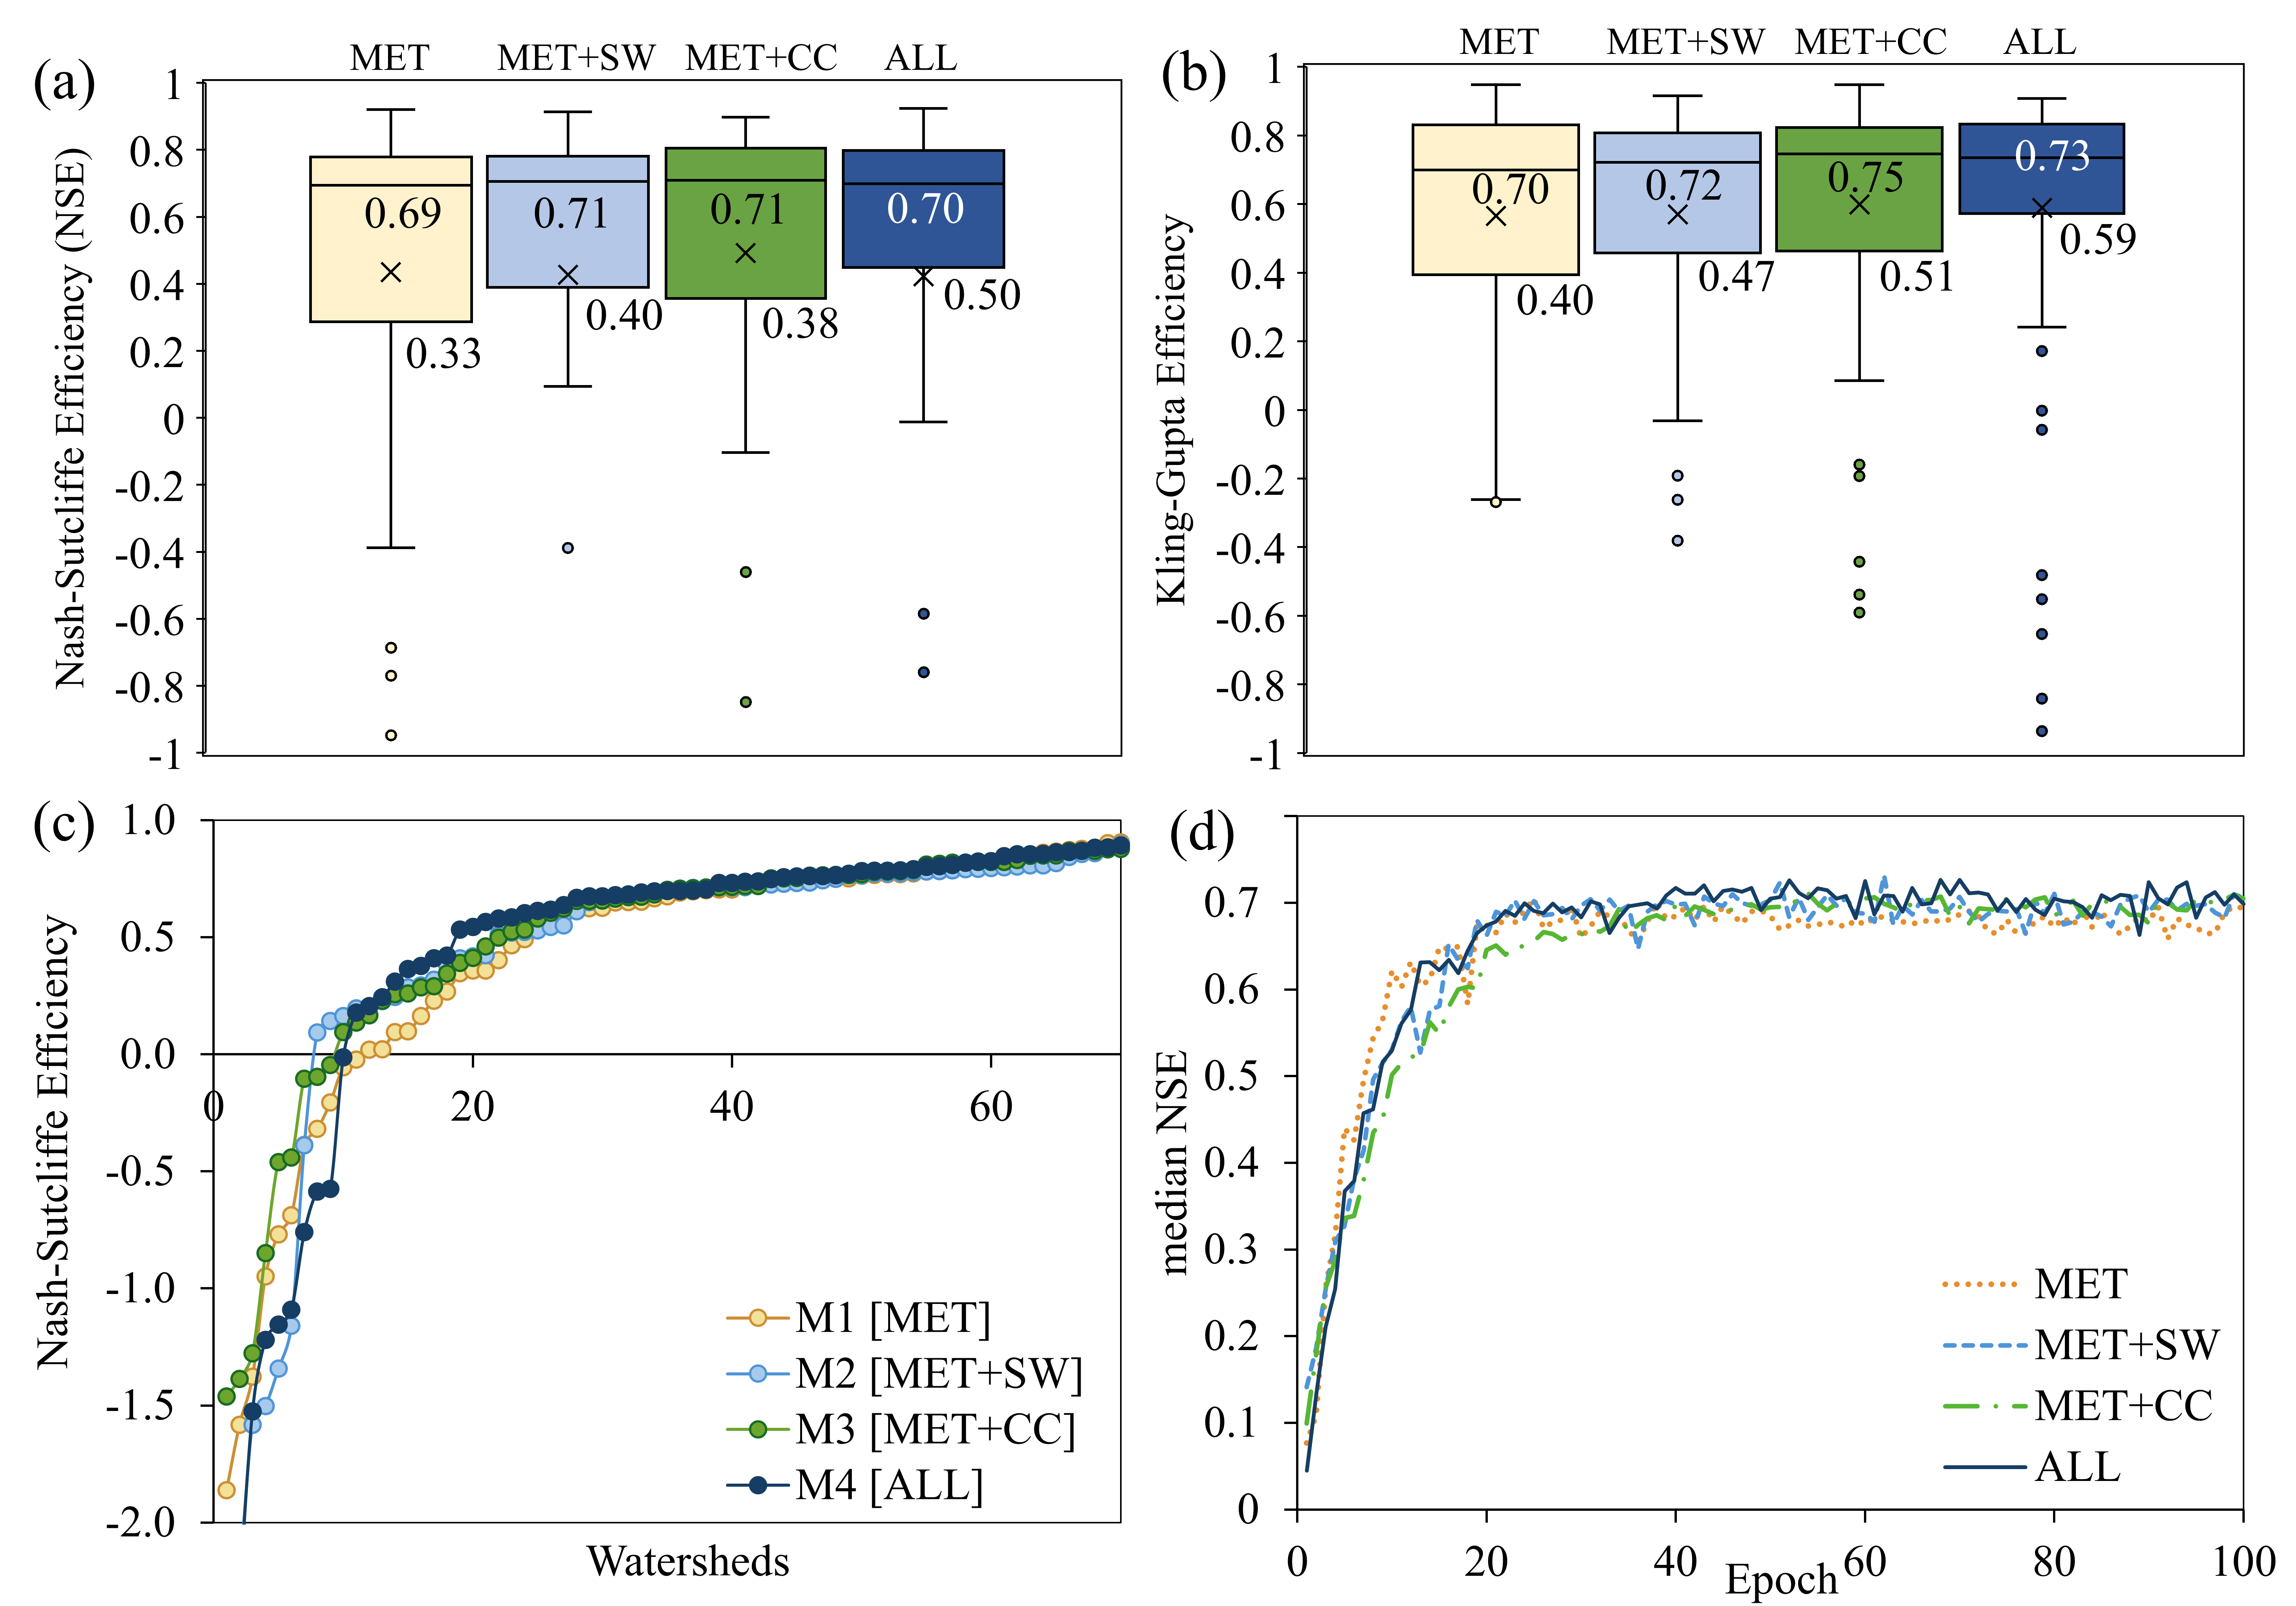
Figure 4. The relative performance of the Long Short-Term Memory discharge models (M) using (a) the Nash-Sutcliffe Efficiency (NSE) and (b) Kling-Gupta Efficiency (KGE), with the exclusion and inclusion of surface water storage time series (SW) and catchment characteristics (CC) and median and first quartile values shown. (c) The ordered distribution of NSE values by model, and (d) the median NSE with increasing epochs. MET: meteorological data

Geographically, the MET model showed satisfactory NSE values (i.e., NSE>0.5) and KGE values (i.e., KGE>0.5) across 100% of the watersheds in the Mid-Atlantic, Southern Coastal Plains, and Northern Forests (Figure 5; Table 3). In contrast most of the watersheds in the Prairie Pothole Region, Middle Rockies, and Southwest saw non-satisfactory NSE (i.e., NSE<0.5) values in the MET model (Figure 5; Table 3). The lower regional NSE was also consistent with greater instability of the NSE values in these regions (Figure A4). By comparing model performance in each watershed we quantified the relative contribution of MET or meteorological forcings to model NSE. We found that the MET model explained much of the maximum NSE, defined as the best performing model per watershed, across many regions. For example, in the Southeast, Mid-Atlantic, and Northern Forests, the MET model explained >90% of the maximum NSE (Table 4, Figure 6). However, in other regions, the MET model explained much less of the maximum NSE, with <60% explained in the Prairie Pothole Region, Rocky Mountains, and Southwest, the same regions that saw low MET NSE values (Table 4).
When we grouped watersheds based on the relative model performance, 15.3% (n=11) of the watersheds had the highest NSE with MET compared to MET+SW (20.8%; n=15), MET+CC (29.2%; n=21), and ALL (34.7%; n=25) (Figure 7), suggesting that the inclusion of SW_{storage} improved upon modeled predictions of discharge in a substantial subset of watersheds. Further, watersheds where MET+SW or ALL improved upon MET or MET+CC, often showed greater amounts of seasonally persistent to permanent surface water extent, for example a watershed in North Dakota, dominated by lakes and wetlands (Figure 7c) or a watershed in Arkansas dominated by forested wetlands (Figure 7e). In 14 watersheds, in contrast, adding SW to meteorology, both alone (i.e., MET compared to MET+SW) or to CC (i.e., MET+CC compared to ALL) did not improve model performance. These select watersheds tended to either perform very strongly with the MET model or very poorly with the MET model, so that 8 of the 14 had an average NSE = 0.81, meaning that the models for those watershed had very little room for improvement, while the remaining 6 watersheds had an average NSE = -0.48. An example of this category is shown in Figure 7b, a mountainous watershed in Idaho, where most of SW_{storage} is seasonal and follows the stream network.
Adding SW_{storage} (MET+SW versus MET) improved NSE in 50% or more of the watersheds within the Mid-Atlantic, Northern Forests, Prairie Pothole Region, Northwest, and Southwest. Adding SW_{storage} to CC (ALL versus MET+CC) resulted in further improvements in the South-Central Plains, Northwest, Southwest, and Prairie Pothole Region (Figure 5; Table 3). These differences were resilient to uncertainty associated with epoch thresholds, where the ALL model consistently outperformed the other models in the Prairie Pothole Region, Northwest and Sothwest (Figure A4). We found that the Prairie Pothole Region watersheds had by far the highest MPE (MET MPE for Prairie Pothole Region = 84.1%). Adding just SW_{storage} (MET+SW versus MET) improved (decreased) MPE to 67.5% across the Prairie Pothole Region watersheds, while adding SW_{storage} to CC (ALL), further decreased MPE to 44.8%. The South-Central Plains and Northwest also saw substantial improvements with MET+SW. Adding SW_{storage} to CC saw smaller improvements, but MPE in the Mid-Atlantic decreased from 6.8% to 2.0% from MET+CC to ALL (Table 3).
Across all watersheds, SW variables contributed an average of 13.8% of the NSE in the MET+SW model, and 10.3% in the ALL model, so that many watersheds showed a contribution of SW variables either in the MET+CC or ALL model (Figure 6). This is similar to the contribution of CC, which contributed an average of 16.3% of the NSE in the MET+CC model and 9.4% in the ALL model (Table 4). The SW variables contributed the most to model NSE within the Prairie Pothole Region and Southwest (33.3% and 31.0%, respectively) (Figure 6). The South-Central Plains, where watersheds were commonly dominated by floodplain wetlands, also saw SW contribute >10% both in the MET+SW and the ALL models (Table 4).

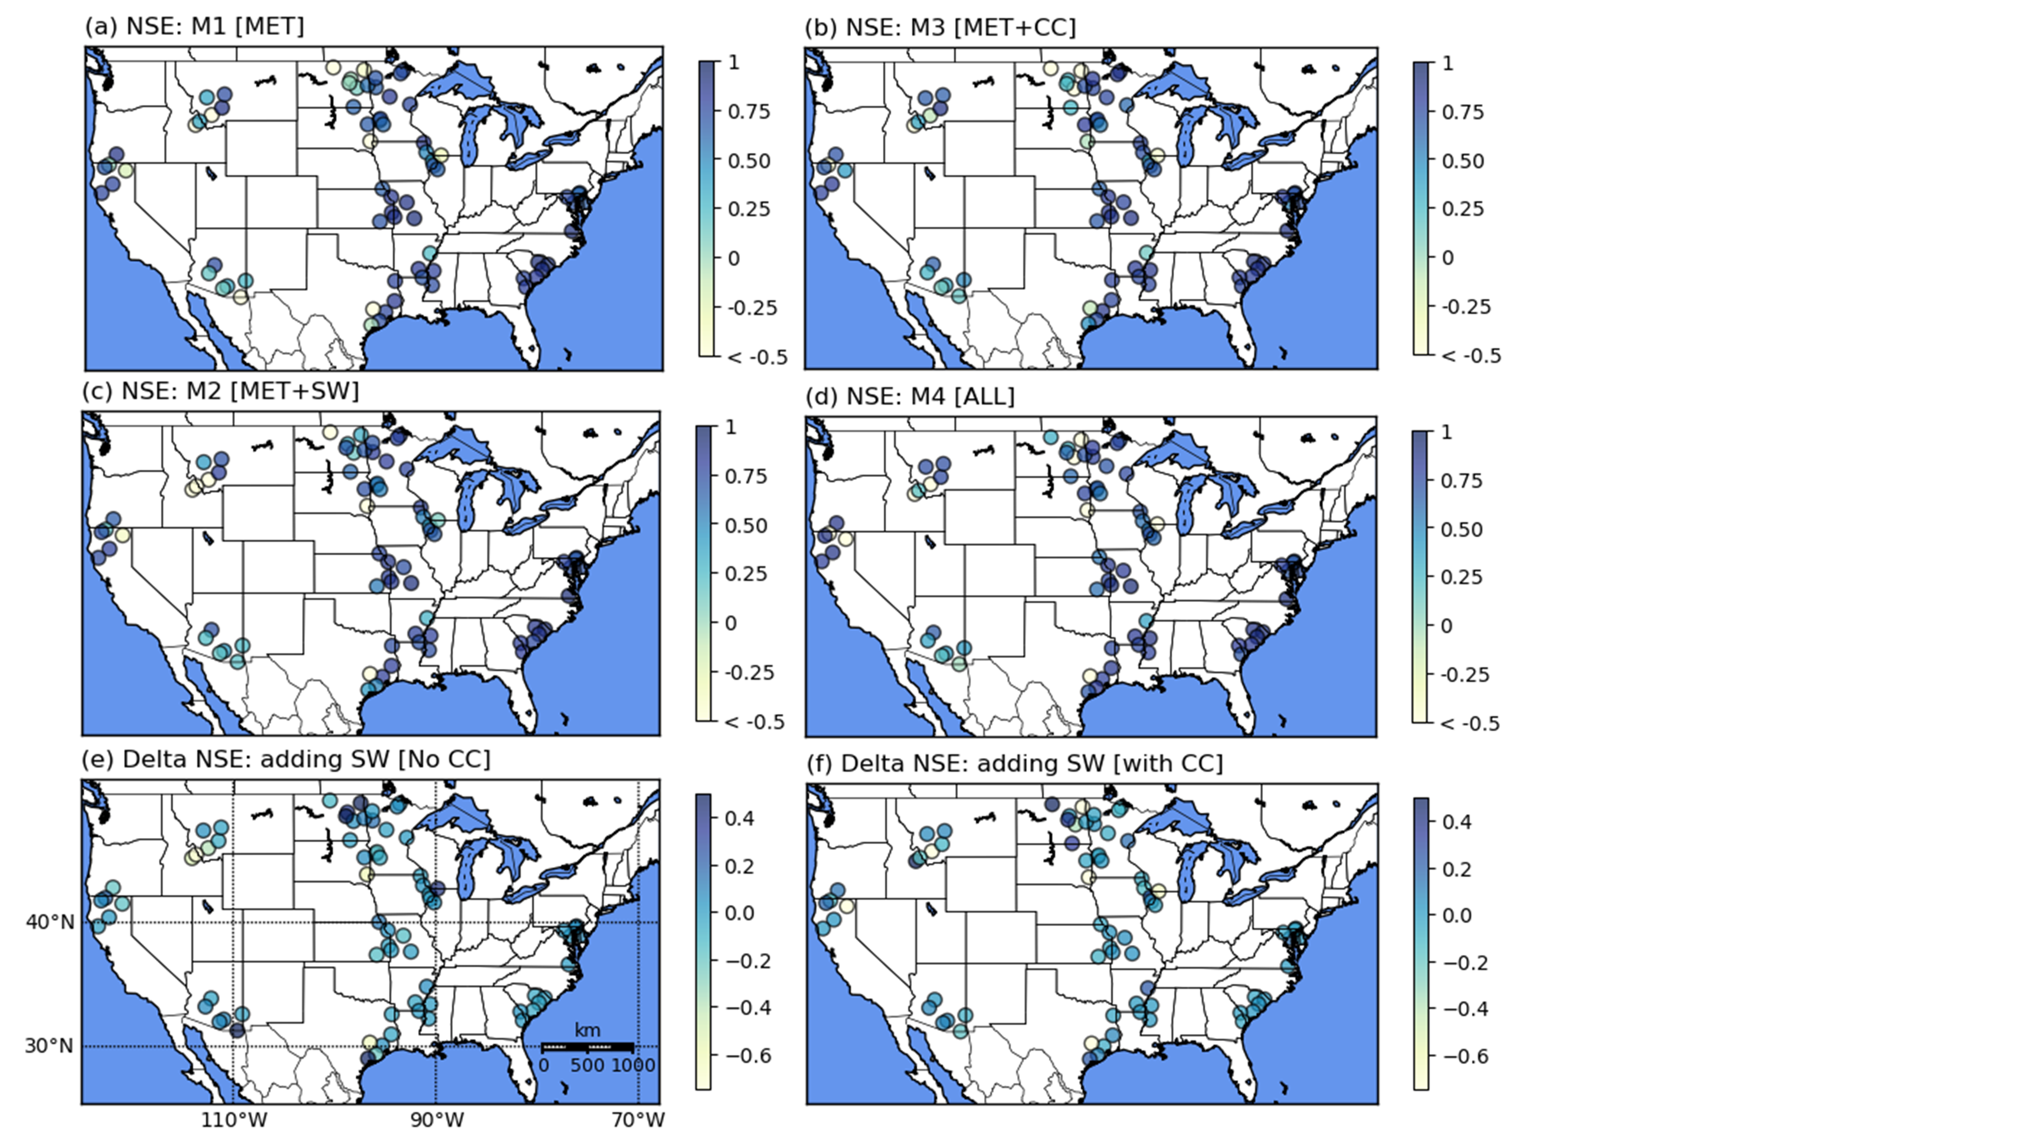
Figure 5. Per basin Nash-Sutcliffe Efficiency (NSE) for (a) the meteorology-only model (MET), (b) no surface water (SW), with catchment characteristics (CC) (MET+CC), (c) surface water but no catchment characteristics (MET+SW), (d) surface water and catchment characteristics (ALL), (e) change from adding surface water, and (f) change from adding surface water with catchment characteristics.
Table 3. Relative model performance by ecoregion. In the columns indicating the percent of watersheds showing improvement, the percent of watersheds with improvements of >5% is shown in parentheses. Ecoregions with improvement in ≥50% of their watersheds are in bold. Flow metrics where ecoregions show improvement with the addition of surface water are also in bold. MET: meteorology, SW: surface water, CC: catchment characteristics, NSE: Nash-Sutcliffe Efficiency, MPE: mean percent error, PPR: Prairie Pothole Region
Ecoregion | MET NSE>0.5 (%) | MET NSE>0.7 (%) | MET+SW NSE > MET NSE (>5%) | ALL>MET+CC (NSE, %) (>5%) | MPE (all flows) MET | MPE (all flows) MET+SW | MPE (all flows) MET+CC | MPE (all flows) ALL
Mid-Atlantic (n=5) | 100 | 40 | 100.0 (60.0) | 40.0 (20.0) | 4.4 | 1.6 | 6.8 | 2.0
Southern Coastal Plains (n=7) | 100 | 100 | 42.9 (0.0) | 57.1 (0.0) | -5.5 | -7.5 | -3.4 | -0.3
South-Central Plains (n=11) | 72.7 | 63.6 | 45.5 (27.3) | 72.7 (36.4) | 14.5 | 10.6 | 5.8 | 7.9
Great Plains (n=13) | 76.9 | 61.5 | 38.5 (23.1) | 46.2 (30.8) | 6.6 | 0.6 | 1.1 | 2.0
Northern Forests (n=7) | 100 | 71.4 | 71.4 (28.6) | 28.6 (14.3) | 0.5 | 1.1 | 6.1 | -7.6
PPR (n=11) | 36.4 | 0 | 63.6 (63.6) | 45.5 (36.4) | 84.1 | 67.5 | 76.7 | 44.8
Middle Rockies (n=6) | 33.3 | 33.3 | 16.7 (16.7) | 50.0 (50.0) | 35.2 | 40.5 | 21.9 | 25.5
Northwest (n=6) | 66.7 | 50 | 50.0 (33.3) | 66.7 (50.0) | 25.6 | 20 | 10 | 22.4
Southwest (n=6) | 16.7 | 16.7 | 66.7 (66.7) | 66.7 (50.0) | 23.6 | -1.7 | -18.1 | -27.3
All (n=72) | 66.7 | 48.6 | 52.8 (34.7) | 52.8 (31.9) | 25.3 | 11.6 | 8.7 | 9.5
Ecoregion | MET Q70 (residual) | MET+SW Q70 (residual) | MET+CC Q70 (residual) | ALL Q70 (residual) | MET Q2 (MPE) | MET+SW Q2 (MPE) | MET+CC Q2 (MPE) | ALL Q2 (MPE)
Mid-Atlantic | 0.37 | 0.43 | 0.57 | 0.26 | -16.7 | -17.6 | -16.6 | -10.7
Southern Coastal Plains | 1.29 | 0.53 | 1.23 | 1.45 | -30.6 | -56.9 | -52.5 | -9.3
South-Central Plains | 2.11 | 2.10 | 2.12 | 1.00 | -12.3 | -12.4 | -45.1 | -24.0
Great Plains | 3.37 | 2.66 | 2.48 | -1.03 | -37.1 | -39.4 | -28.8 | -14.1
Northern Forests | 1.36 | 1.00 | 0.32 | 0.02 | -65.7 | -65.1 | -28.7 | -37.1
PPR | 0.53 | 0.44 | 0.30 | 0.02 | 10.6 | 5.1 | 5.7 | 18.9
Middle Rockies | 1.89 | 2.20 | 0.90 | 0.98 | 1.6 | 5.2 | -4.0 | -4.1
Northwest | 0.85 | 0.57 | 0.73 | 0.20 | -14.2 | -14.7 | -13.5 | 11.2
Southwest | 0.11 | 0.10 | 0.16 | 0.18 | -19.8 | -20.1 | -16.5 | -62.7
All | 0.63 | 0.33 | 0.31 | 0.25 | -15.2 | -20.6 | -18.7 | -13.2

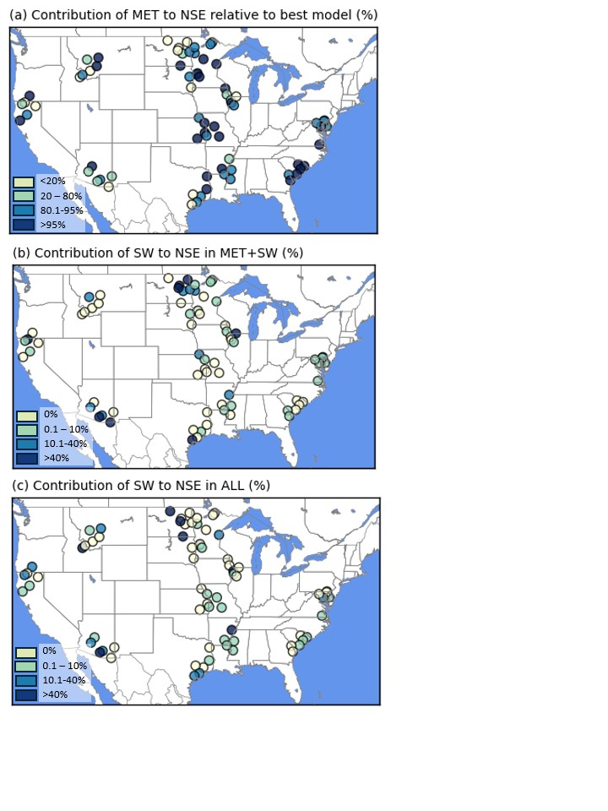
Figure 6. The (a) contribution of meteorological (MET) forcings to the Nash-Sutcliffe Efficiency (NSE) relative to the best performing model for each watershed, individually, (b) the contribution of surface water (SW) to the NSE in the MET+SW model, and (c) the contribution of SW to NSE within the ALL model.

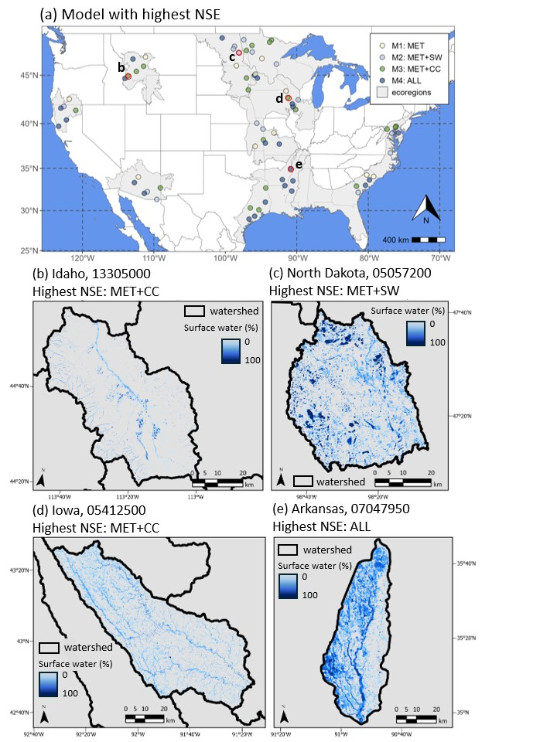
Figure 7. (a) The model showing the highest Nash-Sutcliffe Efficiency (NSE) for each watershed, and examples of surface water (SW) extent and persistence within (b) Idaho, (c) North Dakota, (d) Iowa, and (e) Arkansas, where the number indicates the U.S. Geological Survey’s gage identifer. CC: catchment characteristics, MET: meteorological data only, ALL: meteorological, surface water and catchment characteristics
Table 4. By region, the percent of the best performing model Nash-Sutcliffe Efficiency (NSE), explained by meteorological variables, alone (MET (%)). The remaining columns quantify the mean percent of the model NSE attributable to a specific variable group. SW: surface water, CC: catchment characteristics
Region | MET (%) | SW in MET+SW (%) | SW in ALL (%) | CC in MET+CC (%) | CC in ALL (%)
Mid-Atlantic | 91.1 | 6.3 | 5.1 | 8.2 | 1.0
Southern Coastal Plains | 98.3 | 1.0 | 1.4 | 0.9 | 2.2
South-Central Plains | 74.0 | 11.8 | 11.1 | 21.0 | 12.3
Great Plains | 85.2 | 10.0 | 5.5 | 3.0 | 5.3
Northern Forests | 91.4 | 4.7 | 3.6 | 7.4 | 3.9
PPR | 45.5 | 33.3 | 21.4 | 31.7 | 12.3
Middle Rockies | 56.6 | 2.2 | 20.1 | 25.9 | 24.5
Northwest | 62.8 | 16.4 | 7.2 | 18.1 | 8.5
Southwest | 55.9 | 31.0 | 14.5 | 31.5 | 14.5
All | 73.0 | 13.8 | 10.3 | 16.3 | 9.4

3.2. Temporal patterns in LSTM comparisons
We found that within season improvements in model performance with adding SW_{storage} were most consistent for watersheds within the Northern Forests and Prairie Pothole Region, both ecoregions known for their abundance of wetlands and lakes. Across the multi-month hydrograph components, seven of the nine ecoregions showed improvements in the MET+SW model relative to the MET model within wetting months, with the Northern Forests most prominently showing a 40.5% reduction in absolute PBIAS during wetting months (Table 5; Figure A2). While improvements were less common across ecoregions during the drying months, the Prairie Pothole Region showed a 15.4% improvement in absolute PBIAS.
In high flow months we found six of the nine ecoregions improved with MET+SW relative to MET. The Prairie Pothole Region, for example, had a 10.9% improvement in absolute PBIAS (Table 5), consistent with a reduction in high flow MPE of 5.5% for this region (Table 3). In comparison, when high flow was limited to Q2, improvements in MET+SW relative to MET, were limited to the Northern Forests and Prairie Pothole Region. The ALL model produced the lowest Q2 MPE in the Mid-Atlantic, Southern Coastal Plains, Great Plains, and Northwest ecoregions (Table 3).
During months of low flow, ecoregion improvements in absolute PBIAS for MET+SW compared to MET were less common but substantial in the Northern Forests, which showed a 12.4% improvement and the Prairie Pothole Region, which showed an 18.0% improvement (Table 5). This finding was consistent with both ecoregions also showing a reduction in Q70 residual values with the inclusion of SW in MET+SW and in ALL (Table 3). The South-Central Plains and Northwest also showed improvements in both low flow absolute PBIAS and Q70 residuals. Across all watersheds, low flow, Q70, residual values showed a decrease of 47.6% with MET+SW compared to MET. In addition, the ALL model, produced the lowest Q70 residuals for six of the nine ecoregions (Table 3). While the Southwest saw a relatively large increase in low flow absolute PBIAS from MET to MET+SW, this is attributable to many Southwest watersheds having no flow for much of the low flow season, so that although the absolute Q70 residuals in the Southwest were the smallest of any region (Table 3), minor over-estimations of flow during this period, produced relatively high absolute PBIAS values (Table 5).

Table 5. Change in regional absolute percent bias (PBIAS), by hydrograph component, from adding the surface water storage time series. A reduction in absolute PBIAS, as indicated by negative values, demonstrates an improvement in absolute PBIAS with MET+SW compared to MET. MET: meteorology, SW: surface water
Ecoregion |  | Wetting (% change) |  | High flow (% change) | Drying (% change) |  | Low flow (% change) |  | Annual (% change)
 | Mid-Atlantic | 7.1 | -2.5 |  |  | -5.3 |  | -4.0 |  | -1.7
 | Southern Coastal Plains | -1.8 | 5.0 |  |  | -3.5 |  | 1.5 |  | 0.7
 | South-Central Plains | -1.0 | -2.8 |  |  | 8.2 |  | -5.8 |  | -1.9
 | Great Plains | -3.2 | -5.3 |  |  | 3.0 |  | 2.9 |  | -0.2
 | Northern Forests | -40.5 | -1.7 |  |  | 0.0 |  | -12.4 |  | -11.9
 | Prairie Pothole Region | -0.1 | -10.9 |  |  | -15.4 |  | -18.0 |  | -14.9
 | Middle Rockies | -2.7 | 6.1 |  |  | 7.7 |  | 1.2 |  | 1.9
 | Northwest | 4.0 | 3.9 |  |  | -3.2 |  | -7.9 |  | -2.4
 | Southwest | -13.0 | -4.0 |  |  | 8.8 |  | 16.5 |  | 3.8
 | All | -4.6 | -2.0 |  |  | -0.2 |  | -3.9 |  | -3.0

3.3 Relationship between model performance and surface water variables
We found that the group of watersheds that improved with the addition of SW_{storage} (i.e., MET NSE < MET+SW NSE) had more top quartile amounts of non-floodplain storage and storage dynamics than statistically expected. Specifically, watersheds with substantial, top quartile, (1) median non-floodplain SW_{storage}, (2) greater standard deviation or variability in non-floodplain SW_{storage}, (3) greater spring to summer differences in non-floodplain SW_{storage}, as well as (4) greater seasonal and semi-permanent to permanent non-floodplain surface water extent were all significantly more likely (chi-square test, p<0.05) to show improvements in model NSE when SW_{storage} was added (MET+SW NSE > MET NSE; Table 6). For example, watersheds with top quartile seasonal non-floodplain inundation extent were 36.8% more frequent than expected in watersheds where MET+SW NSE > MET NSE (Table 6). The group of watersheds that showed improvement in MET+SW NSE relative to MET NSE, were also significantly (chi-square test, p<0.05) less likely to show large (i.e., top quartile) (1) standard deviation or variability in floodplain SW_{storage}, (2) spring to summer differences in floodplain SW_{storage}, and (3) greater seasonal floodplain surface water extent (Table 6). Additionally, we found that the catchment characteristics: slope, depth to bedrock, leaf area index, and the rainfall and runoff factor were all significantly correlated with multiple surface water variables (Table A2), suggesting that these variables could help represent surface water characteristics in applications where SW_{storage} is not explicitly included.
Table 6. A comparison of the frequency of the top quartile of inundation (inun.) variables (i.e., watersheds with the most inundation or greatest variability in inundation). The observed versus expected frequency were compared between (1) watersheds in which adding surface water to meteorology improved the Nash-Sutcliffe Efficiency (NSE) (MET+SW NSE > MET NSE) or did not. ~: not significant, MET: meteorology, std dev: standard deviation, temp: temporary, * = p<0.05, ** = p<0.01
Surface water (SW) variable | Difference from expected (%)
Floodplain (FP)
SW storage (median, FP) | 5.3
SW storage (std dev, FP) | -26.3*
Spring – Summer change in SW storage (FP) | -26.3*
Temporary Inun extent (FP) | 5.3
Seasonal Inund extent (FP) | -26.3*
Semi-permanent to permanent Inun extent (FP) | 5.3
Non-floodplain (NFP)
SW storage (median, NFP) | 26.3*
SW storage (std dev, NFP) | 26.3*
Spring - Summer change in SW storage (NFP) | 26.3*
Temporary Inun extent (NFP) | 26.3*
Seasonal Inun extent (NFP) | 36.8**
Semi-permanent to permanent Inun extent (NFP) | 36.8**

4 Discussion
  - Comparison to previous LSTM efforts
As controls of streamflow generation are variable (Berghujs et al. 2016; Wu et al. 2021), accurate predictions of discharge can be challenging. Prior LSTM analyses have demonstrated the effectiveness of using LSTMs to predict discharge across hundreds of stream gages (i.e., >500) using multi-decadal discharge records (Kratzert et al. 2019; Konapala et al. 2020; Ma et al. 2021; Xie et al. 2022; Tang et al. 2023). Despite our analysis using far fewer watersheds (n=72) and a shorter period of data (8 years), limited by the availability of the S1 and S2 archives, our meteorology-only (MET) and meteorology and catchment (MET+CC) models had comparable performance metrics to others (e.g., Kratzert et al. 2018; Tang et al. 2023; Wilbrand et al. 2023). Similarly, LSTMs have been effective in as few as ten gaged basins (e.g., Hunt et al. 2022), suggesting that although deep learning models, like LSTMs, tend to be data hungry, and shouldn’t be applied to single watersheds (Kratzert et al. 2024), they can be effectively applied in instances with less data (e.g., <100 watersheds) – at least for streamflow predictions.
Our geographic performance patterns were also consistent with previous studies. The MET and MET+CC models performed strongest across the eastern U.S, where high precipitation watersheds in the eastern and northwestern U.S. tend to perform well with LSTMs (Konapala et al. 2020; Xie et al. 2022; Tang et al. 2023). Also, our MET model performed poorly in the Southwest and Prairie Pothole Region, where watersheds commonly have seasonal no flow periods, a finding consistent with previous studies (Kratzert et al. 2018; Konapala et al. 2020; Xie et al. 2022; Tang et al. 2023).
4.2 Summary of surface water findings relative to existing literature
Several previous LSTM analyses have included surface-water related catchment characteristics including water fraction (Konapala et al. 2020; Xie et al. 2022), maximum water content (Ma et al. 2021) and modeled soil moisture (Hunt et al. 2022). Novel to our analysis was testing the inclusion of SW_{storage} time series. We found that SW_{storage} influencing river discharge was a relatively common phenomenon. Including additional variables can change LSTM weights and biases. While this may be advantageous for watersheds that benefit from additional information, the changes can also result in a reduced accuracy for watersheds where this additional information was not necessary. Consequently, we saw similar median NSE and KGE values across the models, but the poorer performing watersheds often showed substantial improvements in model performance with the addition of the SW_{storage}. We documented the most consistent improvements occurring as potential storage was filling or wetting up was occuring (Figure 8), followed by high flow months, although when peak flow was defined not seasonally, but as the Q2 of daily flows, this improvement was limited to the Prairie Pothole Region and Northern Forests. This finding is consistent with hydrologic modeling efforts that have documented lakes and large wetlands moderating peak flows (Evenson et al. 2018; Wu et al. 2020), as seasonal flooding coincides with peak flow conditions (Blanchette et al. 2019). We also observed that adding surface water (MET+SW versus MET) reduced low flow residuals in most ecoregions, and at a monthly timestep, these improvements in bias were substantial in the Northern Forests and Prairie Pothole Region, regions dominated by lakes and wetlands, with an abundance of non-floodplain surface water (Figure 2). Differences in specific yield between uplands and non-floodplain wetlands leads to frequent reversals in hydraulic gradients, meaning that non-floodplain wetlands can act as both groundwater sinks and sources (McLaughlin et al. 2014; Lane et al. 2018), contributing to baseflow (Evenson et al. 2015; Zeng et al. 2020) and stabilizing low flow conditions (Ameli and Creed 2017; Blanchette et al. 2019). Theoretically, a fraction of water is diverted to SW_{storage} during periods of wetting, with the amount dependent upon the amount of available storage (Figure 8). This diversion can dampen high flows (Yeo et al. 2019), but contribute water from connected surface water and floodplains with slower residence times, as discharge recedes (Helton et al. 2014; Cohen et al. 2016). Further, under low flow conditions, both connected and disconnected surface water can contribute water as hydraulic gradients reverse (McLaughlin et al. 2014), and water moves via surface or subsurface flows toward the stream (Hayashi and Rosenberry 2002; Cohen et al. 2016; Figure 8).
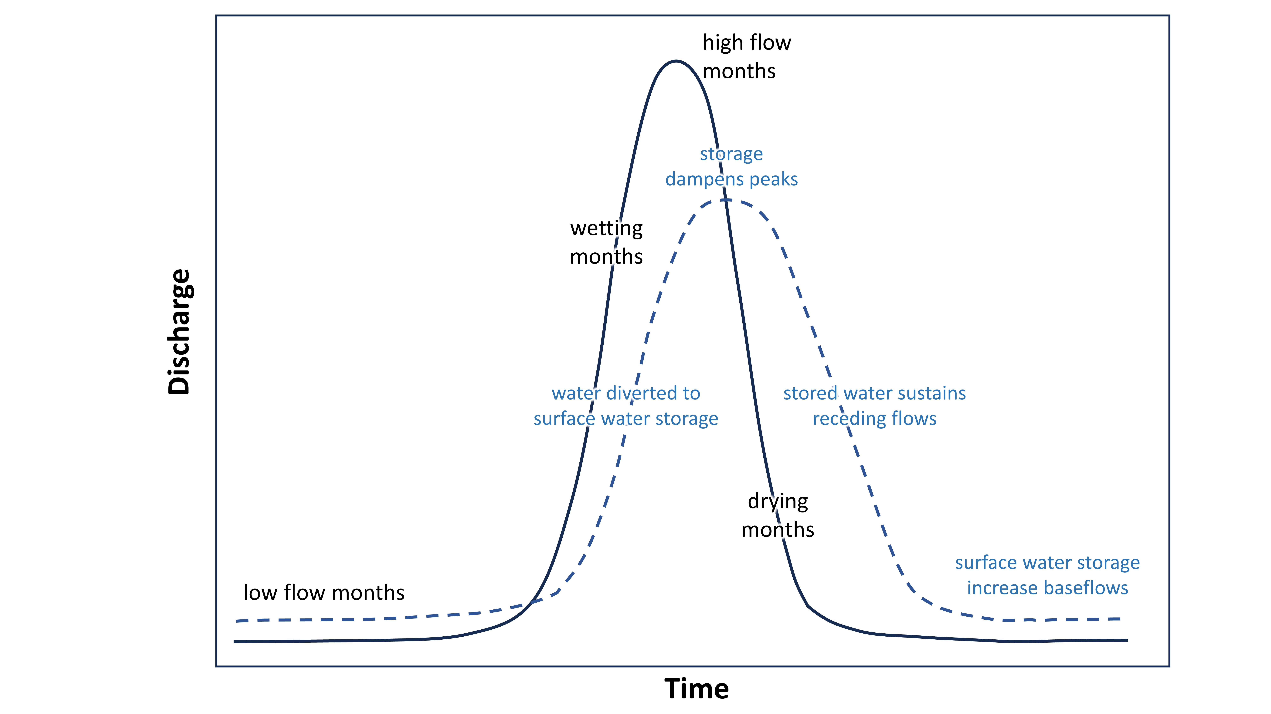
Figure 8. The potential impact of surface water storage, via wetlands, ponds, lakes and floodplains, on a theoretical annual hydrogaph, where the x-axis represents a single year, including wetting, high flow, drying, and low months. The solid and dashed lines represent watersheds with very little and an abundance of surface water storage, respectively.

4.3 Challenges and uncertainty in integrating SW_{storage} into models
Our analysis attempted to bypass some of the biggest challenges facing the integration of remotely sensed surface water into deep learning and hydrologic modeling, including differences in units, return intervals, and data gaps. To match the units of river discharge, we converted our time series of surface water extent (i.e., area over time) to SW_{storage} (i.e., volume over time). Most existing conversion approaches are not designed for diverse water body types. For instance wetland depressions are commonly targeted, but may miss water storage in a flat floodplain (e.g., Minke et al. 2010; Wu and Lane 2016; Bian et al. 2021). While the approach utilized here (Figure A1) enabled us to retain all surface water, including shallow and temporary water, our approach did not account for water level variability, which likely under-estimated our SW_{storage} dynamics. In the future, SWOT (Papa and Frappart 2021) may provide a mechanism to track changes in water level that could enhance the community’s capacity to monitor SW_{storage} dynamics.
Temporal resolution is also a challenge. Hydrologic models are commonly run at a daily or subdaily timestep (Devi et al. 2015), while satellites typically produce data at coarser timesteps, particularly after accounting for cloud or snow related data gaps. Consequently, prior efforts have more commonly used remotely sensed inundation indirectly for calibration, rather than ingesting the data into the model (e.g., Evenson et al. 2018). Interpolating our storage data to a daily timestep benefited the model setup, but introduced uncertainty, and could have amplified existing error within the surface water data. Further, surface water may influence discharge over timescales that are not best represented by a daily timestep.
Generating complete (spatially and temporally) datasets of SW_{storage} remains time and labor intensive. Alternatively, using time series of surface water extent, derived from existing Landsat-based global surface water products (e.g., Pekel et al. 2016; Pickens et al. 2019) would reduce processing time and help scale the inclusion of inundation variables in LSTM analyses. Most Landsat surface water products, however, will have significant data gaps during clouds and snow cover periods (Egorov et al. 2019). We, therefore, instead, prioritized a multi-sensor approach in this analysis to maximize inundation time series consistency as well as the inclusion of vegetated water. To characterize the potential difference between extent and storage, we correlated our time series of surface water extent in each watershed to the corresponding storage time series (Appendix A). We found a median±standard deviation Pearson correlation of R=0.88±0.12 with correlation values ranging from R=0.49 to R=0.98 across watersheds, suggesting that while generally extent was highly correlated with storage, the conversion induced greater changes in time series dynamics in some watersheds.
Further, since catchment characteristics are simple to generate and the MET+CC model represented the strongest model for nearly 30% of the watersheds, the inclusion of catchment characteristics that are correlated with surface water dynamics, like slope, depth to bedrock, or leaf area index, could be adequate, at least for watersheds where the MET+CC NSE exceeded the MET+SW NSE. Even so, while the inclusion of catchment characteristics can help an LSTM model watershed-based differences in discharge, dynamic datasets provide important data on temporal variability in watershed condition. Further, more direct proxies of surface water, like proportion floodplain or area of seasonal wetlands (Woznicki et al. 2019), could further improve the impact of catchment characteristics.
4.4 Challenges in deriving hydrologic processes from deep learning models like LSTMs
In a process-based hydrological model, calibrating to a new variable and comparing changes in predicted discharge can help determine the relevance of that variable (e.g., Rajib et al. 2018). In contrast, deep learning models, like LSTMs, have been shown to infer the influence of additional inputs, such as snow-water equivalent, without their explicit inclusion (Kratzert et al. 2019; Konapala et al. 2020). While this phenomenon makes deep learning models ideal for improving the accuracy of predicting river discharge (Nearing et al. 2020; Lees et al. 2022), it can also make it more difficult to quantify the importance of a newly introduced variable. For example, if every spring, snowmelt fills a river and the flood extent corresponds with the timing and magnitude of snowmelt, it is feasible that a deep learning model could infer the influence of flooding on discharge from meteorology, alone. Our multi-model approach was designed to help us infer the general influence of variable groups (e.g., meteorological data, catchment characteristics, and SW_{storage}), while bypassing some of the potential pitfalls of feature importance tests, like reduced importance for correlated variables (Gorski et al. 2024; Takefuji et al. 2025). However, the LSTMs may have been able to account for most floodplain dynamics using seasonal patterns in meteorology and catchment characteristics, like slope. In contrast, the LSTMs may have had less success “learning” the influence of non-floodplain SW_{storage}, so that its explicit inclusion helped represent a disconnect between meteorological forcings and discharge, at least in some watersheds.

5 Conclusions
In this effort, we leveraged multiple LSTM models with different variable combinations to test when and where the influence of SW_{storage} on discharge could be discerned. Since the included watersheds represented a wide range of storage capacity, adding SW_{storage} did not universally improve predictions of discharge. Also, as our watersheds were under-sampled in the northeastern U.S. and mountainous regions, our findings cannot be generalized to these regions. Still, adding SW_{storage} disproportionately benefited poorly performing watersheds, and improvements at the ecoregion scale were most consistent across ecoregions with a high density of lakes and depressional wetlands. Specifically adding SW_{storage} consistently improved predictions of discharge in the Prairie Pothole Region and consistently improved predictions during wetting months and low flow periods in the Northern Forests. Further, watersheds with a greater abundance of non-floodplain SW_{storage} and dynamics benefitted disproportionately from the inclusion of SW_{storage} in the LSTM models. Together, these findings suggest that non-floodplain wetlands may be contributing water during low flow conditions. Our findings have implications for guiding watershed management, including informing wetland and floodplain restoration efforts (Roni et al. 2019; Singh et al. 2019) and improving the resilience of river systems to current and future floods and droughts (Winsemius et al. 2016; Stewart et al. 2020).

Acknowledgments
We appreciate comments on earlier versions from Blake Schaeffer and Matthew Cashman. We also appreciate support from Jeremy Havens on graphics. Any use of trade, firm, or product names is for descriptive purposes only and does not imply endorsement by the U.S. Government. This publication represents the views of the authors and does not necessarily reflect the views or policies of the U.S. EPA.

Funding and Disclosure Statement
This research was funded by the U.S. Geological Survey’s National Land Imaging and Land Change Science Programs and the U.S. Environmental Protection Agency’s, Office of Research and Development through an interagency agreement (DW-014-92569201-0, “Multisource remote sensing to enhance national mapping of aquatic resources”). The authors have no relevant financial or non-financial conflicts of interests to disclose.

Data Availability Statement
The data unique to this publication is available in Vanderhoof et al. (2025). The LSTM models were trained using the NeuralHydrology package (Kratzert et al. 2022).

Author Contributions
Conceptualization: MKV, WK, WD, HED, CRL, JRC; Methodology: MKV, WK, WD, KS; Formal analysis and investigation: MKV, WK, WD, HED, CRL, JRC; Writing - original draft preparation: MKV; Writing - review and editing: WK, WD, HED, CRL, JRC, KS, AR; Funding acquisition: MKV, JRC.

References
Abatzoglou J.T. 2013. Development of gridded surface meteorological data for ecological applications and modelling. International Journal of Climatology, 33. https://doi.org/10.1002/joc.3413
Abatzoglou, J.T., Dobrowski, S.Z., Parks, S.A.,Hegewisch, K.C. 2018. TerraClimate, a high-resoluton global dataset of monthly climate and climatic water balance from 1958-2015. Scientific Data, 5, 170191. Abbaspour K C (2011). SWAT-CUP4: SWAT Calibration and Uncertainty Programs– A User Manual. Swiss Federal Institute of Aquatic Science and Technology, Switzerland.
Addor, N., Newman, A.J., Mizukami, N., Clark, M.P. 2017. The CAMELS data set: catchment attributes and meteorology for large-sample studies. Hydrology and Earth System Sciences, 21, 5293–313.
Adeli, S., Salehi, B., Mahdianpari, M., Quackenbush, L J., Brisco, B., Tamiminia, H., Shaw, S. 2020. Wetland monitoring using SAR data: A meta-analysis and comprehensive review. Remote Sensing, 12(14), 2190.
Allen, G.H., Yang, X., Gardner, J., Holliman, J., David, C.H., Ross, M. 2020. Timing of Landsat overpasses effectively capturing flow conditions of large rivers. Remote Sensing, 12(9), 1510.
Althoff, D., Rodrigues, L.N., da Silva, D.D. 2021. Addressing hydrological modeling in watersheds under land cover change with deep learning, Advances in Water Resources, 154, 103965.
Ameli, A.A., Creed, I.F. 2019. Does wetland location matter when managing wetlands for watershed-scale flood and drought resilience? Journal of the American Water Resources Association, 55, 529–42.
Barzegar, R., Aalami, M.T., Adamowski, J. 2021. Coupling a hybrid CNN-LSTM deep learning model with a boundary corrected maximal overlap discrete wavelet transform for multiscale lake water level forecasting, Journal of Hydrology, 598, 126196.
Beck, H.E., de Roo, A., van Dijk, A.I.J.M. 2015. Global maps of streamflow characteristics based on observations from several thousand catchments. Journal of Hydrometeorology, 16, 1478-1501.
Berghujs, W.R., Woods, R.A., Hutton, C.J., & Sivapalan, M. 2016. Dominant flood generating mechanisms across the United States. Geophysical Research Letters, 43, 4382-4390.
Beven, K. 2020. Deep learning, hydrological processes and the uniqueness of place. Hydrological Processes, 34, 3608–3613.
Bian, L., Melesse, A.M., Leon, A.S., Verma, V., Yin, Z. 2021. A deterministic topographic wetland index based on LiDAR-derived DEM for delineating open-water wetlands. Water, 13(8), 2487.
Blanchette, M., Rousseau, A.N., Foulon, É., Savary, S., Poulin, M. 2019. What would have been the impacts of wetlands on low flow support and high flow attenuation under steady state land cover conditions? Journal of Environmental Management, 234, 448–457.
Brooks, B.W., Lazorchak, J.M., Howard, M.D.A., Johnson, M.V.V., Morton, S.L., Perkins, D.A.K., Reavie, E.D., Scott, G.I., Smith, S.A., Steevens, J.A. 2016. Are harmful algal blooms becoming the greatest inland water quality threat to public health and aquatic ecosystems? Environmental Toxicology and Chemistry, 35(1), 6-13.
Budyko, M. 1958. The Heat Balance of the Earth’s Surface. Springer, Washington, D.C., USA.
Cowardin, L.M., Carter, F.C., & Golet, E.T. 1979. Classification of wetlands and deepwater habitats of the United States. United States Department of the Interior, Fish and Wildlife Service, Washington, D.C., USA.
Cohen, M.J., Creed, I.F., Alexander, L., Basu, N.B., Calhoun, A.J.K., Craft, C., D’Amico, E. et al. (2016). Do geographically isolated wetlands influence landscape functions. Proceedings of the National Academy of Science, 113(8), 1978-1986.
Devi, G.K., Ganasri, B.P., Dwarakish, G.S. 2015. A review on hydrological models. Aquatic Procedia, 4, 1001-1007.
Dixon, M. J.R., Loh, J., Davidson, N.C., Beltrame, C., Freeman, R., Walpole, M. 2016. Tracking global change in ecosystem area: The Wetland Extent Trends index. Biological Conservation, 193, 27-35.
Donnelly, J.P., Naugle, D.E., Collins, D.P., Dugger, B.D., Allred, B.W., Tack, J.D., Dreitz, V.J. 2019. Synchronizing conservation to seasonal wetland hydrology and waterbird migration in semi-arid landscapes. Ecosphere, 10(6), e02758.
Du, Y., Fan, J., Happonen, A., Paulraj, D., Tuape, M. 2024. Lake water level forecasting using LSTM and GRU: A deep learning approach. In: Arai, K. (eds) Proceedings of the Future Technologies Conference (FTC) 2024, Volume 3. FTC 2024. Lecture notes in networks and systems, vol 1156. Springer, Cham. https://doi.org/10.1007/978-3-031-73125-9_12.
Eamus, D., Hatton, T., Cook, P., Colvin, C. 2006. Ecohydrology: vegetation function, water and resource management, CSIRO Publishing, Australia, 360 pp.
Egorov, A.V., Roy, D.P., Zhang, H.K., Li, Z., Yan, L., Huang, H. 2019. Landsat 4, 5, and 7 (1982 to 2017) Analysis Ready Data (ARD) observation coverage over the conterminous United States and implications for terrestrial monitoring. Remote Sensing, 11(4), 447.
Evenson, G.R., Golden, H.E., Lane, C.R., D’Amico, E. 2015. Geographically isolated wetlands and watershed hydrology: A modified model analysis. Journal of Hydrology, 529, 240-256.
Evenson, G.R., Jones, C.N., McLaughlin, D.L., Golden, H.E., Lane, C.R. DeVries, B., Alexander, L.C., Lang, M.W., McCarty, G.W., Sharifi, A. 2018. A watershed-scale model for depressional wetland-rich landscapes. Journal of Hydrology X. 1, 100002.
Falcone, J. 2011. GAGES-II: Geospatial attributes of gages for evaluating streamflow. U.S. Geological Survey, Reston, Virginia, https://doi.org/10.5066/P96CPHOT. Fang, K., Kifer, D., Lawson, K.,Shen, C. 2020. Evaluating the potential and challenges of an uncertainty quantification method for Long Short-Term Memory models for soil moisture predictions, Water Resources Research, 56, e2020WR028095.
Fathy, I., Negm, A.M., El-Fiky, M., Nassar, M., Al-Sayed, E. 2015. Runoff hydrograph modeling for arid regions (case study: Wadi Sudr – Sinai). International Water Technology Journal, 5(1), 58-68.
Feng, D., Fang, K., Shen, C. 2020. Enhancing streamflow forecast and extracting insights using long‐short term memory networks with data integration at continental scales. Water Resources Research, 56, e2019WR026793.
Filippucci, P., Brocca, L., Bonafoni, S., Saltalippi, C., Wagner, W., Tarpanelli, A. 2022. Sentinel-2 high-resolution data for river discharge monitoring. Remote Sensing of Environment, 281, 113255.
Fluet-Chouinard, E., Stocker, B. D., Zhang, Z., Malhotra, A., Melton, J.R., Poulter, B., Kaplan, J. O., Goldewijk, K.K., Siebert, S., Minayeva, T., Hugelius, G., Joosten, H., Barthelmes, A., Prigent, C., Aires, F., Hoyt, A.M., Davidson, N., Finlayson, C.M., Lehner, B., Jackson, R. B., McIntyre, P.B. 2023. Extensive global wetland loss over the past three centuries. Nature, 614(7947), 281-286.
Fossey, M., Rousseau, A.N., Bensalma, F., Savary, S., Royer, A. 2015. Integrating isolated and riparian wetland modules in the PHYSITEL/HYDROTEL modelling platform: model performance and diagnosis. Hydrological Processes, 29(22), 4683-4702.
Fuentes, I., Padarian, J., Van Ogtrop, F., Vervoort, R. 2019. Spatiotemporal evaluation of inundated areas using MODIS imagery at a catchment scale. Journal of Hydrology, 573, 952-963.
Gesch, D., Oimoen, M., Greenlee, S., Nelson, C., Steuck, M., Tyler, D. 2002. The national elevation dataset. Photogrammetric Engineering and Remote Sensing, 68(1), 5–11.
Golden, H.E., Lane, C.R., Rajib, A., Wu, Q. 2021. Improving global flood and drought predictions: integrating non-floodplain wetlands into watershed hydrologic models. Environmental Research Letters, 16, 091002.
Gorski, G., Larsen, L., Wingenroth, J., Zhang, L., Bellugi, D., Appling, A.P. 2024. Stream nitrate dynamics driven primarily by discharge and watershed physical and soil characteristics at intensively monitored sites: Insights from deep learning. Water Resoures Research, 60(9), e2023WR036591.
Graf, W.L. 1999. Dam nation: A geographic census of American dams and their large-scale hydrologic impacts. Water Resources Research, 35(4), 1305-1311.
Griffith, G.E., Omernik, J.M., Woods, A.J. 1999. Ecoregions, watersheds, basins, and HUCs: How state and federal agencies frame water quality. Journal of Soil and Water Conservation, 54(4), 666-677.
Grimm, K., Chu, X. 2020. Depression threshold control proxy to improve HEC-HMS modeling of depression-dominated watersheds. Hydrological Science Journal, 65, 200–11.
Gupta, H.V., Kling, H., Yilmaz, K.K., Martinez, G.F. 2009. Decomposition of the mean squared error and NSE performance criteria: Implications for improving hydrological modelling. Journal of Hydrology, 377, 80–91.
Haag, K.H., Lee, TM., Herndon, D.C. 2005. Bathymetry and vegetation in isolated marsh and cypress wetlands in the northern Tampa Bay Area, 2000-2004. U.S. Geological Survey Scientific Investigations Report 2005-5109, 49 p.
Hayashi, M., van der Kamp, G. 2000. Simple equations to represent the volume-area-depth relations of shallow wetlands in small topographic depressions. Journal of Hydrology, 237(1-2), 74-85.
Hayashi, M., Rosenberry, D.O. 2002. Effects of ground water exchange on the hydrology and ecology of surface water. Groundwater, 40(3), 309-316.
Heimhuber, V., Tulbure, M., Broich, M. 2017. Modeling multidecadal surface water inundation dynamics and key drivers on large river basin scale using multiple time series of Earth-observation and river flow data. Water Resources Research, 53, 1251-1269.
Helton, A.M., Poole, G.C., Payn, R.A., Izurieta, C., Stanford, J.A. 201. Relative influences of the river channel, floodplain surface, and alluvial aquifer on simulated hydrologic residence time in a montane river floodplain. Geomorphology, 205, 17-26.Herbert, Z.C., Asghar, Z., Oroza, C.A. 2021. Long-term reservoir inflow forecasts: Enhanced water supply and inflow volume accuracy using deep learning, Journal of Hydrology, 601, 126676.
Hochreiter, S., Schmidhuber, J. 1997. LSTM can solve hard long time lag problems. Proceedings of Conference on Neural Information Processing Systems (Denver, CO), pp 473–9.
Homer, C., Dewitz, J., Jin, S., Xian, G., Costello, C., Danielson, P., Gass, L., Funk, M., Wickham, J., Stehman, S., Auch, R., Riiters, K. 2020. Conterminous United States land cover change patterns 2001-2016 from the 2016 National Land Cover Database. ISPRS Journal of Photogrammetry and Remote Sensing, 162, 184-199.
Hou, J., van Dijk, A., Beck, H. 2020. Global satellite-based river gauging and the influence of river morphology on its application. Remote Sensing of Environment, 239, 1-17.
Hunt, K.M.R., Matthews, G.R., Pappenberger, F., Prudhomme, C. 2022. Using a long short-term memory (LSTM) neural network to boost river streamflow forecasts over the western United States. Hydrology and Earth System Sciences, 26, 5449–5472.
Jibril, M.M., Bello, A., Aminu, I.I., Ibrahim, A.S., Bashir, A., Malami, S.I., Habibu, M.A., Magaji, M.M. 2022. An overview of streamflow prediction using random forest algorithm. GSC Advanced Research and Reviews, 13(1), 50-57.
Jones, J.W. 2019. Improved automated detection of subpixel-scale inundation—revised Dynamic Surface Water Extent (DSWE) partial surface water tests. Remote Sensing, 11, 374.
Khazaei, B., Read, L.K., Casali, M., Sampson, K.M., & Yates, D.N. 2022. GLOBathy, the global lakes bathymetry dataset. Scientific Data, 9, 36.
Kling, H., Fuchs, M., Paulin, M. 2012. Runoff conditions in the upper Danube basin under an ensemble of climate change scenarios. Journal of Hydrology, 424, 264–277. Klotz, D., Kratzert, F., Gauch, M., Sampson, A.K., Brandstetter, J., Klambauer, G., Hochreiter, S., Nearing, G. 2022. Uncertainty estimation with deep learning for rainfall-runoff modeling. Hydrology and Earth System Sciences, 26(6), 1673-1693.
Knoben, W.J.M., Freer, J.E., Woods, R.A. 2019. Technical note: Inherent benchmark or not? Comparing Nash–Sutcliffe and Kling–Gupta efficiency scores. Hydrology and Earth System Sciences, 23, 4323–4331.
Konapala, G., Kao, S.C., Painter, S.L., Lu, D. 2020. Machine learning assisted hybrid models can improve streamflow simulation in diverse catchments across the conterminous US. Environmental Research Letters, 15, 104022.
Kratzert, F., Klotz, D., Herrnegger, M., Sampson, A.K., Hochreiter, S., Nearing, G.S. 2019. Toward improved predictions in ungauged basins: Exploiting the power of machine learning. Water Resources Research, 55, 11344–11354.
Kratzert, F., Klotz, D., Brenner, C., Schulz, K., Herrnegger, M. 2018. Rainfall-runoff modelling using long short-term memory (lstm) networks. Hydrology and Earth System Sciences, 22, 6005–6022.
Kratzert, F., Gauch, M., Nearing, G., Klotz, D. 2022. Neuralhydrology–a python library for deep learning research in hydrology. Journal of Open Source Software, 7, 4050.
Kratzert, F., Gauch, M., Klotz, D., Nearing, G. 2024. HESS Opinions: Never train a Long Short-Term Memory (LSTM) network on a single basin. Hydrology and Earth System Sciences, 28, 4187-4201.
Kuppel, S., Houspanossian, J., Nosetto, M.D., Jobbágy, E.G. 2015. What does it take to flood the Pampas? Lessons from a decade of strong hydrological fluctuations. Water Resources Research, 51, 2937–2950.
Lane, C.R., Leibowitz, S.G., Autrey, B.C., LeDuc, S.D., Alexander, L.C. (2018). Hydrological, physical, and chemical functions and connectivity of non-floodplain wetlands to downstream waters: a review. Journal of the American Water Resources Association, 54(2), 346-371.
Lang, L., Gao, X., Li, Y., Li, Z., Wu, F. 2025. Incorporating multi-timescale data into a single long short-term memory network to enhance reservoir-regulated streamflow simulation. Journal of Hydrology, 654, 132806.
Lee, S., Yeo, I.Y., Lang, M.W., Sadeghi, A.M., McCarty, G.W., Moglen, G.E., Evenson, G.R. (2018). Assessing the cumulative impacts of geographically isolated wetlands on watershed hydrology using the SWAT model coupled with improved wetland modules. Journal of Environmental Management, 223, 37-48.
Lees, T., Reece, S., Kratzert, F., Koltz, D., Gauch, M., De Bruijn, J., Sahu, R.K., Greve, P., Slater, L., Dadson, S.J. 2022. Hydrological concept formation inside long short-term memory (LSTM) networks. Hydrology and Earth System Sciences, 26, 3079-3101.
Ley, A., Bormann, H., Casper, M. 2024. Linking explainable artificial intelligence and soil moisture dynamics in a machine learning streamflow model. Hydrology Research, 55(6), 613-627.
Li, W., Huang, C., Yang, Y., Liu, Z., Qing, G. 2025. Evaluation of deep learning models applied to reservoir outflow prediction under extreme flood events. Hydrological Sciences Journal, https:doi.org/10.1089/02626667.2025.2537204.
Lindsay, J.B., Creed, I.F. 2006. Distinguishing between artefact and real depressions in digital elevation data. Computers and Geosciences, 32(8): 1192-1204.
Lindsay, J.B., Dhun, K. 2015. Modelling surface drainage patterns in altered landscapes using LiDAR. International Journal of Geographic Information Science, 29(3), 397-411.
Ma, K., Feng, D., Lawson, Tsai, W.P., Liang, C., Huang, X., Sharma, A., Shen, C. 2021. Transferring hydrologic data across continents – leveraging data-rich regions to improve hydrologic prediction in data-sparse regions. Water Resources Research, 57(5), e2020WR028600.
Mahoney, D.T., Christensen, J.R., Golden, H.E., Lane, C.R., Evenson, G.R., White, E., Fritz, K.M., D’Amico, E., Barton, C.D., Williamson, T.N., Sena, K.L., Agouridis, C.T. 2023. Dynamics of streamflow permanence in a headwater network: Insights from catchment-scale model simulations. Journal of Hydrology, 620, part A, 129422.
Maier, H.R., Galelli, S., Razavi, S., Castelletti, A., Rizzoli, A., Athanasiadis, I.N., Sànchez-Marrè, M., Acutis, M., Wu, W., Humphrey, G.B. 2023. Exploding the myths: An introduction to artificial neural networks for prediction and forecasting. Environmental Modelling & Software, 167, 105776.
McLaughlin, D.L., Kaplan, D.A., Cohen, M.J. 2014. A significant nexus: geographically isolated wetlands influence landscape hydrology. Water Resources Research, 50, 7153–66.
Mengen, D., Ottinger, M., Leinenkugel, P., Ribbe, L. 2020. Modeling river discharge using automated river width measurements derived from Sentinel-1 time series. Remote Sensing, 12(19), 3236.
Minke, A.G., Westbrook, C.J., van der Kamp, G. 2010. Simplified volume-area-depth method for estimating water storage of prairie potholes. Wetlands, 30, 541-551.
Moriasi, D.N., Gitau, M.W., Pai, N., Daggupati, P. 2015. Hydrologic and water quality models: performance measures and evaluation criteria. Transactions of the ASABE, 58(6), 1763-1785.
Mu, Q., Zhao, M., Running, S.W. 2014. MODIS Global Terrestrial Evapotranspiration (ET) Product MOD16A2 Collection 5, University of Montana, Missoula, MT.
National Atlas of the United States. 2006. Major Dams of the United States, Puerto Rico and the US Virgin Islands. Delivered by ArcGIS online (last accessed August 16, 2024).
Newman, A., Sampson, K., Clark, M., Bock, A., Viger, R.J., Blodgett, D. 2014. A large-sample watershed-scale hydrometeorological dataset for the contiguous USA. UCAR/NCAR, Boulder, CO, https://dx.doi.org/10.5065/D6MW2F4D.
Nilsson, K.A., Rains, M.C., Lewis, D.B., Trout, K.E. 2013. Hydrologic characterization of 56 geographically isolated wetlands in west-central Florida using a probabilistic method. Wetland Ecology and Management, 21, 1-14.
Omernik, J.M., Griffith, G.E. 2014. Ecoregions of the conterminous United States: Evolution of a hierarchical spatial framework. Environmental Management, 54(6), 1249-1266.
Ouyang, W., Lawson, K., Feng, D., Ye, L., Zhang, C., Shen, C. 2021. Continental-scale streamflow modeling of basins with reservoirs: Towards a coherent deep-learning-based strategy, Journal of Hydrology, 599, 126455.
Papa, F., Frappart, F. 2021. Observations: A review of current advances and future opportunities for hydrological sciences. Remote Sensing, 13(20), 4162.
Pekel, J., Cottam, A., Gorelick, N., Belward, A. 2016. High-resolution mapping of global surface water and its long-term changes. Nature, 540, 418-436.
Pervez, M.S., Brown, J.F. 2010. Mapping irrigated lands at 250-m scale by merging MODIS data and National Agricultural Statistics. Remote Sensing, 2(10), 2388-2412.
Pickens, A., Hansen, M., Hancher, M., Stehman, S., Tyukavina, A., Potapov, P., Marroquin, B., Sherani, Z. 2020. Mapping and sampling to characterize global inland water dynamics from 1999 to 2018 with full Landsat time-series. Remote Sensing of Environment, 243, 111792.
Pilgrim, D.H., Cordery, I., Baron, B.C. 198. Effects of catchment size on runoff relationships. Journal of Hydrology, 58(3-4), 205-221.
Rajib, A., Merwade, V., Yu, Z. 2018. Rationale and efficacy of assimilating remotely sensed potential evapotranspiration for reduced uncertainty of hydrologic models. Water Resources Research, 54(7), 4615-4637.
Rajib, A., Golden, H.E., Lane, C.R., Wu, Q. 2020. Surface depression and wetland water storage improves major river basin hydrologic predictions. Water Resources Research, 56, e2019WR026561.
Rains, M.C., Leibowitz, S.G., Cohen, M.J., Creed, I.F., Golden, H.E., Jawitz, J.W., Kalla, P., Lane, C.R., Lang, M.W., McLaughlin, D.L. 2016. Geographically isolated wetlands are part of the hydrological landscape. Hydrological Processes, 30(1), 153–160.
Raulings, E.J., Morris, K., Roache, M.C., Boon, P.I. 2010. The importance of water regimes operating at small spatial scales for the diversity and structure of wetland vegetation. Freshwater Biology, 55(3), 701-715.
Roni, P., Hall, J.E., Drenner, S.M., Arterburn, D. 2019. Monitoring the effectiveness of floodplain habitat restoration: A review of methods and recommendations for future monitoring. WIREs Water, 6(4), e1355.
Schieder, N.W., Walters, D.C., Kirwan, M.L. 2018. Massive upland to wetland conversion compensated for historical marsh loss in Chesapeake Bay, USA. Estuaries. and Coasts, 41(4), 940-951.
Scott, D.T., Gomez-Velez, J.D., Jones, C.N., Harvey, J.W. 2019. Floodplain inundation spectrum across the United States, Nature Communications, 10, 5194.
Seiller, G., Hajji, I., Anctil, F. 2015. Improved the temporal transposability of lumped hydrological models on twenty diversified U.S. watersheds. Journal of Hydrology: Regional Studies, 3, 379-399.
Shaw, D.A., Vanderkamp, G., Conly, FM., Pietroniro, A., Martz, L. 2012. The fill-spill hydrology of prairie wetland complexes during drought and deluge, Hydrological Processes, 26, 3147–3156.
Singh, N.K., Gourevitch, J.D., Wemple, B.C., Watson, K.B., Rizzo, D.M., Polasky, S., Ricketts, T.H. 2019. Optimizing wetland restoration to improve water quality at a regional scale. Environmental Research Letters, 14(6), 064006.
Slater, L.J., Villarini, G. 2017. Evaluating the drivers of seasonal streamflow in the U.S. Midwest. Water, 9, 695.
Soulard, C., Waller, E., Walker, J., Petrakis, R., Smith, B. 2022. DSWEMOD – The production of high-frequency surface water map composites from daily MODIS images. Journal of the American Water Resources Association, 58(2), 248-268.
Stepchinski, L.M., Rains, M.C., Lee, L.C., Lis, R.A., Nutter, W.L., Rains, K.C., Stewart, S.R. 2023. Hydrologic connectivity and flow generation from California vernal pool, swale, and headwater stream complexes to downstream waters. Wetlands, 43, 34.
Stewart, I.T., Rogers, J., Graham, A. 2020. Water security under severe drought and climate change: Disparate impacts of the recent severe drought on environmental flows and water supplies in Central California, Journal of Hydrology X, 7, 100054.
Stoker, J., Miller, B. 2022. The accuracy and consistency of 3D elevation program data: A systematic analysis. Remote Sensing, 14(4), 940.
Takefuji, Y. 2025. Challenges in feature importance interpretation: Analyzing LSTM-NN predictions in battery material flotation. Journal of Industrial Information Integration, 45, 100809.
Tandon, K., Sen, S. 2024. A probabilistic integration of LSTM and Gaussian process regression for uncertainty-aware reservoir water level predictions. Hydrological Sciences Journal, 70(1), 144-161.
Tang, S., Sun, F., Liu, W., Wang, H., Feng, Y., & Li, Z. 2023. Optimal postprocessing strategies with LSTM for global streamflow prediction in ungauged basins. Water Resources Research, 59(7), e2022WR034352.
Thornton, M.M., Shrestha, R., Wei, Y., Thornton, P.E., Kao, S-C., Wilson, B.E. 2022. Daymet: Daily Surface Weather Data on a 1-km Grid for North America, Version 4 R1. ORNL DAAC, Oak Ridge, Tennessee, USA. https://doi.org/10.3334/ORNLDAAC/2129
Tourian, M.J., Schwatke, C., Sneeuw, N. 2017. River discharge estimation at daily resolution from satellite altimetry over an entire river basin. Journal of Hydrology, 546, 230-247.
Tran, H., Zhou, T., Tan, Z., Fang, Y., Leung, L.R. 2025. Improving the prediction of daily reservoir releases over the CONUS using conditioned LSTM. Journal of Hydrology, 661(part C), 133750.
Trancoso, R., Phinn, S., McVicar, T.R., Larsen, J.R., McAlpine, C.A. 2016. Regional variation in streamflow drivers across a continental climatic gradient. Ecohydrology, 10, e1816.
U.S. Army Corps of Engineers (USACE) 2009. National inventory of dams. Army Corps of Engineers, Federal Emergency Management Agency, Washington, D.C.
U.S. Fish & Wildlife Service 2018. National Wetlands Inventory. U.S. Fish & Wildlife Service, Falls Church, VA, https://data.nal.usda.gov/dataset/national-wetlands-inventory. (Last accessed August 17, 2024).
U.S. Geological Survey 2022. USGS TNM Hydrography (NHD). U.S. Geological Survey, Reston, VA, https://apps.nationalmap.gov/services/ (Last accessed August 4, 2024).
Valayamkunnath, P., Barlage, M., Chen, F., Gochis, D.J., Franz, K.J. 2020. Mapping of 30-meter resolution time-drained croplands using a geospatial modeling approach. Scientific Data, 7, 257.
Van Asselen, S., Verburg, P.H., Vermaat, J.E., Janse, J.H. 2013. Drivers of wetland conversion: A global meta-analysis. PLoS One, 8, e81292.
Van Dijk, A., Brakenridge, G., Kettner, A., Beck, H., De Groeve, T., Schellekens, J. 2016. River gauging at global scale using optical and passive microwave remote sensing. Water Resources Research, 52, 6404-6418.
Vanderhoof, M.K., Alexander, L.C., Todd, M.J. 2016. Temporal and spatial patterns of wetland extent influence variability of surface water connectivity in the Prairie Pothole Region, United States. Landscape Ecology, 31(4), 805-824.
Vanderhoof, M.K., Alexander, L., Christensen, J., Solvik, K., Nieuwlandt, P., Sagehorn, M. 2023. High-frequency time series comparison of Sentinel-1 and Sentinel-2 for open and vegetated water across the United States (2017-2021). Remote Sensing of Environment, 288, 113498.
Vanderhoof, M.K., Christensen, J.R., Alexander, L.C., Lane, C.R., Golden, H.E. 2024. Climate change will impact surface water extents across the central United States. Earth’s Future, 12(2), e2023EF004106.
Vanderhoof, M.K., Keenan, W., Dolan, W. 2025. Data release of surface water storage time series (2016-2023): U.S. Geological Survey, https://doi.org/10.5066/P14WYWSY.Vinokić, L., Dotlić, M., Prodanović, V., Kolaković, S., Simonovic, S.P., Stojković, M. 2025. Effectiveness of three machine learning models for prediction of daily streamflow and uncertainty assessment, Water Research X, 27, 100297.
Vishwakarma, B.D., Devaraju, B., Sneeuw, N. 201. What is the spatial resolution of GRACE satellite products for hydrology? Remote Sensing, 10(6), 852.
Wasko, C., Sharma, A. 2017. Global assessment of flood and storm extremes with increased temperatures. Scientific Reports, 7, 7945.
Wilbrand, K., Taormina, R., ten Veldhuis, M. C., Visser, M., Hrachowitz, M., Nuttall, J., Dahm, R. 2023. Predicting streamflow with LSTM networks using global datasets. Frontiers in Water, 5, 1166124.
Winsemius, H.C., Aerts, J.C.J.H., van Beek, L.P.H., Bierkens, M.F.P., Bouwman, A., Jongman, B., Kwadijk, J.C.J., Ligtvoet, W., Lucas, P.L., van Vuuren, D.P., Ward, P.J. 2016. Global drivers of future river flood risk. Nature Climate Change, 6, 381-385.
Woznicki, SA., Baynes, J., Panlasigui, S., Mehaffey, M., Neale, A. 2019. Development of a spatially complete floodplain map of the conterminous United States using random forest. Science of the Total Environment, 647, 942-953.
Wu, Q., Lane, C. R. 2016. Delineation and quantification of wetland depressions in the Prairie Pothole Region of North America. Wetlands, 36(2), 215-227.
Wu, S., Zhao, J., Wang, H., Sivapalan, M. 2021. Regional patterns and physical controls of streamflow generation across the conterminous United States. Water Resources Research, 57(6), e2020WR028086.
Wu, Y., Zhang, G., Rousseau, A.N., Xu, Y.J., Foulon, E. 2020. On how wetlands can provide flood resilience in a large river basin: a case study in Nenjiang river Basin, China. Journal of Hydrology, 587, 125012.
Xiao, Y., Wang, G., Zhao, H., Wang, J., Qiao, B. 2023. Estimation of lake storage based on the surrounding topography around the lake from the SRTM DEM. Water, 15(6), 1015.
Xiang, Z., Yan, J., Demir, I. 2020. A rainfall-runoff model with LSTM-based sequence-to-sequence learning. Water Resources Research, 56(1), e2019WR025326.
Xie, J., Liu, X., Tian, W., Wang, K., Bai, P., Liu, C. 2022. Estimating gridded monthly baseflow from 1981 to 2020 for the contiguous US using long short-term memory (LSTM) networks. Water Resources Research, 58, e2021WR031663.
Yang, W., Tan, B., Huang, D., Rautiainen, M., Shabanov, N.V., Wang, Y., Privette, J.L., Huemmrich, K.F., Fensholt, R., Sandholt, I., Weiss, M., Ahl, D.E., Gower, S.T., Nemani, R.R., Knyazikhin, Y., Myneni, R.B. 2006. MODIS leaf area index products: From validation to algorithm improvement. IEEE Transactions in Geoscience Remote Sensing, 44, 1885–1898.
Yang, X., Qin, Q., Yesou, H., Ledauphin, T., Koehl, M., Grussenmeyer, P., Zhu, Z. 2020. Monthly estimation of the surface water extent in France at a 10-m resolution using Sentinel-2 data. Remote Sensing of Environment, 244, 111803.
Yao, S., Chen, C., Chen, Q., Zhang, J., He, M. 2023. Combining process-based model and machine learning to predict hydrological regimes in floodplain wetlands under climate change, Journal of Hydrology, 626 (part A), 130193.
Yeo, I., Lee, S., Lang, M.W., Yetemen, O., McCarty, G.W., Sadeghi, A.M., Evenson, G. 2019. Mapping landscape-level hydrological connectivity of headwater wetlands to downstream waters: A catchment modeling approach – Part 2. Science of the Total Environment, 653, 1557-1570.
Yu, Q., Tolson, B.A., Shen, H., Han, M., Mai, J., Lin, J. 2024. Enhancing long short-term memory (LSTM)-based streamflow prediction with a spatially distributed approach, Hydrology and Earth System Sciences, 28(9), 2107-2122.
Zeng, L., Shao, J. Chu, X. 2020. Improved hydrologic modeling for depression-dominated areas. Journal of Hydrology, 590, 125269.
Zimba, H., Kawawa, B., Chabala, A., Phiri, W., Selsam, P., Meinhardt, M., Nyambe, I. 2018. Assessment of trends in inundation extent in the Barotse Floodplain, upper Zambezi River Basin: A remote sensing-based approach. Journal of Hydrology: Regional Studies, 15, 149-170.
Zhang, Q., Zhan, C., Wang, Y., Zhang, H., Lin, Z. 2023. A coupled model applied to complex river-lake systems. Hydrological Sciences Journal, 69(1), 95-105.

Figure Captions
Figure 1. Selected U.S. Geological Survey (USGS) gaged watersheds (blue polygons) in relation to median aridity (2016-2023), where increased aridity is indicated in yellow. Black lines encompass the labeled ecoregions. A histogram equalize stretch was applied to present the aridity data.
Figure 2. Catchment characteristics including (a) annual precipitation, (b) maximum monthly leaf area index, (c) percent sand, (d) percent slope, (e) total floodplain surface water, and (f) total non-floodplain surface water.
Figure 3. Flowchart showing data processing and analysis including the development of the surface water extent and surface water storage time series, as well as the development of the Long Short-Term Memory models. USGS: United States Geological Survey, NHD: National Hydrography Dataset, MET: meteorological data; NA: not available
Figure 4. The relative performance of the Long Short-Term Memory discharge models (M) using (a) the Nash-Sutcliffe Efficiency (NSE) and (b) Kling-Gupta Efficiency (KGE), with the exclusion and inclusion of surface water storage time series (SW) and catchment characteristics (CC) and median and first quartile values shown. (c) The ordered distribution of NSE values by model, and (d) the median NSE with increasing epochs. MET: meteorological data
Figure 5. Per basin Nash-Sutcliffe Efficiency (NSE) for (a) the meteorology-only model (MET), (b) no surface water (SW), with catchment characteristics (CC) (MET+CC), (c) surface water but no catchment characteristics (MET+SW), (d) surface water and catchment characteristics (ALL), (e) change from adding surface water, and (f) change from adding surface water with catchment characteristics.
Figure 6. The (a) contribution of meteorological (MET) forcings to the Nash-Sutcliffe Efficiency (NSE) relative to the best performing model for each watershed, individually, (b) the contribution of surface water (SW) to the NSE in the MET+SW model, and (c) the contribution of SW to NSE within the ALL model.
Figure 7. (a) The model showing the highest Nash-Sutcliffe Efficiency (NSE) for each watershed, and examples of surface water (SW) extent and persistence within (b) Idaho, (c) North Dakota, (d) Iowa, and (e) Arkansas, where the number indicates the U.S. Geological Survey’s gage identifer. CC: catchment characteristics, MET: meteorological data only, ALL: meteorological, surface water and catchment characteristics
Figure 8. The potential impact of surface water storage, via wetlands, ponds, lakes and floodplains, on a theoretical annual hydrogaph, where the x-axis represents a single year, including wetting, high flow, drying, and low months. The solid and dashed lines represent watersheds with very little and an abundance of surface water storage, respectively.

Appendix A
Post-processing of surface water time series
To limit commission error in the surface water time series and further reduce between sensor classification discrepancies, a water mask, defined as the maximum allowable surface water extent, was manually derived for each watershed, and applied across the time series (Vanderhoof et al. 2024). To generate each water mask, the Sentinel-1 open water and vegetated water, and Sentinel-2 open water, and vegetated water percentile rasters, defined as the percent of time a pixel was mapped as open or vegetated water, respectively, were manually reviewed for each watershed. Percentile thresholds were selected (Table A3), below which the frequency of erroneous water pixels visually exceeded the frequency of correctly classified water pixels. We used ancillary data, including the NWI dataset (USFWS 2019), land cover (Homer et al. 2020), and base map imagery, delivered through ArcMap, to provide additional information on the likelihood of surface water occurring in a location. The spatial extent where water pixels were retained was defined as pixels located within the 100-year floodplain (Woznicki et al. 2019), to account for short-term flood events, or pixels where the water percentile was greater than the selected threshold in any of the four percentile rasters (Table A3, Figure 2). Pixels classified as water outside of the water mask were reclassified as non-water.
In-stream surface water was also excluded from the analysis. In-stream surface water was defined as the National Hydrography Dataset (NHD) high-resolution flowlines (USGS, 2022) classified as either perennial or a named artificial path, where artificial path was a common classification for rivers, and converted to a 20 m raster resolution to match the spatial resolution of the surface water extent data. As we limited watershed size, wide rivers were not common. Surface water extent intersecting the in-stream surface water was masked out.
Following the gap-filling, 1.6% of the observations, where an observation refers to a single timestep for a watershed, were visually identified as incompletely gap-filled or having unacceptable levels of omission or commission error. Of these observations, 52% occurred in January 2016 or February 2016 (70% occurred in 2016 before the launch of Sentinel-2B), where limited observations resulted in unfilled data. In the January-February 2016 cases, total surface water extent from the same timestep in 2017 was used as a fill value. The remaining anomalous observations were replaced with the total surface water extent value from t-1 and t+1.
To evaluate the influence of the storage conversion on the time series dynamics, the gap-filled surface water extent time series were correlated with the surface water storage time series, per watershed, at a 2-week timestep (2016-2023) using Pearson correlation.

LSTM algorithm

The NeuralHydrology CudaLSTM model class at each time-step requires, (1) x[t], the value at time t, (2) h[t-1], the hidden state value from the previous time step, and (3) c[t-1], the memory cell value from the previous time step. Given an input sequence $x$ = [$x$[1],…., $x$[T]] with a total of T time steps, where each element $x$[t] is a vector containing the input features or model inputs at time step t (1 ≤ t ≤ T), these equations characterize a forward pass through the LSTM:
$i\left[t\right]= σ(W_{i}x\left[t\right]+U_{i}h\left[t-1\right]+b_{i},$ [6]
$f[t] = σ(W_{f}x\left[t\right]+U_{f}h\left[t-1\right]+b_{f},$ [7]
$g[t] = tanh(W_{g}x\left[t\right]+U_{g}h\left[t-1\right]+b_{g},$ [8]
$o[t] = σ(W_{o}x\left[t\right]+U_{o}h\left[t-1\right]+b_{o},$ [9]
$c[t] = f[t]⊙l c[t-1] + i[t] ⊙ g[t],$ [10]
$h[t] = o[t]⊙$ tanh(c[t]), [11]
where i[t] is the input gate, f[t] is the forget gate, g[t] is the cell input, o[t] is the output gate, and x[t] is the network values at time step t (1 ≤ t ≤ T), where the length of T is determined by the input sequence length. Further, h[t−1] is the hidden state and, c[t−1] the cell state from the previous time step. In the first-time step, the hidden and cell states are initialized as a vector of zeros. W, U, and b are learnable parameters for each gate, where subscripts indicate which gate the specific weight matrix or vector is applied to. The equations also utilize sigmoid functions (σ), hyperbolic tangent functions (tanh), and element-wise multiplication (⊙). The cell states (c[t]) characterize the memory of the system. The cell states can get modified by the forget gate (f[t]), which can delete states, and the input gate (i[t]) and cell update ($g$[t]), which can add new information. In the latter scenario, the cell update is the information that is added and the input gate controls into which cells the new information is added. Lastly, the output gate (o[t]) controls which information, stored in the cell states, is outputted.

Table A1. The study area watershed characteristics by ecoregion. The Palmer Drought Severity Index (PDSI) rank percentiles for 2016-2023 is shown relative to 1980-2023. Consolidated land cover types (>20%) from the 2019 National Land Cover Database (NLCD) are shown. Agriculture represents cultivated crops and hay/pasture, forest represents deciduous, evergreen and mixed forest, water and wetlands represents open water, forested and emergent herbaceous wetlands, and developed represents open space, low, medium and high-density development. Stream density is derived from the high-resolution National Hydrography Dataset. NWI: National Wetland Inventory
Ecoregion | Stream density (m km²) | NWI (% of area) | Floodplain (% of area) | PDSI (min, %) | PDSI (max, %) | PDSI (median, %) | Land cover (%)
Mid-Atlantic | 1439.2 | 8.5 | 6.8 | 13.7 | 100.0 | 65.6 | agriculture (46%), forest (30%), developed (18%)
Southern Coastal Plains | 1442.0 | 18.0 | 13.7 | 20.7 | 98.9 | 69.0 | forest (29%), water and wetlands (27%), agriculture (26%)
South-Central Plains | 1734.4 | 8.1 | 18.3 | 12.4 | 99.1 | 70.3 | forest (37%), agriculture (34%)
Great Plains | 1571.2 | 3.2 | 11.7 | 8.3 | 99.1 | 66.4 | agriculture (71%)
Northern Forests | 662.2 | 30.5 | 8.0 | 5.3 | 100.0 | 67.3 | water and wetlands (36%), agriculture (32%), forest (26.7%)
Prairie Pothole Region | 754.2 | 9.3 | 6.0 | 4.9 | 99.8 | 61.5 | agriculture (75%)
Middle Rockies | 1507.7 | 2.9 | 3.7 | 0.9 | 95.7 | 53.6 | grassland/shrub-scrub (60%), forest (29%)
Northwest | 2167.9 | 4.8 | 6.7 | 0.0 | 89.5 | 34.7 | grassland/shrub-scrub (49%), forest (40%)
Southwest | 1992.1 | 1.6 | 4.7 | 0.3 | 92.8 | 45.8 | grassland/shrub-scrub (74%), forest (22%)

Table A2. Spearman correlation values between surface water (SW) variables evaluated and catchment characteristics included. Significant (p<0.05) correlations, with the Bonferonni correction applied, are shown in bold. Non-floodplain (NFP) variables and correlations are shaded gray. FP: floodplain, MAM: spring, JJA: summer, SP and P: semi-permanent and permanent
Catchment Characteristics | SW storage (median, FP) | SW storage (median, NFP) | SW storage (std dev, FP) | SW storage (std dev, NFP) | MAM - JJA change in SW storage (FP) | MAM - JJA change in SW storage (NFP) | Temp Inun extent (FP) | Temp Inun extent (NFP) | Seasonal Inund extent (FP) | Seasonal Inun extent (NFP) | SP and P Inun extent (FP) | SP and P Inun extent (NFP)
Area | 0.44 | 0.38 | 0.47 | 0.38 | 0.26 | 0.24 | -0.01 | 0.05 | 0.05 | 0.02 | 0.14 | 0.05
Elevation | -0.07 | -0.12 | -0.20 | -0.20 | -0.23 | -0.20 | -0.42 | -0.51 | -0.8 | -0.55 | -0.45 | -0.35
Slope | -0.49 | -0.66 | -0.46 | -0.71 | -0.33 | -0.68 | 0.02 | -0.3 | -0.55 | -0.76 | -0.63 | -0.75
Developed cover | 0.04 | 0.02 | 0.11 | 0.08 | 0.12 | 0.02 | 0.40 | 0.33 | 0.60 | 0.29 | 0.25 | 0.05
Agriculture cover | 0.29 | 0.36 | 0.24 | 0.42 | 0.14 | 0.34 | 0.24 | 0.12 | 0.39 | 0.33 | 0.18 | 0.19
Forest cover | -0.16 | -0.19 | -0.10 | -0.23 | 0.04 | -0.15 | -0.06 | 0.32 | 0.07 | 0.02 | 0.06 | 0.03
Irrigated agriculture | 0.05 | -0.01 | 0.12 | -0.10 | 0.24 | 0.00 | 0.04 | -0.24 | 0.03 | -0.09 | 0.12 | 0.05
Tile drained agriculture | 0.23 | 0.33 | 0.23 | 0.44 | 0.09 | 0.37 | 0.15 | 0.26 | 0.36 | 0.40 | 0.20 | 0.17
Leaf Area Index (max) | 0.33 | 0.49 | 0.34 | 0.55 | 0.3 | 0.53 | -0.17 | 0.61 | 0.48 | 0.69 | 0.53 | 0.57
Leaf Area Index (diff) | 0.40 | 0.57 | 0.32 | 0.64 | 0.26 | 0.60 | -0.21 | 0.49 | 0.33 | 0.61 | 0.41 | 0.49
Number of dams | 0.18 | 0.13 | 0.07 | 0.05 | -0.06 | -0.02 | 0.00 | 0.14 | -0.09 | -0.02 | 0.02 | -0.01
Dam storage | 0.42 | 0.26 | 0.34 | 0.19 | 0.21 | 0.18 | 0.06 | 0.37 | 0.12 | 0.20 | 0.37 | 0.24
Distance from dams to gage | 0.35 | 0.34 | 0.45 | 0.38 | 0.28 | 0.23 | 0.12 | 0.06 | 0.28 | 0.15 | 0.25 | 0.13
Depth to bedrock | 0.49 | 0.63 | 0.46 | 0.66 | 0.34 | 0.57 | -0.12 | 0.33 | 0.49 | 0.71 | 0.66 | 0.69
Rainfall and Runoff Factor | 0.08 | 0.06 | 0.22 | 0.15 | 0.21 | 0.09 | 0.49 | 0.47 | 0.80 | 0.47 | 0.41 | 0.26
Geological permeability | 0.09 | 0.17 | 0.08 | 0.10 | 0.12 | 0.17 | -0.36 | 0.16 | -0.06 | 0.21 | 0.18 | 0.31
Silt fraction | 0.11 | 0.05 | 0.07 | 0.11 | 0.05 | 0.04 | 0.22 | -0.06 | 0.02 | -0.12 | -0.15 | -0.25
Clay fraction | -0.01 | -0.11 | -0.01 | -0.04 | -0.07 | -0.13 | 0.39 | -0.01 | 0.27 | 0.00 | 0.00 | -0.10
Sand fraction | -0.08 | -0.01 | -0.05 | -0.09 | -0.02 | -0.01 | -0.35 | 0.05 | -0.17 | 0.08 | 0.10 | 0.22

Table A3. Thresholds selected from Sentinel-1 (S1) and Sentinel-2 (S2) based surface water percentiles to account for variable accuracy between watersheds, sensors, and classes (open water (OW) compared to vegetated water (VW). ~ indicates that this output was excluded from the allowable water mask. S: Southern, S-C: South-Central
Region | Gage ID | S1 OW (%) | S1 VW (%) | S2 OW (%) | S2 VW (%) | Region | Gage ID | S1 OW (%) | S1 VW (%) | S2 OW (%) | S2 VW (%)
Mid-Atlantic | 01491000 | 5 | ~ | 10 | 20 | Prairie Pothole | 06471200 | 20 | 30 | 5 | 20
Mid-Atlantic | 01578475 | 5 | 15 | 10 | 20 | Prairie Pothole | 06479525 | 10 | 25 | 5 | 25
Mid-Atlantic | 01580520 | 5 | 10 | 10 | 15 | Prairie Pothole | 06481500 | 15 | 25 | 5 | 25
Mid-Atlantic | 01594440 | 5 | 10 | 10 | 15 | Great Plains | 06815000 | 15 | 15 | 10 | 20
Mid-Atlantic | 01643000 | 10 | 30 | 15 | ~ | Great Plains | 06821190 | 10 | 20 | 10 | 20
S. Coastal Plains | 02049500 | 5 | 30 | 10 | 45 | Great Plains | 06908000 | 5 | 15 | 15 | 25
S. Coastal Plains | 02131500 | 5 | 20 | 10 | 35 | Great Plains | 06916600 | 10 | 20 | 10 | 30
S. Coastal Plains | 02135000 | 5 | 25 | 5 | 25 | Great Plains | 06918060 | 5 | 30 | 10 | 30
S. Coastal Plains | 02136000 | 5 | 30 | 5 | 30 | Great Plains | 06928000 | 10 | 15 | 10 | 35
S. Coastal Plains | 02175000 | 5 | 30 | 10 | 35 | S-C Plains | 07047950 | 15 | 30 | 15 | 30
S. Coastal Plains | 02198000 | 5 | 5 | 5 | 20 | Great Plains | 07169500 | ~ | 15 | 10 | 20
S. Coastal Plains | 02202500 | 5 | 10 | 10 | 15 | S-C Plains | 07288500 | 10 | 30 | 10 | 35
Prairie Pothole | 05056000 | 15 | 20 | 5 | 10 | S-C Plains | 07290000 | 5 | 10 | 5 | 30
Prairie Pothole | 05057200 | 20 | 20 | 10 | 20 | S-C Plains | 07346070 | 5 | 10 | 10 | 30
Northern Forests | 05062500 | 15 | 20 | 5 | 20 | S-C Plains | 07363500 | 5 | 20 | 10 | 25
Prairie Pothole | 05066500 | 15 | ~ | 5 | 20 | S-C Plains | 07364200 | 10 | 25 | 15 | 35
Northern Forests | 05078500 | 10 | 20 | 5 | 30 | S-C Plains | 08033500 | 5 | 30 | 10 | 35
Prairie Pothole | 05090000 | 15 | 35 | 5 | 30 | S-C Plains | 08068090 | 5 | 30 | 10 | 35
Prairie Pothole | 05123400 | 20 | 30 | 5 | 25 | S-C Plains | 08110000 | 5 | 20 | 10 | ~
Northern Forests | 05131500 | 10 | 30 | 10 | 30 | S-C Plains | 08117500 | 10 | ~ | 10 | 35
Northern Forests | 05132000 | 5 | 30 | 5 | 30 | S-C Plains | 08164000 | 5 | 35 | 10 | 30
Northern Forests | 05244000 | 10 | 30 | 5 | 25 | Southwest | 09439000 | 10 | 5 | 15 | 10
Prairie Pothole | 05300000 | 15 | 25 | 5 | 20 | Southwest | 09485700 | 5 | 15 | 10 | 15
Northern Forests | 05304500 | 10 | 35 | 5 | 25 | Southwest | 09487000 | 5 | 10 | 10 | 15
Prairie Pothole | 05313500 | 10 | 25 | 5 | 15 | Southwest | 09512800 | 5 | 20 | 15 | 20
Northern Forests | 05336700 | 5 | 25 | 5 | 25 | Southwest | 09517000 | 5 | 20 | 20 | 15
Great Plains | 05388250 | ~ | 15 | 10 | 15 | Southwest | 09537500 | 10 | 15 | 10 | ~
Great Plains | 05412500 | ~ | 10 | 10 | 20 | Northwest | 11348500 | 5 | 15 | 10 | 20
Great Plains | 05418500 | 10 | 10 | 10 | 20 | Northwest | 11376000 | 10 | 10 | 15 | 15
Great Plains | 05422000 | 10 | 20 | 10 | 20 | Northwest | 11473900 | 10 | ~ | 15 | 15
Great Plains | 05434500 | ~ | 15 | 10 | 20 | Northwest | 11501000 | 10 | 20 | 25 | 25
Great Plains | 05447500 | 10 | 30 | 10 | 15 | Northwest | 11517500 | 10 | 15 | 20 | 20
Middle Rockies | 06018500 | 25 | ~ | 10 | 30 | Northwest | 11519500 | 10 | 10 | 20 | 15
Middle Rockies | 06052500 | 25 | ~ | 15 | 40 | Middle Rockies | 12324680 | 30 | ~ | 10 | 30
Middle Rockies | 06076690 | 30 | ~ | 10 | 40 | Middle Rockies | 13302005 | 30 | ~ | 15 | 35
Prairie Pothole | 06468170 | 15 | 30 | 5 | 25 | Middle Rockies | 13305000 | 30 | ~ | 20 | 35

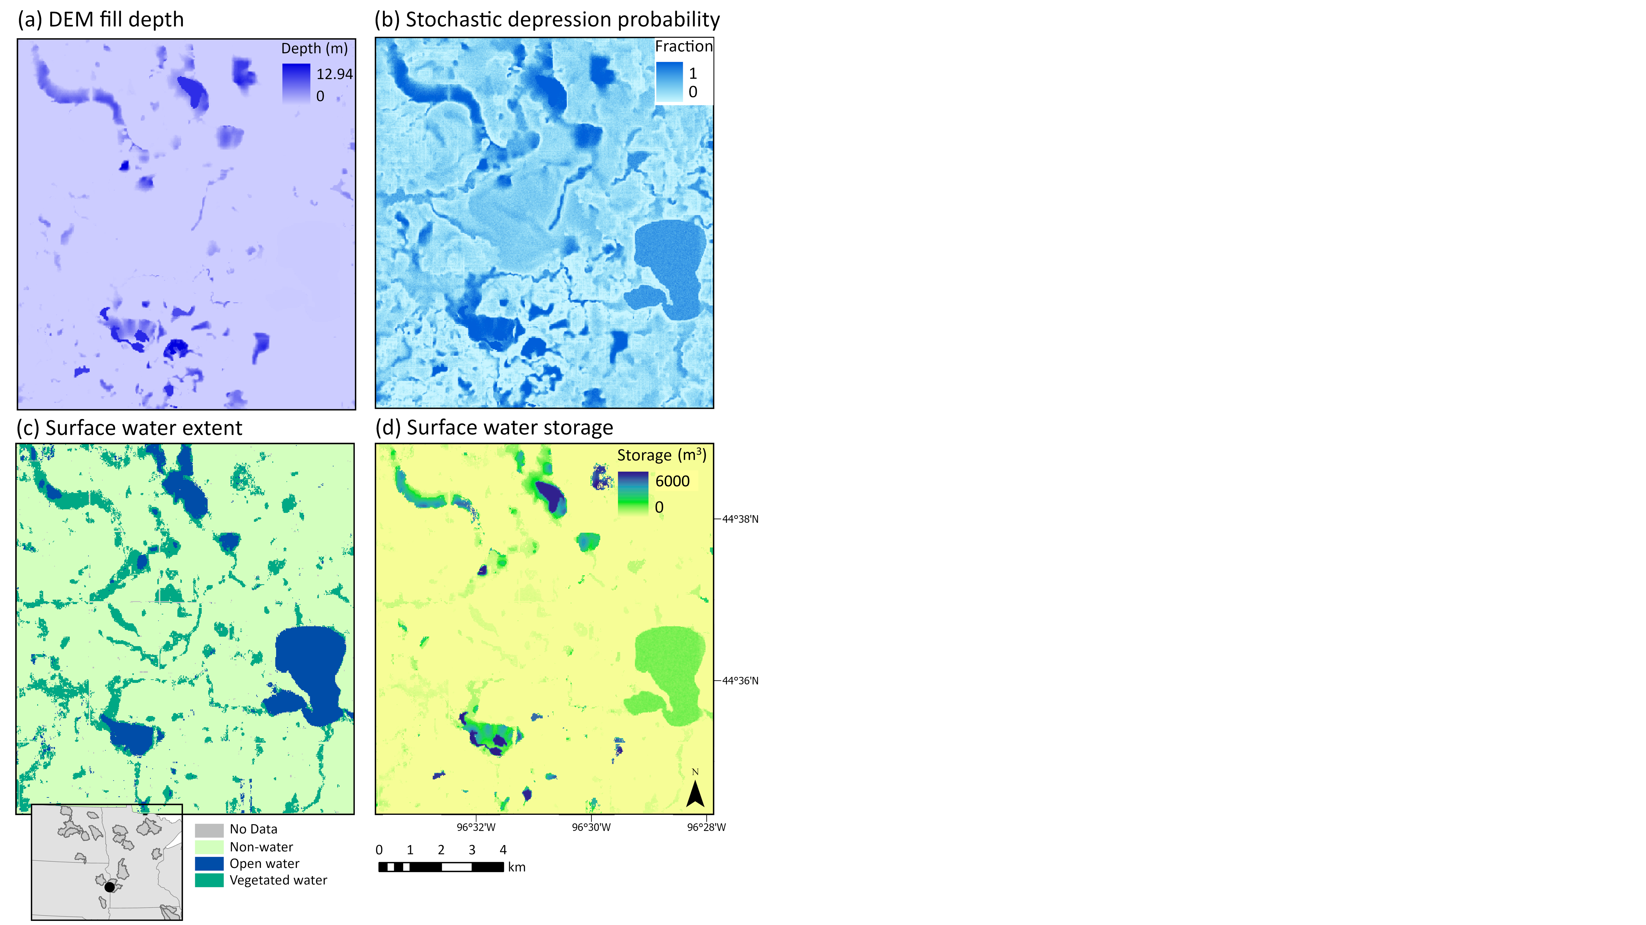
Figure A1. (a) Digital Elevation Model (DEM) fill depth was paired with a (b) stochastic depression probability, to convert (c) open and vegetated water extent (m²) to (d) surface water storage (m³). This example is from the July 15-29, 2020 two-week period (gage: 05300000 on the border of South Dakota and Minnesota). Inset map shows extent relative to states and study watersheds.
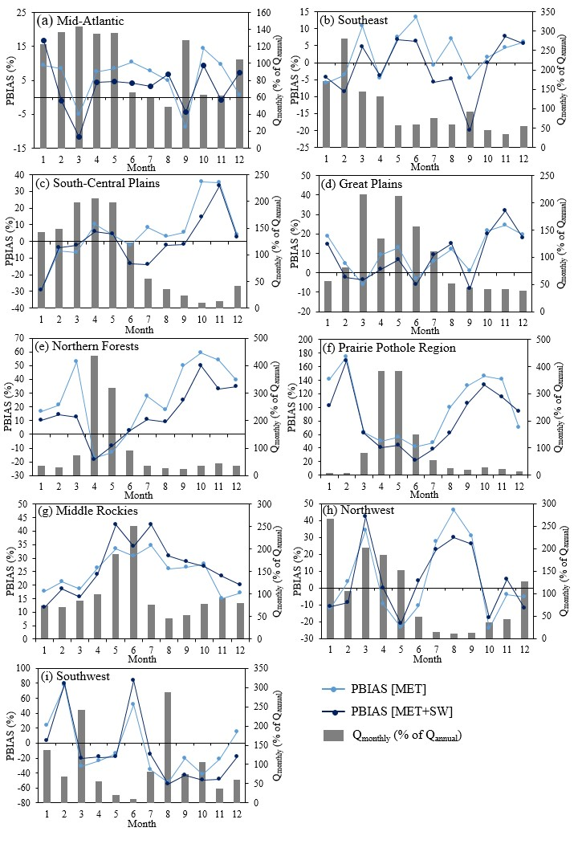
Figure A2. Percent bias (PBIAS) per ecoregion, month, and model compared to discharge, normalized as a percent of average Qannual for watersheds in the (a) Northeast, (b) Southeast, (c) Gulf Coast, (d) Midwest, (e) Upper Midwest, (f) Prairie Pothole Region, (g) Northern Rockies, (h) West, and (i) Southwest. SW: surface water, MET: meteorological data

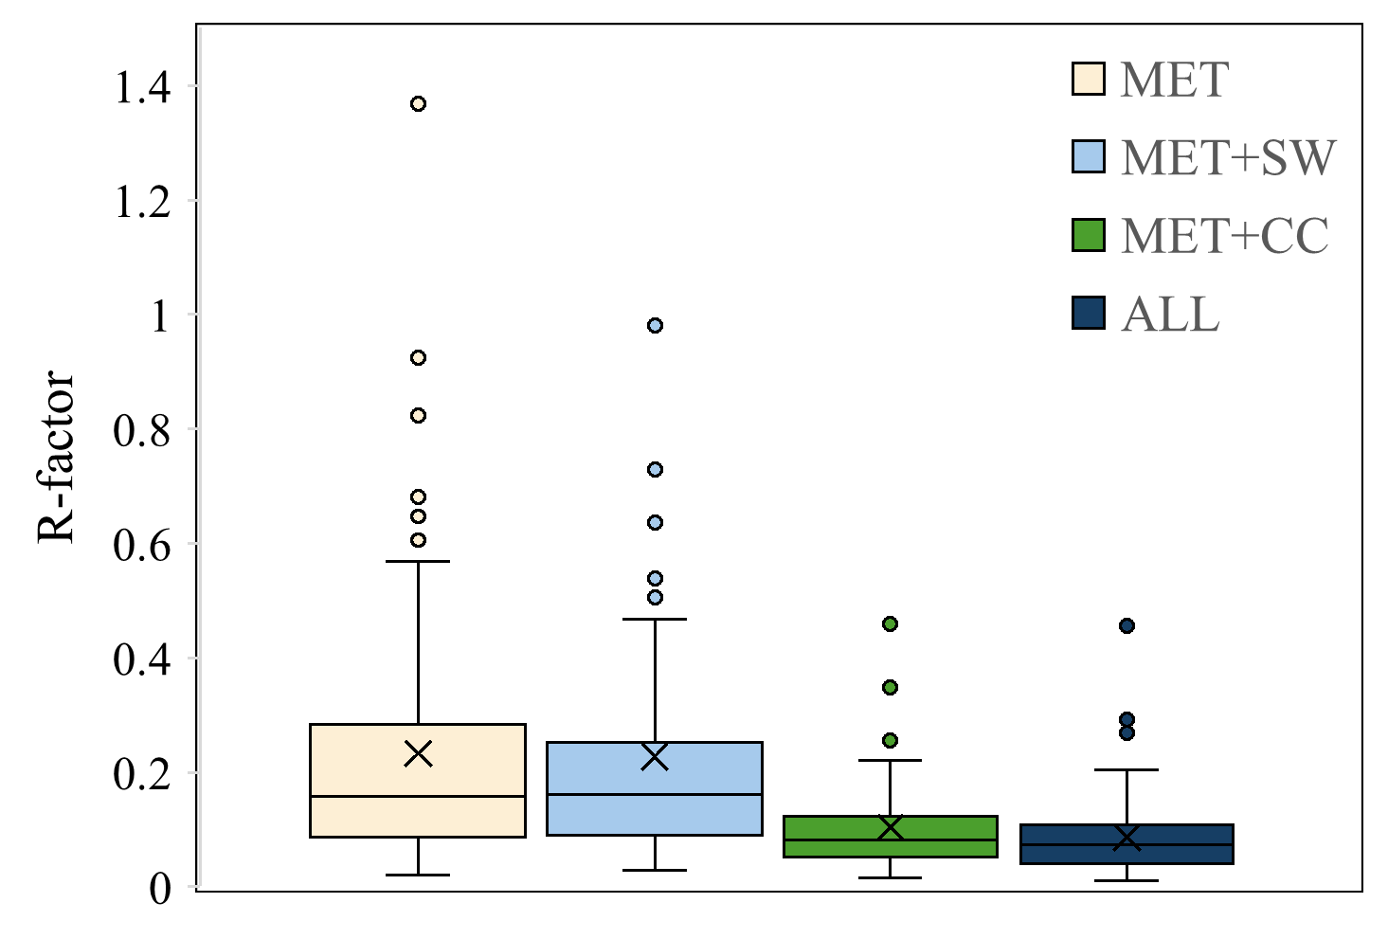
Figure A3. Uncertainty in predicted discharge from model ensembles, as quantified using the R-factor. MET: meteorology, SW: surface water, CC: catchment characteristics
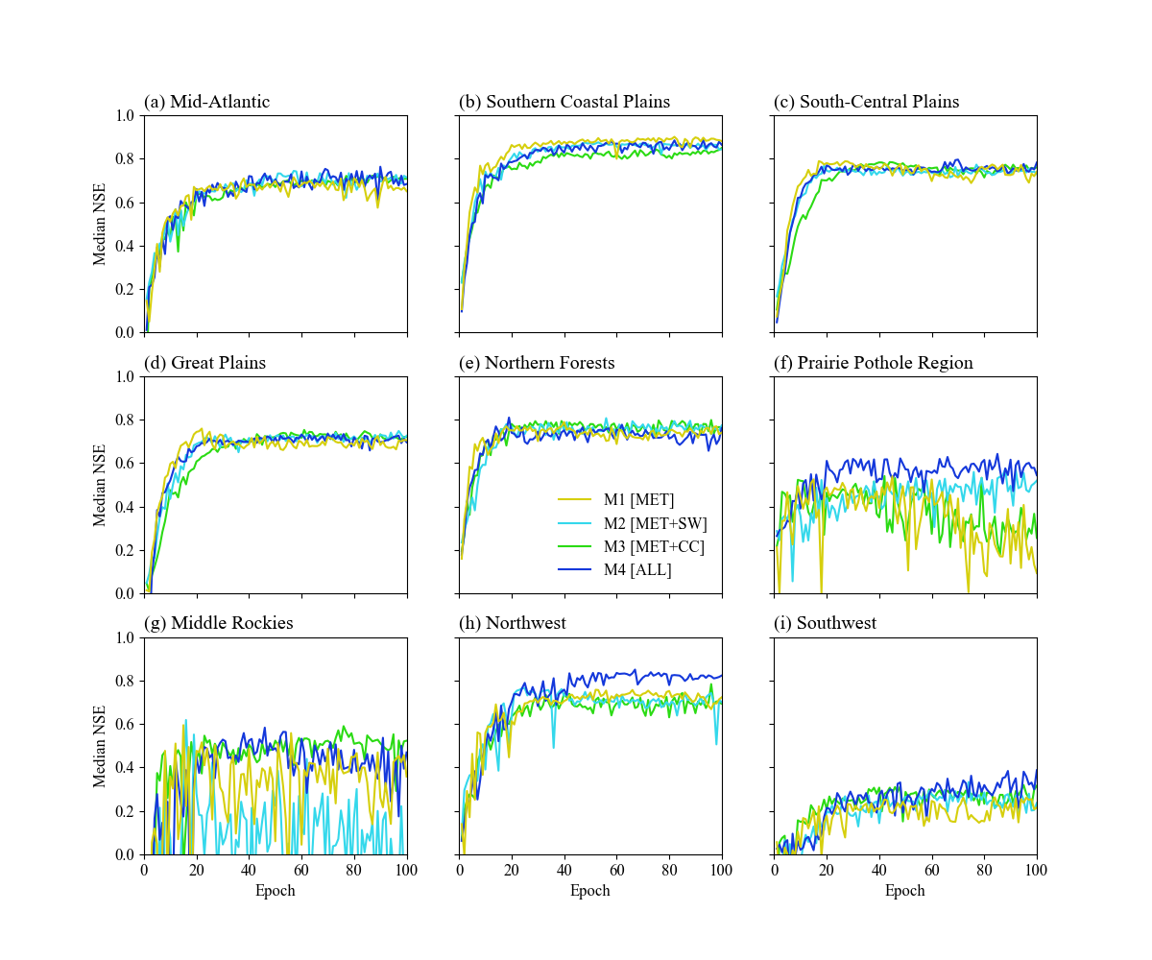
Figure A4. Changes in median Nash-Sutcliffe Efficiency (NSE) with increasing epoch by region.

