Statewide compilation of Nebraska’s Quaternary geology

Nolan Barrette¹, Samuel A. Johnstone¹, Paul Hanson², R.M. Joeckel²
¹U.S. Geological Survey, Geosciences and Environmental Change Science Center, MS 980, 1 Denver Federal Center, Denver, CO
²University of Nebraska-Lincoln, School of Natural Resources, Lincoln, NE

Abstract

Quaternary geologic mapping efforts previously have not represented the state of Nebraska with complete mapping in a published map or report, with the exception of some small-scale national efforts. Our approach to addressing this problem was to compile and synthesize multiple maps and datasets of varying scales into one complete state-scale Quaternary geologic map of the state of Nebraska. We started with three main previously published sources, a map of the soil types of Nebraska, a map of the dune types within the Sand Hills of Nebraska, and the 1:1,000,000 scale maps from the Quaternary Atlas Series and augmented them by summarizing interpretations from 1:250,000 and 1:24,000 scale mapping where data were available. In addition, we utilized digital elevation model (DEM) derivatives and remotely sensed imagery to generate new mapping to maintain continuity past the boundaries of available data. Based on the available data this product was targeted at 1:750,000 scale and fills a previous hole of Quaternary mapping available for the state and contributes to a better regional understanding of Quaternary geology across the central United States.

Introduction
Quaternary surficial processes across the conterminous United States have left three profound, continental-scale imprints: vast glacial deposits from recurring glacial cycles, continental drainage networks, and major eolian sedimentation; with Nebraska squarely centered to record the impact of each. Despite being studied extensively at local and regional scales, the Quaternary geology of Nebraska has not been consistently depicted in any national resolution publications at finer resolution than 1:5,000,000 scale (Soller and Reheis, 2004). The state geologic map of Nebraska, as with some other neighboring publications, emphasizes pre-Quaternary geology. The Quaternary Geologic Atlas of the Unites States map series (Miscellaneous Investigations Series I-1420) only covers the conterminous US east of -102° longitude, splitting the state. Consequences of this can be seen in compilations of geology; the State Geologic Map Compilation (Horton et al., 2017) shows an abrupt end at the boundary of Nebraska (and some neighboring states) and the 1:5,000,000 Surficial Materials in the Conterminous United Sates (Soller and Reheis, 2004) clearly reflects the contrast in available data across the 102° meridian.
In this publication we seek to address this gap by efficiently creating a statewide compilation of Quaternary geology at a target scale of 1:750,000 by primarily relying on existing data and interpretations. First, we begin with an overview of the geologic setting of Nebraska briefly touching on regional bedrock with subsequent focus on the Cenozoic geologic history. Next, we explain the premise of the Geologic Mapping Schema (GeMS) standard and how we used this to store our map digitally. We then describe the data sources we used for this compilation effort and our summarizing observations about the geology originally documented in the source maps, including our approach to assembling these sources into a single, compiled dataset. We follow this by describing our philosophy behind our different compilation units and how those data sources informed our criteria for each. Finally, we conclude with some basic observations from the map and suggestions for future work that could aide in further revision of this map.

Geologic Setting
Sedimentary rocks recording Pennsylvanian and Permian cyclothems (Heckel, 2008) and Cretaceous sedimentation associated with the Western Interior Seaway (Roberts and Kirschbaum, 1995) are present beneath the Miocene to Pliocene Ogallala Group that covers much of the state. The Ogallala Formation records a period of Miocene erosion that dominated the Rocky Mountains (Flanagan and Montagne, 1993; Mears, 1993; Condon, 2005) and culminated in subsequent sediment loading, subsidence, and basin infilling in the Great Plains (Condon, 2005). Today, Nebraska sits at the intersection of three continental-scale sedimentation processes: continental glaciations, major continental drainage systems, and vast eolian transport across the great plains. Previous mapping has shown extensive quaternary deposits that mantle most of the state of Nebraska (Hallberg et al., 1991; Swinehart et al., 1994; Soller and Reheis, 2004; Horton et al., 2017). These include expansive loess deposits in the Central to Southeast regions that can exceed 30m thick, recent and modern alluvial deposits, and massive dune and sheet sands in the central plateau of the state (Swinehart et al., 1994).
Terraces along the modern drainage network in Nebraska and nearby Colorado and Wyoming record a lengthy history of incision and avulsions as the topography responded to significant climatic changes through the Neogene and subsequent Quaternary glacial and interglacial cycles. Deposits from the ancestral South Platte and North Platte Rivers and their tributaries are recognized as early as the late Eocene within Nebraska, Colorado, and Wyoming, with the modern drainage system developing in the late Miocene to Pliocene (Condon, 2005). This evolution was partially coeval with the deposition of the Ogallala Formation. Unconformable deposition of Ogallala Group units, such as the Broadwater Formation in northern and western Nebraska, have been interpreted as widespread erosion as a result of regional uplift in the Pliocene (Condon, 2005). Preserved terraces along the modern Niobrara River record this regional formation of the Broadwater Formation, mapped as Pliocene on the O’Neill 1° x 2° Quadrangle, and at least three subsequent terraces recording Plio-Pleistocene to Holocene alluvial surfaces (Diffendal Jr. et al., 2008). Along the modern Platte River, terraces likely partially equivalent to the Broadwater Formation (Condon, 2005) and possibly of Early Pleistocene origin are preserved in the Scottsbluff 1° x 2° Quadrangle (Swinehart and Diffendal Jr., 1997) and are recognized in the North Platte 1° x 2° Quadrangle as Pliocene in age (Diffendal Jr., 1991). The Platte River 4° x 6° Quadrangle similarly shows terraces, but of an Early Pleistocene and Pliocene origin (Swinehart et al., 1994). Some of the ambiguity between these mapping efforts likely stems from the difficulty in distinguishing between upper Pliocene and lower Pleistocene strata regionally, especially in places where it manifests as a gradual transition in sedimentation across the epochs (Condon, 2005).
This transition from Pliocene to Pleistocene also coincided with some of the first loess deposits recognized in the region. The Fullerton Formation has been identified in South-central Nebraska, previously thought to be Pleistocene and now considered Pliocene, that consists of primarily loess with some gravel interbeds and is likely sourced from local stream channels (Condon, 2005). As the climate shifted into the Pleistocene, characterized by the advance and retreat of continental-scale ice sheets and alpine glaciers worldwide over multiple glacial and interglacial periods, Nebraska experienced an assemblage of alluvial, eolian, and glacial deposition. Early to middle Pleistocene till deposits have previously been identified in eastern Nebraska and generally are recognized as pre-Illinoian in age (Wayne, 1985; Aber, 1999; Korus et al., 2021). Different extents of the ice margin in eastern Nebraska during this time shifted drainage patterns of the ancestral Platte River, where Swinehart et al. (1994) hypothesized that Early Pleistocene drainage was routed North near the modern Niobrara River and its confluence with the modern Missouri River and continued southward following the ice margin. They suggest that subsequent advance of the ice lobe to its farthest extent westward into eastern Nebraska likely routed the river network far to the South near the modern Republican River, followed by its rearrangement into the modern drainage pattern during the mid-Pleistocene (Illinoian) and into the late Pleistocene (Wisconsinan), see Figure 1. While the ice margin was actively in
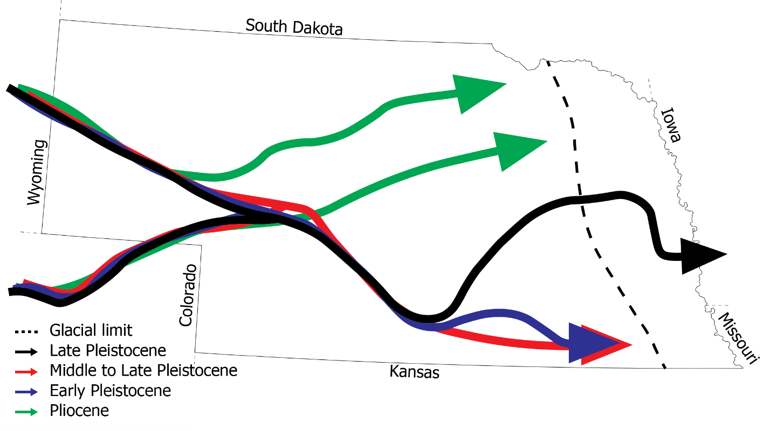
Figure 1. Sketch modified from Swinehart et al. (1994) showing postulated drainage patterns from late Pliocene to late Pleistocene. Solid lines show the main ancestral drainage of the Platte River. Heavy doted lines represent terminal moraine positions of undifferentiated pre-Illinoian glacial maxima.
eastern Nebraska, sequences of alluvium and loess were deposited in central and western Nebraska with lithologies potentially grading into one another (May and others, 1995, Condon, 2005) and not always being present laterally (Lugn, 1935, Condon, 2005). The transition into the middle to late Pleistocene was accompanied by widespread loess deposition. The Loveland Formation, late Illinoian in age, is a widely recognized unit throughout the mid-continent and has been dated at 163.0 ± 34.0 ka using thermoluminescence methods (Maat and Johnson, 1996). This is overlain by the Gilman Canyon Formation, a silt containing several paleosols that’s believed to be the contact between early and mid-Wisconsinan deposits (Reed and Dreeszen, 1965) and has been radiocarbon dated as old as ~40 ka (Muhs et al., 1999). Overlaying the dissected topography of the Gilman Canyon is the late Wisconsin Peoria Loess (Lugn, 1935, Condon, 2005), which is similarly recognized across the mid-continent as is the Loveland Formation and has reported radiocarbon ages between ~12 ka and ~21 ka (Feng et al., 1994). These loess sequences border the Platte River valley and blanket much of the surrounding uplands, notably of the Loess Hills and Loess Plains regions of Nebraska, and previously have been mapped with thicknesses generally up to 30m (Swinehart et al., 1994) and locally up to 75m thick (Condon, 2005). These loess deposits are mapped at the surface generally following a NE-SW trend that bisects the state.
Late Pleistocene to Holocene progression signified a change in eolian deposition in the region to include massive sand dune deposits. These deposits have been recognized across the Great Plains (Muhs and Budahn, 2019), the Colorado Plateau, and the Basin and Range physiographic regions (Muhs et al., 2003), however the largest areas of eolian sands are in the Great Plains. Currently active eolian sand in this semi-arid region is generally limited to the southernmost dunes in New Mexico and Texas, however a few smaller areas do exist where previously stable sand has been activated by human activities such as farming or infrastructure development (Muhs and Budahn, 2019). The Sand Hills region, located in north-central to southwestern Nebraska, is the largest dune field in the Western Hemisphere and covers roughly ¼ of the area of Nebraska. The age and provenance of this massive volume of sand has long been hypothesized and continually refined over the better part of the last century, from an early interpretation of the late Pleistocene Peoria Loess and Sand Hills dune sands being derived from Tertiary deposits contemporaneously (Lugn, 1935, Condon, 2005), to the addition of radiocarbon age dating and subsequent hypotheses that the Sand Hills probably have had a long history through glacial and inter-glacial cycles, even though dating evidence points mainly to late Holocene activity (Muhs et al., 1997). Newer evidence has shown both a more refined age dating of the Sand Hills, as well as a likely source of the sediment. Miao et al., (2007) were able to show with optically stimulated luminescence age dating methods that multiple periods of eolian activity have occurred during the Holocene, with sustained activity from 9.6 to 6.5 ka and subsequent periods of activity at 1.0 - 0.7 ka and 2.3 - 4.5 ka (with peaks centered on 2.5 and 3.8 ka). They interpreted these periods of dune activity as responses to frequent, severe drought in the mid-continent, potentially corresponding to hypothesized links between Holocene droughts and sea surface temperature anomalies or the El Nino-Southern Oscillation phenomenon. Muhs and Budahn, (2019) showed new evidence for the origin of the Sand Hills sand using a comparison of hypothetical sediment sources through trace element composition and ultimately argued the Ogallalla Group has the best fit compositionally to the Sand Hills.

Map Data Schema

We utilized the Geologic Mapping Schema (GeMS) standard digital data format for this product (USGS, 2020). In referring to data in this format we describe tables in bold and fields in italics. In this publication we have grouped our data into four spatial layers: ContactsAndFaults, MapUnitPolys, GeologicLines, and OverlayPolys. The ContactsAndFaults line vector data holds all the line geometry features that bound map-unit polygons; including contacts, faults (non-existent in this dataset), boundaries of water bodies, and map boundaries. The MapUnitPolys polygon vector data contains all the units within the mapped area, which includes geologic map units and open water, and are all bounded by the features within ContactsAndFaults. The GeologicLines line vector data stores lines associated with geologic features that do not define a boundary between a map-unit polygon. Finally, we use the OverlayPolys polygon vector data to store an approximate representation of thickness of loess. In addition, the dataset contains four non-spatial tables: DataSources, DescriptionOfMapUnits, GeoMaterialDict, and Glossary. The DataSources table identifies the references for the content of the geologic map database and ties each individual spatial feature to one or multiple data sources by way of a pipe-delimited (“|”) DataSourcesID foreign key to the Datasources_ID field in the DataSources table. When multiple, delimited data sources are referenced by a feature they are listed in order of greatest influence on the mapped feature. The DescriptionOfMapUnits table captures the descriptions of the map units and is related to the MapUnitPolys by way of a MapUnit primary and foreign key. The GeoMaterialDict table provides definitions and a hierarchy for GeoMaterial names within the GeMS schema, which is an important part of the detailed descriptions held within the DMU. Finally, the Glossary stores definitions for the terminology used throughout the GeMS geodatabase.
Symbolization of the map is based on the Federal Geographic Data Committee (FGDC) Digital Cartographic Standard for Geologic Map Symbolization publication (FGDC, 2006). These symbols are stored in the Symbol field in each feature class or non-spatial table and are a key to a specific cartographic symbol in the FGDC standard.

Spatial data compilation

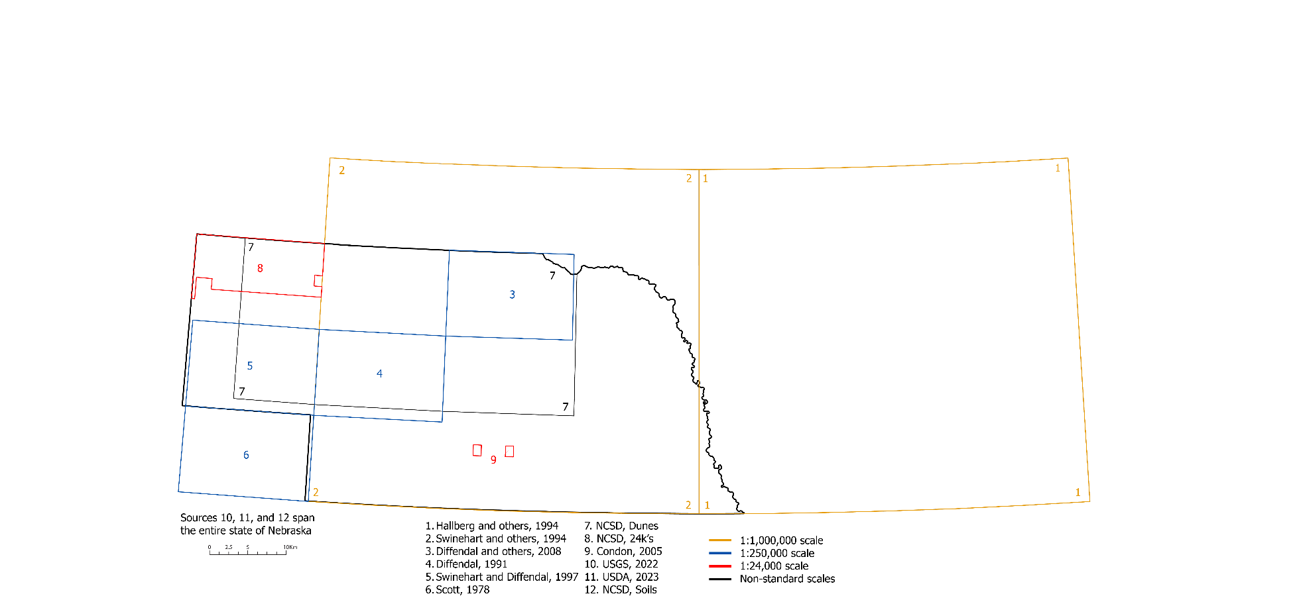Figure 2. Locations of previous mapping used in compiling the Quaternary Geology of Nebraska.

We relied on a suite of previous mapping, referenced in Figure 2, either for direct digital reproduction or as a reference to aide in new mapping from remote sensing. As a foundation, we began with the digital data for the Soils of Nebraska map provided by the Nebraska Conservation and Survey Division (NCSD Soils). The Soils of Nebraska map describes the state of Nebraska with 80 unique soil associations, which we grouped into 9 categories based on the parent material these soils formed in: loess; sandy and loamy materials; loess and till; sandstone, siltstone, limestone, and shale; alluvium or loess on stream terraces and bottomlands; sandy and loamy materials underlain by coarse sand and gravel; alluvium on bottomlands; loess, sandstone, siltstone, and limestone; and eolian sands and alluvium in sand hills. We dissolved the original detailed polygons on these more general categories to create an initial pass at statewide MapUnitPolys and ContactsAndFaults data. Into this data we appended, after cropping out underlying areas, mapping of specific dune types found within the Sand Hills of Nebraska (NCSD Dunes), seen in Figure 3.
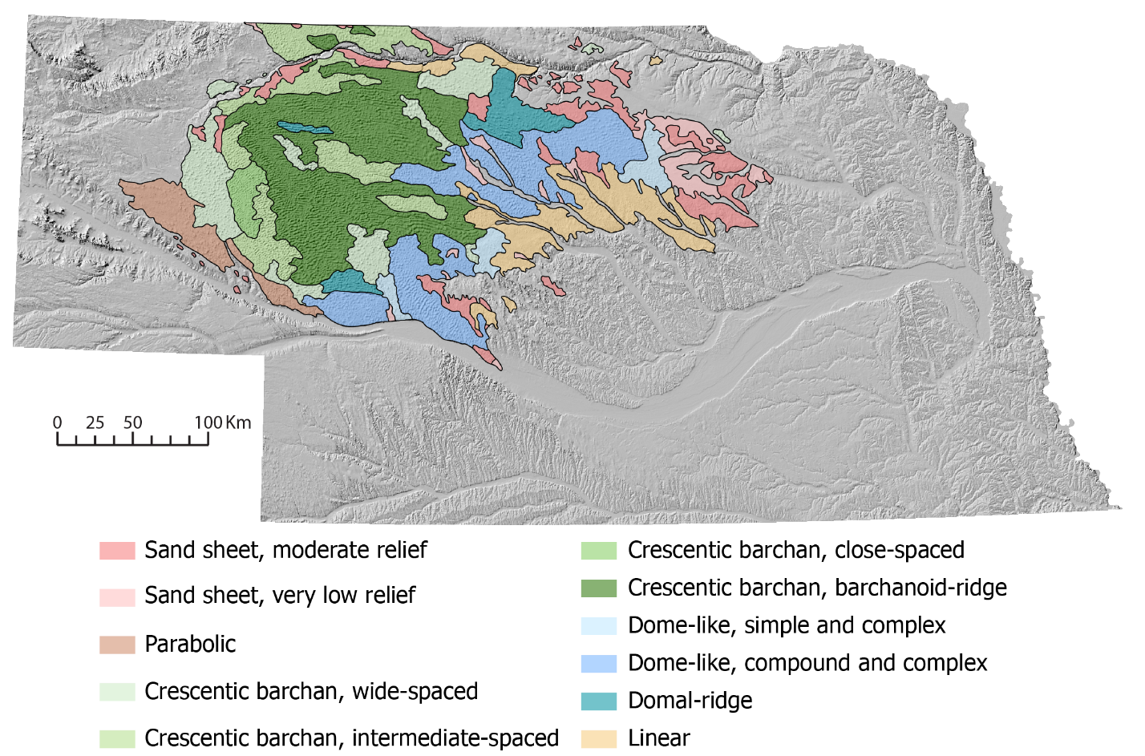
Figure 3. Original dune types dataset (NCSD Dunes). The colored polygons overlay a hillshade of the state.
Following this initial digital compilation of existing mapping we refined the location of major contacts. These efforts focused most on areas where more detailed mapping was not available (Figure 2), which we discuss more below, but instead where contacts, primarily the margins of alluvial deposits and terraces inset into valleys, were defined by the statewide soils maps (NCSD Soils). As shown in Figure 4, hillshades and other elevation derivatives from USGS 3DEP data (U.S. Geological Survey, 2022) were used to relocate contacts to more closely correspond to readily observable topographic changes.
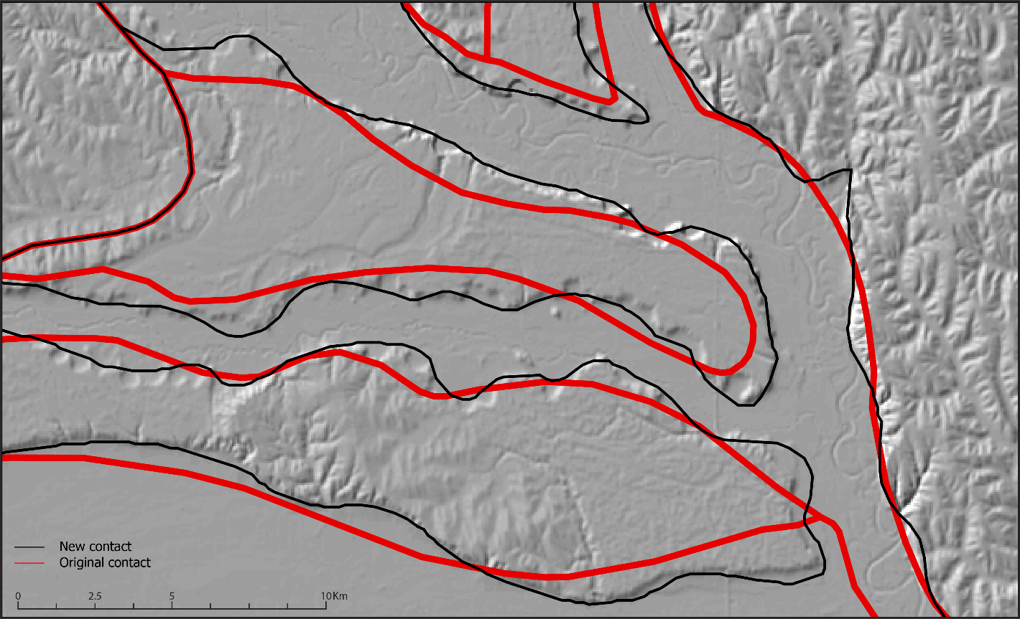
Figure 4. A region north of the confluence of the Elkhorn and Platte Rivers showing original contacts from (NCSD Soils) in red and our newly mapped contacts in black, both overlaying a hillshade from U.S. Geological Survey, (2022).
Figure 2 illustrates previous mapping more and less detailed than the target scale was available in many areas to refine the digital assembly described above. When previously published maps were available, we digitized Quaternary geology at a target scale of 1:750,000 while attempting to capture the map patterns and relationships with topography indicated by published mapping. This was done iteratively by examining the source maps and identifying the margins of map units in elevation derivatives and remotely sensed imagery, including examining land-use patterns. Beyond the margins of published data, we extended Quaternary features where they could be identified in elevation derivatives and imagery. With a minor exception in the westernmost portion of the state, 1:1,000,000 scale mapping was available almost everywhere that 1:250,000 scale or better mapping was not and could serve as a general guide for the continuity of deposits across the map area. Our generalizations of more detailed mapping required not just smoothing of line work, but aggregation of polygons into a more general set of units. In the section that follows we discuss in more detail our target classification of units. Our coarser scale map typically shows the same geology as the more detailed maps, just more general in stratigraphy and spatial expression. However, Figure 5 highlights an example where a colluvial unit of minor thickness was not compiled to emphasize the continuity of terraces along the Platte River.
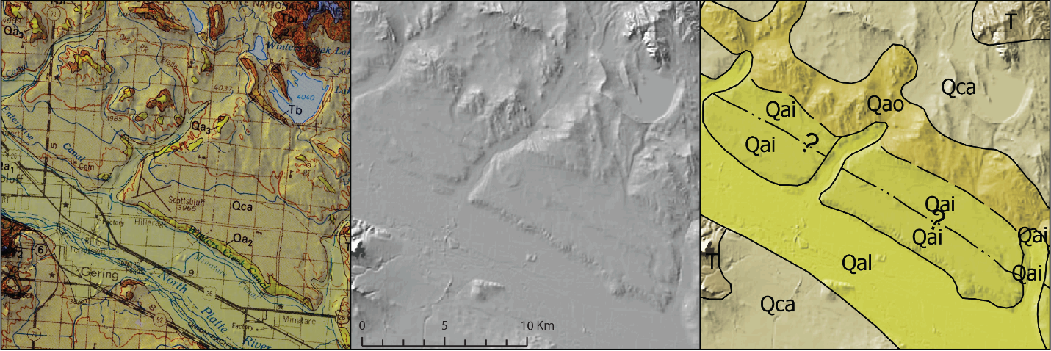
Figure 5. A region near Scottsbluff, NE, illustrating our mapping decisions compared to those of the source map. Panel A shows the 1:250,000 scale original map data from Swinehart and Diffendal Jr., (1997), overlaying the topographic data from U.S. Geological Survey, (2022) shown in panel B. Panel C shows our new mapping similarly overlaying the topographic data in panel B.
Figure 6 illustrates the spatial distribution of reproduced and modified linework described above. The central portion of the state is covered by mapping of the Sand Hills and is unchanged. Areas in the northwest, far west, and west central were covered by mapping more detailed than the target scale (Fig. 4), which resulted in a large proportion of manual generalization. These areas were centered on major fluvial systems, often with abundant terraces that continued along the river, resulting in modified linework continuing along rivers outside the boundaries of these maps. Finally, all the major river networks are bound by modified and/or original linework, reflecting our decision to use topographic data to update the delineation of the alluvial valleys and tributaries to be consistent statewide.
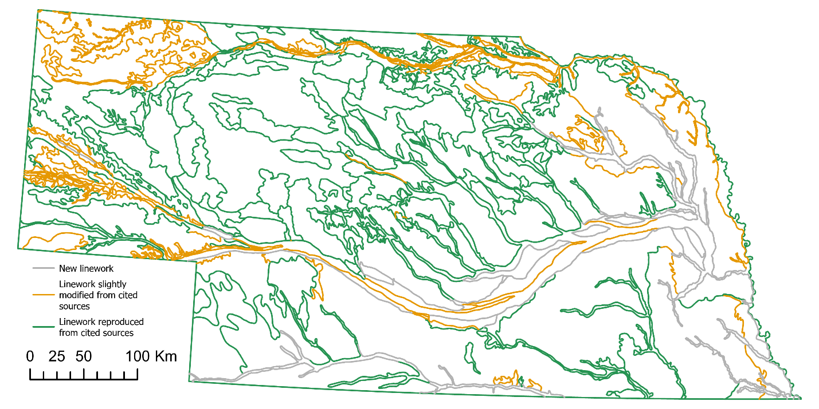
Figure 6. Linework modification. Grey lines show new linework based only on U.S. Geological Survey, (2022) topographic data. Orange lines show linework that has been modified from the original data sources. Green lines show linework that has been directly taken from original data sources.
Additionally, Swinehart et al., (1994) and Hallberg et al., (1994) contained digital data that were directly used in this map as auxiliary data, included in the GeologicLines and OverlayPolys feature classes. The GeologicLines feature class contains the location of glacial terminuses (Pre-Illinoian), while the OverlayPolys feature class contains loess thickness polygons. The margins of the OverlayPolys were adjusted from source data in one location, so that rather than showing the abrupt termination of loess at the margin of the original map the loess continued as shown by the distribution of MapUnitPolys.

Synthesis of existing geology

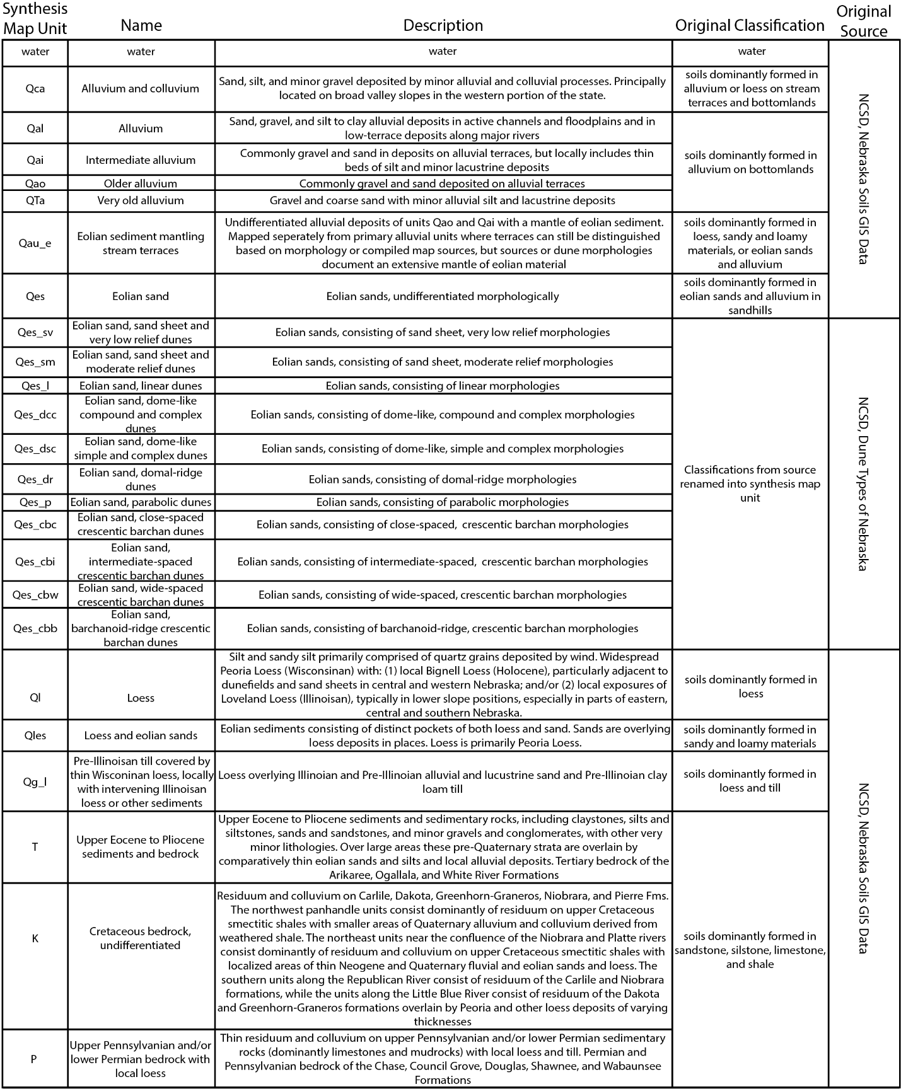
From the initial soil parent material associations described above we defined five broad, process-based classifications within which we organized our synthesis map units: alluvium, colluvium, residuum and bedrock, eolian, and glacial. These are shown in Table 1, which denotes the synthesis map unit symbol, the name of the map unit, description of the synthesis map unit, the original classification if applicable, and the original source of the data. These broad categories are further subdivided based on previous geologic mapping. Our alluvium units are broken out into four units based on ages that could be consistently correlated between source publications: modern alluvium (Qal), intermediate alluvium (Qai) of more recently active stream channels on terraces, older alluvium (Qao) seen on higher level terraces, and very old alluvium (QTa). These very-old alluvium deposits are only present at or near the surface between the North and South Platte Rivers, and are considered to be Plio-Pleistocene in age, as denoted by both Swinehart and Diffendal Jr., (1997) and Diffendal Jr., (1991). However, previous mapping by Diffendal Jr. et al., (2008) and Souders, (2000) suggests these deposits are pervasive underneath the Late Pleistocene to Holocene eolian sediments of the Sand Hills and extend northeast to the Niobrara River. Where significant eolian deposits mantle terrace deposits, evident from previous mapping or eolian landforms on these terraces, we capture this stratigraphy with an eolian sediment mantling terraces unit (Qau_e). Additionally, a colluvium and alluvium unit (Qca) is included and characterizes broad valley slopes and hillslopes in the western portion of the state. Our eolian units are generally split into three categories: loess (Ql), undivided loess and eolian sands (Qles), and eolian sand (Qes). Rather than characterize the entire Sand Hills as Qes, we adapted the morphologic distinction of the Sand Hills atlas (NCSD Dunes) to fit our general symbol and naming convention, subdividing this region into 11 variants of Qes based on dune morphology and relief. We use a glacial unit (Qg_l) that describes the area in the southwest portion of the state that has a significant pre-Illinoian till covered by younger loess. Lastly, our residuum and bedrock units are divided by general age of the bedrock the residuum is formed in: Tertiary (T), Cretaceous (K), and Pennsylvanian to Permian (P).

Table 1. Crosswalk table showing relationships between original source classifications and our synthesis map units.
Correlations of terraces units along the Niobrara and North Platte and Platte River’s are shown in Figure 7. As mentioned above, QTa deposits are only observed along the Platte River, where they are located approximately 100 m above river level near the confluence of the North and South Platte Rivers (and the local convexity in the river profile that highlights the Lake McConaughy reservoir). At the upstream end of the Platte River, Qao and Qai deposits are around 60-70 m and 30-40 m above river level, respectively, with two clear levels of Qai terraces separated by around 10 m. The relief between terraces and the modern Platte River decreases downstream with Qai deposits merely 10 m above the river. Qau_e deposits are more abundant downstream, where they are typically above Qai deposits, however these eolian mantled terraces are also observed at the upstream end of the Platte River in line with both the upper Qai terraces and Qao terraces. A different relationship is seen in the Niobrara, where terrace heights above river level increase downstream and emerge below a knickpoint at ~250 km downstream. Near the downstream limit of the Niobrara profile Qao deposits are around 80-90 m above the river, while Qai are seen at two distinct levels of around 40 m and 70 m, respectively. As with upstream sections of the Platte River, eolian mantled terraces are observed at comparable elevations to the upper Qai terrace deposits, about 70 m above river level.
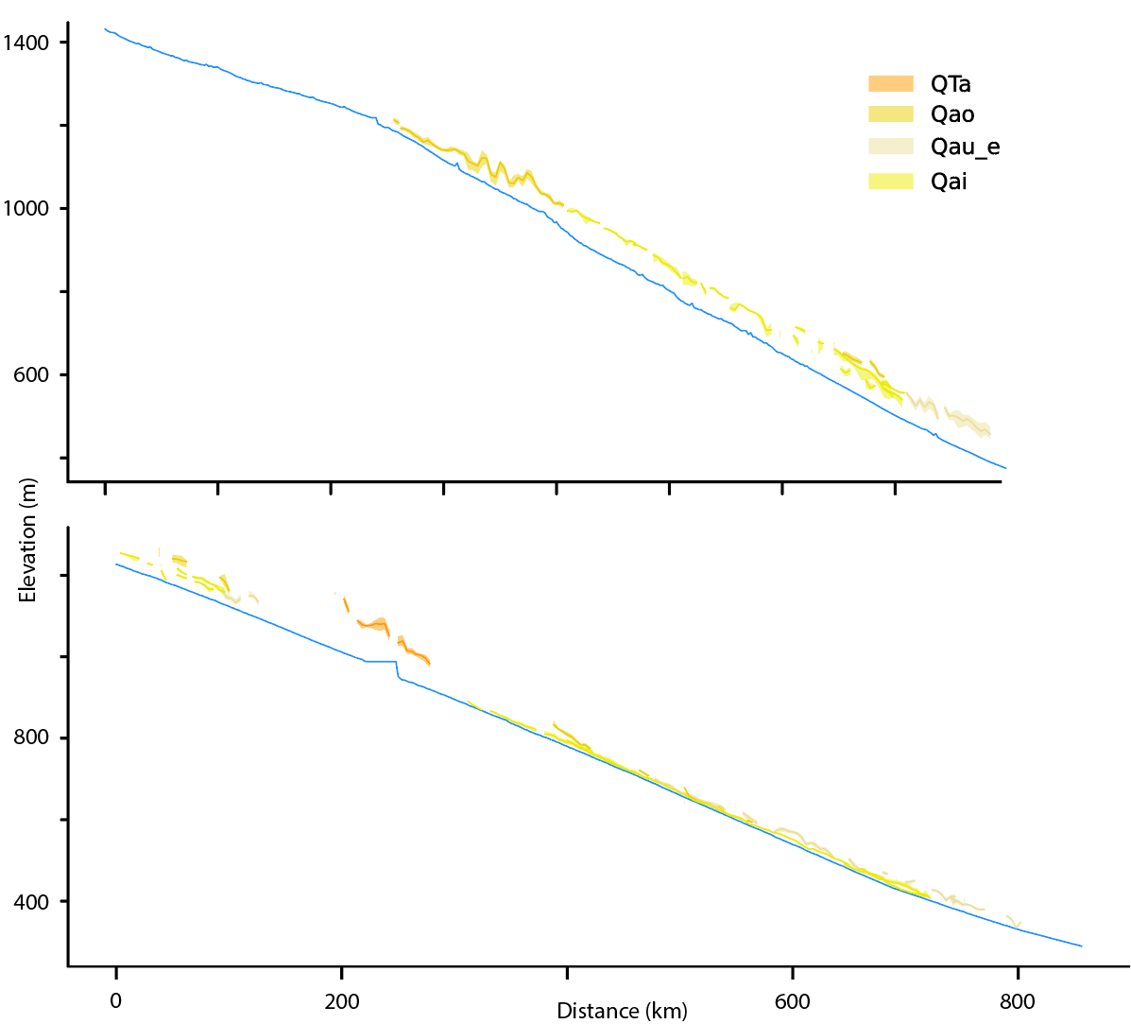
Figure 7. Longitudinal profiles and elevations of adjacent terraces for the Niobrara (top) and North Platte and Platte Rivers (bottom). Terrace elevations are taken from digital elevation models, and each pixel's elevation is projected to the closest point along the river (discretized with a point every 2 km). These distributions of elevations and distances are summarized for each terrace as the upper and lower quartiles (shaded region) and median value (solid line) of elevation measured in 4 km moving windows.

Discussion and Conclusions
Our final compiled map can be seen in Figure 8, highlighting a few distinct trends. The first is that exposures of pre-Quaternary geology are relatively isolated. These older units are primarily observed in the western panhandle of the state where regional river systems have produced the most local relief through incision. Additionally, these bedrock sediments and outcrops can be found in similar topographic settings in the bluffs near the confluence of the Niobrara and Missouri Rivers and extend upstream into part of the Niobrara River valley. Other locations of residuum and bedrock do occur in the southeast portion of the state, however these locations generally have small extents and are similarly proximal to river valleys. The concentration of pre-Quaternary deposits in the west is mirrored by loess thickness, as described by Swinehart et al., (1994) and shown as an inset map, and the dominant Sand Hills in the central part of the map. In total, eolian sediments occupy >70% of the map area. These dune fields are generally mantling Pleistocene loess deposits, but interfingering of deposits does occur spatially.
Along the Platte and Niobrara Rivers two distinct levels seem recognizable in our Qai terraces, separated from one another by approximately 10 m (Fig. 7). Along the Niobrara this reflects compilation of previous mapping and characterization by Diffendal Jr. et al., (2008), who interpreted the two levels we have grouped into Qai as Holocene and upper Pleistocene. Similarly to what’s observed here, Diffendal Jr. et al., (2008) depicted eolian mantling as more prevalent, though not exclusive, on older terraces; the upper of the two Qai levels observed here and our Qao. In the upper reaches of the Niobrara, our Qao is questionable due to the discrepancy seen between the longitudinal profile, illustrated in Figure 7, compared to the 1:24,000 scale mapping from NCSD 24k, (Mutliple Publication Dates), where the previous mapping suggests an older age of early Pleistocene, while the longitudinal profile suggests a potentially younger age where our Qai unit may be more appropriate. It appears plausible that these two Qai terrace levels may be present more regionally, most distinctly in the North Platte River valley, but potentially correlate to some of our Qau_e terraces downstream along the Platte River. While of limited spatial extent, Condon (2005) recognized two terrace levels within our Qai in the central reaches of the Platte River (Fig. 2), and with comparable base level (the Missouri River) and regional climate we might expect similar incision histories. However, without more detailed new mapping and correlation, the contrasting relationship between the longitudinal profile and terraces provide some reason for caution in simply correlating based on position. Along the Niobrara, terraces seem consistent with expected patterns of formation arising from knickpoint migration (Finnegan, 2013), increasing in elevation away from a knickpoint. Indeed, even a small knickpoint is seen at ~600 km downstream, which together with the larger knickpoint at ~200 km downstream could be responsible for the generation of the Holocene and upper Pleistocene terraces of Diffendal Jr. et al., (2008). If true, that suggests these terraces are likely time-transgressive (Finnegan, 2013). In contrast, terraces at the downstream end of the Platte River are at much lower relative elevation and no comparable knickpoint is observed in the map area. Perhaps this is simply a reflection of the larger catchment area of the Platte River, in which we would expect a knickpoint to migrate more quickly. Alternatively, perhaps this reflects a different history where the Niobrara River and North Platte are eroding through older sedimentary rocks, while the downstream reaches of the Platte River are forced to contend with additional transportation of eolian sediment, which in the past has even lead to local damming of the river (Muhs et al., 2000).

Figure 8. Quaternary geologic map of Nebraska. Insets show the loess thickness in meters and the index to mapping sources.

While this map provides a consistent depiction of Quaternary deposits across Nebraska it is heavily reliant on previous investigations and remote interpretation. Continued investigations are needed to verify the interpretations and chronology of the source publications that are often decades old. Although 1:250,000 scale mapping does exist for much of Nebraska, these maps generally prioritize pre-Quaternary units. Therefore, additional research regarding Quaternary stratigraphy and spatial distribution would provide a higher level of confidence for correlation of units across the region. These studies would aide in our understanding of the history of incision and avulsions recorded in terraces found across the state, the interplay between fluvial and eolian activity, and more generally the consequences of Pleistocene glacial and interglacial cycles in the region.

Acknowledgements
Margaret Berry and C.A. Ruleman provided reviews on an early draft of this map that helped tremendously in guiding the work. Primary support for this work came from the FEDMAP component of the US Geological Survey National Cooperative Geologic Mapping Program. This draft manuscript is distributed solely for purposes of scientific peer review. Its content is deliberative and predecisional, so it must not be disclosed or released by reviewers. Because the manuscript has not yet been approved for publication by the U.S. Geological Survey (USGS), it does not represent any official USGS finding or policy. Any use of trade, firm, or product names is for descriptive purposes only and does not imply endorsement by the U.S. Government.

References
Aber, J.S., 1999, Pre-Illinoian glacial geomorphology and dynamics in the central United States, west of the Mississippi, in Glacial Processes Past and Present, Geological Society of America, doi:10.1130/0-8137-2337-X.113.
Condon, S.M., 2005, Geologic Studies of the Platte River, South-Central Nebraska and Adjacent Areas—Geologic Maps, Subsurface Study, and Geologic History: U.S. Geological Survey Professional Paper 1706, Plates 1 & 2, https://pubs.usgs.gov/pp/pp1706/.
Diffendal Jr., R.F., 1991, Geologic map showing configuration of the bedrock surface, North Platte, 1º x 2º quadrangle, Nebraska: U.S. Geological Survey Miscellaneous Investigations Series Map I-2277.
Diffendal Jr., R.F., Voorhies, M.R., Voorhies, E.J., LaGarry, H.E., Timperley, C.L., and Perkins, M.E., 2008, GEOLOGIC MAP OF THE O’NEILL 1º X 2º QUADRANGLE, NEBRASKA, WITH CONFIGURATION MAPS OF SURFACES OF FORMATIONS: SCHOOL OF NATURAL RESOURCES, CONSERVATION AND SURVEY DIVISION, INSTITUTE OF AGRICULTURE AND NATURAL RESOURCES, UNIVERSITY OF NEBRASKA-LINCOLN GEOLOGIC MAP GMC-34, https://digitalcommons.unl.edu/natrespapers/304.
Feng, Z.-D., Johnson, W.C., and Diffendal Jr., R.F., 1994, ENVIRONMENTS OF AEOLIAN DEPOSITION IN SOUTH-CENTRAL NEBRASKA DURING THE LAST GLACIAL MAXIMUM: Physical Geography, v. 15, p. 249–261, doi:10.1080/02723646.1994.10642515.
FGDC, 2006, FGDC Digital Cartographic Standard for Geologic Map Symbolization: Federal Geographic Data Committee Document Number FGDC-STD-013-2006, 290 p., https://ngmdb.usgs.gov/fgdc_gds/.
Finnegan, N.J., 2013, Interpretation and downstream correlation of bedrock river terrace treads created from propagating knickpoints: Journal of Geophysical Research: Earth Surface, v. 118, p. 54–64, doi:10.1029/2012JF002534.
Flanagan, K.M., and Montagne, J., 1993, Neogene stratigraphy and tectonics of Wyoming, in Snoke, A.W., Steidtmann, J.R., and Roberts, S.M., editors, Geology of Wyoming: Geological Survey of Wyoming Memoir No. 5, p. 572–607.
Hallberg, G.R. et al., 1991, Quaternary geologic map of the Des Moines 4° x 6° Quadrangle, United States: U.S. Geological Survey Miscellaneous Investigations Series Map I-1420 (NK-15), https://ngmdb.usgs.gov/Prodesc/proddesc_9217.htm.
Heckel, P.H., 2008, Pennsylvanian cyclothems in Midcontinent North America as far-field effects of waxing and waning of Gondwana ice sheets, in Special Paper 441: Resolving the Late Paleozoic Ice Age in Time and Space, Geological Society of America, v. 441, p. 275–289, doi:10.1130/2008.2441(19).
Horton, J.D., San Juan, C.A., and Stoeser, D.B., 2017, The State Geologic Map Compilation (SGMC) geodatabase of the conterminous United States: Data Series Report 1052, 56 p., doi:10.3133/ds1052.
Korus, J.T., Joeckel, R.M., Abraham, J.D., Høyer, A.-S., and Jørgensen, F., 2021, Reconstruction of pre-Illinoian ice margins and glaciotectonic structures from airborne ElectroMagnetic (AEM) surveys at the western limit of Laurentide glaciation, Midcontinent U.S.A.: Quaternary Science Advances, v. 4, p. 100026, doi:10.1016/j.qsa.2021.100026.
Maat, P.B., and Johnson, W.C., 1996, Thermoluminescence and new 14C age estimates for late quaternary loesses in southwestern Nebraska: Geomorphology, v. 17, p. 115–128, doi:10.1016/0169-555X(95)00099-Q.
Mears, B., Jr., 1993, Geomorphic history of Wyoming and high-level erosion surfaces, in Snoke, A.W., Steidtmann, J.R., and Roberts, S.M., editors, Geology of Wyoming: Geological Survey of Wyoming Memoir No. 5, p. 609–626.
Miao, X., Mason, J.A., Swinehart, J.B., Loope, D.B., Hanson, P.R., Goble, R.J., and Liu, X., 2007, A 10,000 year record of dune activity, dust storms, and severe drought in the central Great Plains: Geology, v. 35, p. 119, doi:10.1130/G23133A.1.
Muhs, D.R., Aleinikoff, J.N., Stafford, T.W., Jr, Kihl, R., Been, J., Mahan, S.A., and Cowherd, S., 1999, Late Quaternary loess in northeastern Colorado: Part I—Age and paleoclimatic significance: GSA Bulletin, v. 111, p. 1861–1875, doi:10.1130/0016-7606(1999)111<1861:LQLINC>2.3.CO;2.
Muhs, D.R., and Budahn, J.R., 2019, New geochemical evidence for the origin of North America’s largest dune field, the Nebraska Sand Hills, central Great Plains, USA: Geomorphology, v. 332, p. 188–212, doi:10.1016/j.geomorph.2019.02.023.
Muhs, D.R., Reynolds, R.L., Been, J., and Skipp, G., 2003, Eolian sand transport pathways in the southwestern United States: importance of the Colorado River and local sources: Quaternary International, v. 104, p. 3–18, doi:10.1016/S1040-6182(02)00131-3.
Muhs, D.R., Stafford, T.W., Swinehart, J.B., Cowherd, S.D., Mahan, S.A., Bush, C.A., Madole, R.F., and Maat, P.B., 1997, Late Holocene Eolian Activity in the Mineralogically Mature Nebraska Sand Hills: Quaternary Research, v. 48, p. 162–176, doi:10.1006/qres.1997.1913.
Muhs, D.R., Swinehart, J.B., Loope, D.B., Been, J., Mahan, S.A., and Bush, C.A., 2000, Geochemical Evidence for an Eolian Sand Dam across the North and South Platte Rivers in Nebraska: Quaternary Research, v. 53, p. 214–222, doi:10.1006/qres.1999.2104.
NCSD 24k, Mutliple Publication Dates, 7.5" Geologic maps published by the Nebraska Conservation and Survey Division in Northwest Nebraska:, https://snr.unl.edu/csd/geology/statemap.aspx.
NCSD Dunes Dune Types of Nebraska:, https://snr.unl.edu/data/geographygis/index.aspx.
NCSD Soils Nebraska Soils GIS Data:, https://snr.unl.edu/data/geographygis/soil.aspx.
Reed, E.C., and Dreeszen, V.H., 1965, Revision of the Classification of the Pleistocene Deposits of Nebraska:
Roberts, L.N.R., and Kirschbaum, M.A., 1995, Paleogeography of the Late Cretaceous of the Western Interior of Middle North America - Coal Distribution and Sediment Accumulation: U.S. Geological Survey Professional Paper 1561,.
Soller, D.R., and Reheis, M.C., 2004, Surficial materials in the conterminous United States: U.S. Geological Survey Open-file Report 03-275.:
Souders, V.L., 2000, Geologic maps and cross sections showing configurations of bedrock surfaces, Broken Bow 1° x 2° quadrangle, east-central Nebraska: U.S. Geological Survey Geologic Investigations Series I–2725.
Swinehart, J.B., and Diffendal Jr., R.F., 1997, Geologic map of the Scottsbluff 1° x 2° quadrangle, Nebraska and Colorado: U.S. Geological Survey IMAP 2545, https://doi.org/10.3133/i2545.
Swinehart, J.B., Dreeszen, V.H., Richmond, G.M., Tipton, M.J., Bretz, R., Steece, F.V., Hallberg, G.R., and Goebel, J.E., 1994, Quaternary geologic map of the Platte River 4° x 6° quadrangle, United States: U.S. Geological Survey U.S. Geological Survey Miscellaneous Investigations Series Map I-1420 (NK-14), https://ngmdb.usgs.gov/Prodesc/proddesc_9216.htm.
U.S. Geological Survey, 2022, 1 Arc-second Digital Elevation Models (DEMs) - USGS National Map 3DEP Downloadable Data Collection:, https://www.usgs.gov/3d-elevation-program.
USGS, 2020, GeMS (Geologic Map Schema)—A standard format for the digital publication of geologic maps: Techniques and Methods Report 11-B10, doi:10.3133/tm11B10.
Wayne, W.J., 1985, Drainage Patterns and Glaciations in Eastern Nebraska:

